**CPS592: ChemScan: Your Guide to Chemical-Free Living**

Rohan Ravindra Patil

Joshua Praneeth Moorathoty

Abraham Vincent Prannoy Kumar Mulaka

Pavan Kumar Medevelli

PROTOTYPES

Prototype-1:

Prototype-1 is basically designed in a simple way. In the step -1 we designed a landing page where you can start your application. Then in the step-2 it shows a main menu page. In the main menu page, you have the scan and library. So, when you click on the scan icon then the next step-3 will be the scanner. The scan icon is used to scan your food products. After that when you click on library, you can find specific additives then its shows what are food chemicals that are hazardous to us. For example, if you search for Ammonium Acetate. It shows a hazard, as it not good to consume. Then after scanning the product the final step is, it gives the output what are all food chemicals involved in that product that are safe to consume or it shows a warning that it is a hazard.

Usability test:

We done a survey by showing our prototypes, so we got some responses which help us to choose our final prototype. When we showed our prototype 1 to a friend he said “ *How can we know that what type of chemicals are hazardous without knowing the user health conditions*”. So we got an idea to implement a design in our prototype that the user can enter his health problem based on his health problem it shows what are the food chemicals that are injurious to him. And recommends the food based on his health diet.

Prototype-2:

Prototype-2 is designed in such a way that is customizable by the user as it required to him. So, the step1 will be the login page where the user login with their credentials then after logging into the application the next step will be the personal details it includes the name, age, weight, height, health problems, eating habits and date of birth. In this page if suppose the user is suffering from diabetes then he can use this application to control that health problem. After entering the details then the next page is directed to step 3. Where the user can find the scan, library, weekly tracker report and swapping of junks products with the healthy products. Then the next step-4 will be the scanner and the step-5 will be the food tracker it shows the report of the user how much food chemicals he has consumed from morning to night. Then at the last step will be about consulting the professional nutritionist.

Usability test:

When we showed our prototype-2 to other friend he quoted saying “*why should I use this application as I already know that I diagnosed with diabetes, so I follow healthy diet instead of junk food*”. We got to know that some users are not friendly to use this type of prototype as people who are suffering from health problems, they have consulted a doctor. They follow the diet that is prescribed by the doctor. So, by taking the responses from some people we thought about prototype-3 in which we designed in such a way that what are all food related news is going on.

Prototype-3:

In this prototype-3 the step-1 will be the login page then the next page has the news about the new chemicals that are harmful. A scan icon is used to scan the products, then it has the information to learn about chemicals that are harmful, it has replaced the unhealthy products with the healthy products like for example, frozen meat is replaced with fresh-cut meat and then statistics. After the next page will be the scanner. Then in our next page user can search for food chemicals and how it causes harm to the user like if the user search about ammonium acetate it shows information that it’s a hazard as the ammonium acetate is a white, crystalline solid with a slight vinegar-like odor. It is used in chemical analysis and preserving the meats. So, in the next step user can replace the unhealthy food with some healthy food like for example if the user type pizza in the search bar, then it shows some salad instead to make user consume healthy food. Then final step will be the weekly report shown in a pie chart. In the pie chart the red portion is how much harmful chemicals the user has consumed from the past week and the green portion shows what are all safe chemicals have found in it. We also added the share option in it so that the user can share his weekly report with his friends and family.

Usability test:

When we showed our prototype-3 to our mutual friend. He was so impressed by this prototype as he is a gym rat. He said “*I spend lot of time in the gym when it comes to the diet I always find difficult to know about the food chemicals that I’m consuming whether they are good or bad to me*”. So this made us feel so impressive and we have selected this as our final prototype. He also suggested us saying “*mostly sometimes in a hurry I consume some junk while I’m hungry so I think I should be notified before having it.*” So, we included the trigger notification in our final prototype that is to be notified just in time whenever you are in a grocery store or when you reach home.

Final prototype:

In our final prototype step-1 will be login page then the next step has food safety i.e., in this it shows the food related news and how to store groceries, leftovers so that they last longer and how to avoid food poisoning on a cheat day if the user is craving for some junk food. It has the scan icon, food chemicals library, statistics, and food replacement and if the user tap on scan icon, he can scan the food products with the scanner and the library icon shows the harmful chemicals like Aluminum is for food coloring, Ammonium acetate is for preservation etc. Then if the user wants to check the weekly stats. It shows what all chemicals he has consumed from the few weeks, and he can also share his report with the sharing options as shown in picture. Then if the user wants to replace the unhealthy food with some healthy food it recommends based on the product for example if the user want to have puff sweets it recommends having simply granola.

So this is our last step in the prototype in which the user get a notification whenever he is in the grocery store before buying the groceries he can scan them and get to know about the food chemicals that are involved that food product. Sometimes the users are not comfortable scanning the food products at the store. So whenever he reaches home our applications pops out a notification saying finally home, lets scan our purchases.

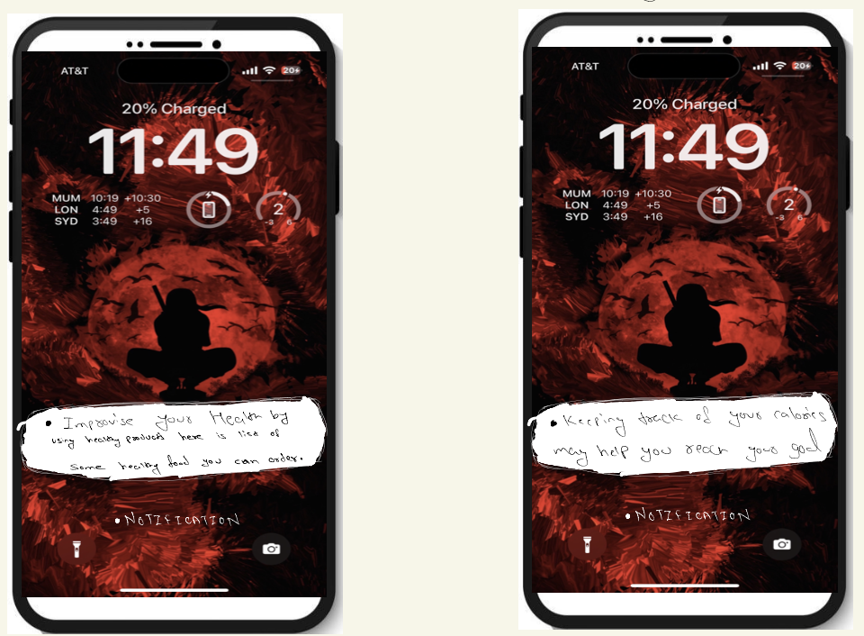

So, in this step whenever the user is about to order food online it triggers a notification saying.

“*Improvise your health by using healthy products so here is the list of some healthy food you can order*”. And whenever user want to cheat his meal on weekends It gives a notification saying, “*keeping track of your calories may help you reach your goa*l.” So, the notification pop out just in time before he is about to consume unhealthy food.