**Name:** YASHAS BYSANI MURALIDHAR **Name:** Arpitha Nagavara Ananthamurty

**Student ID:** 204605414 **Student ID:** 204854351

**Email:** [ybysanimuralidhar@toromail.csudh.edu](mailto:ybysanimuralidhar@toromail.csudh.edu) **Email:**[anagavaraananthamur2@toromail.csudh.com](mailto:anagavaraananthamur2@toromail.csudh.com)

**ASSIGNMENT 5**

**CSC – 501**

1. **Whether your program can be compiled and executed successfully, and including two test cases and their screen shot outputs.**

Yes, our program does compile and execute successfully.

**Test Case – 1**

* Network Length and Width: 5 x 5
* Number of Nodes: 12
* Transmission Range: 5
* Data Generators: 5
* Data Packets: 10
* Storage Capacity: 10

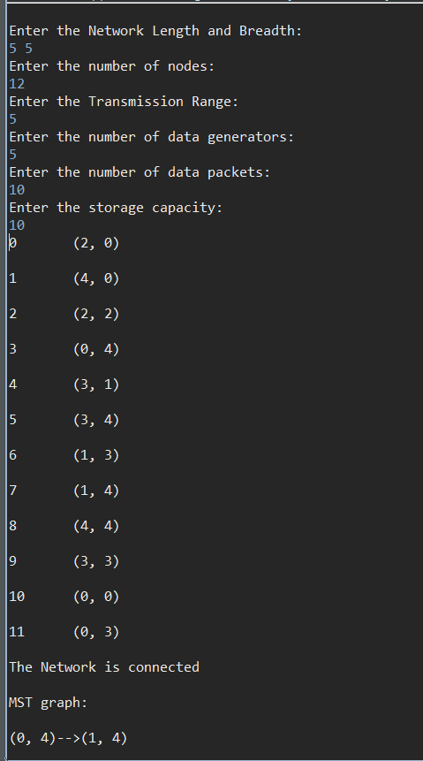

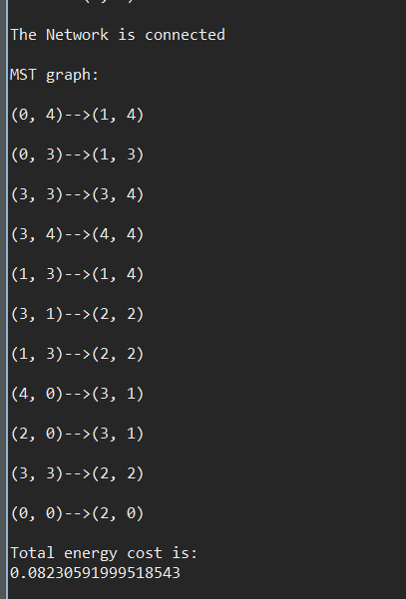

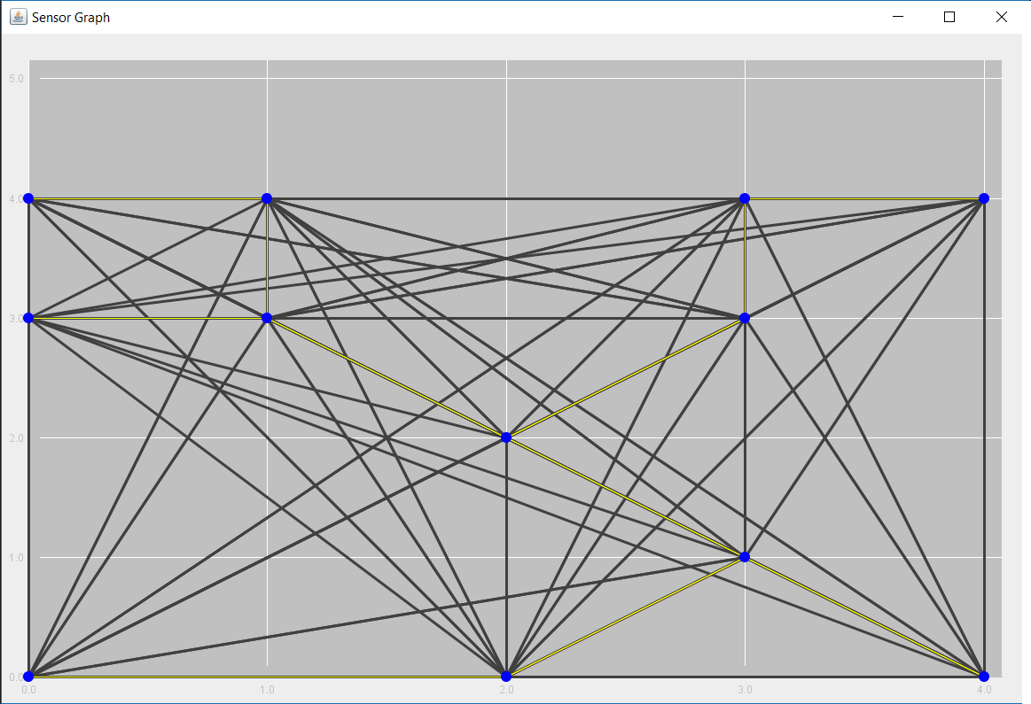

**Test Case - 2**

* Network Length and Width: 5 x 5
* Number of Nodes: 15
* Transmission Range: 4
* Data Generators: 1
* Data Packets: 2
* Storage Capacity: 2

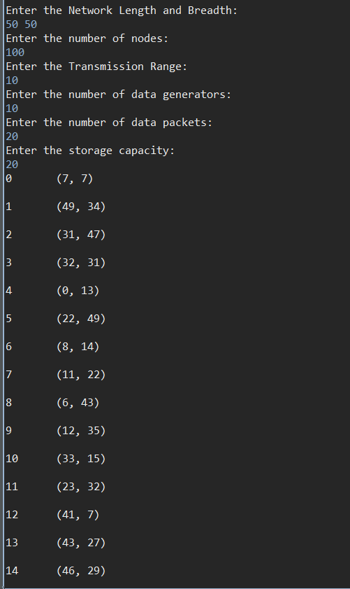 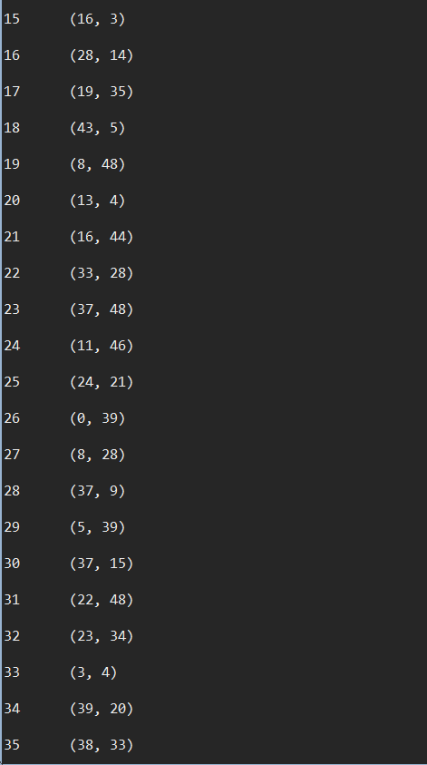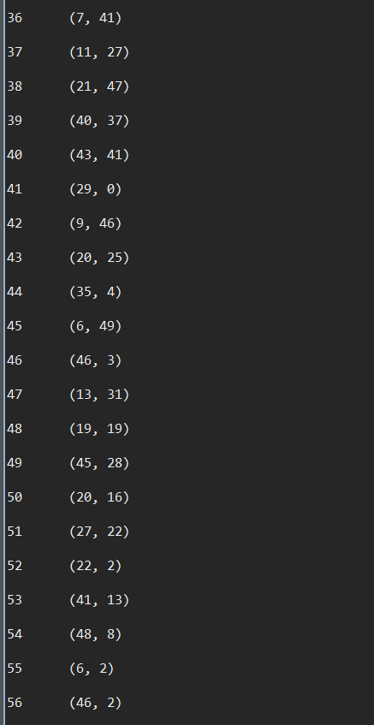 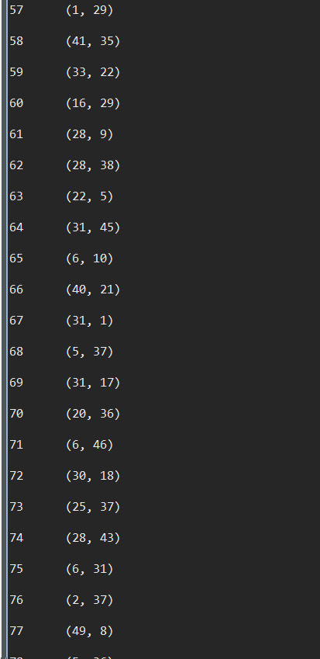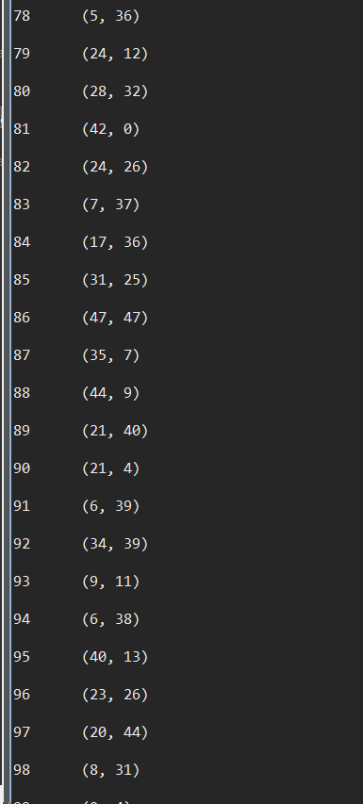 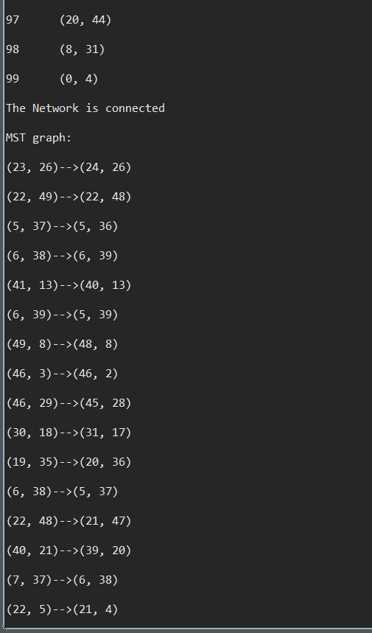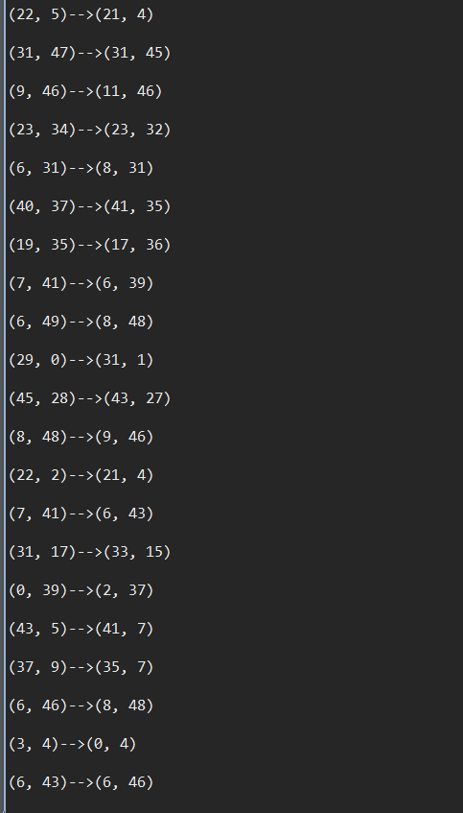 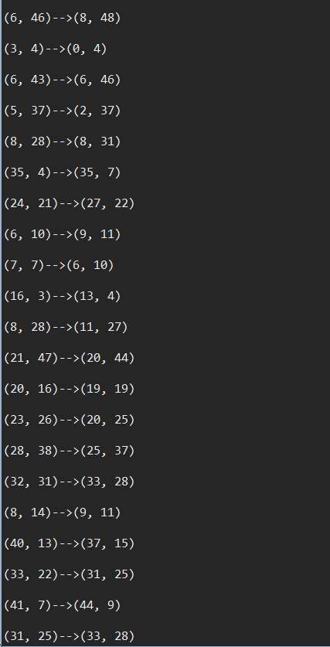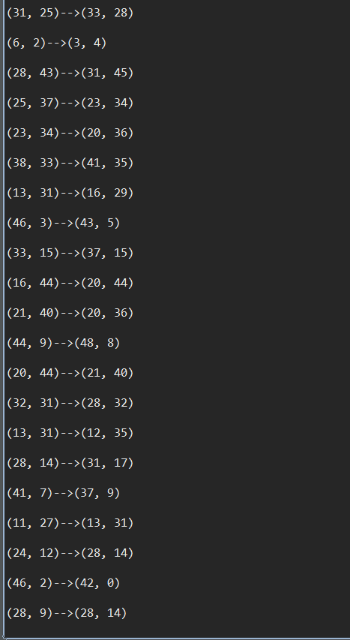 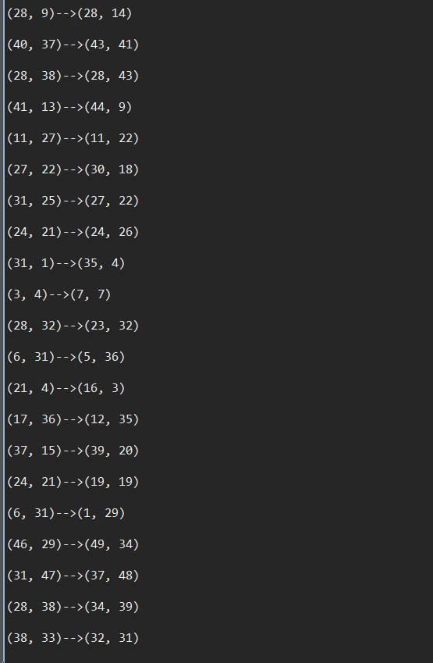

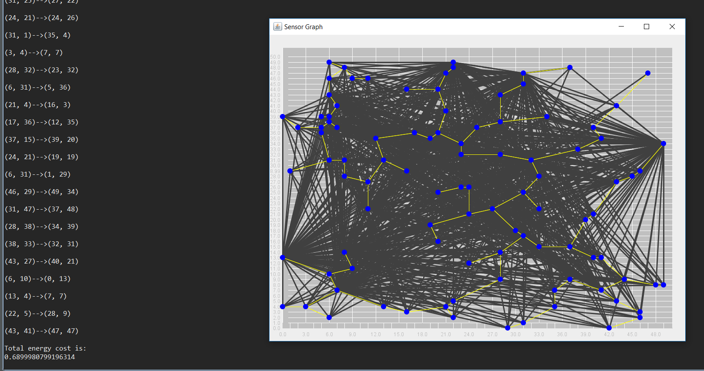

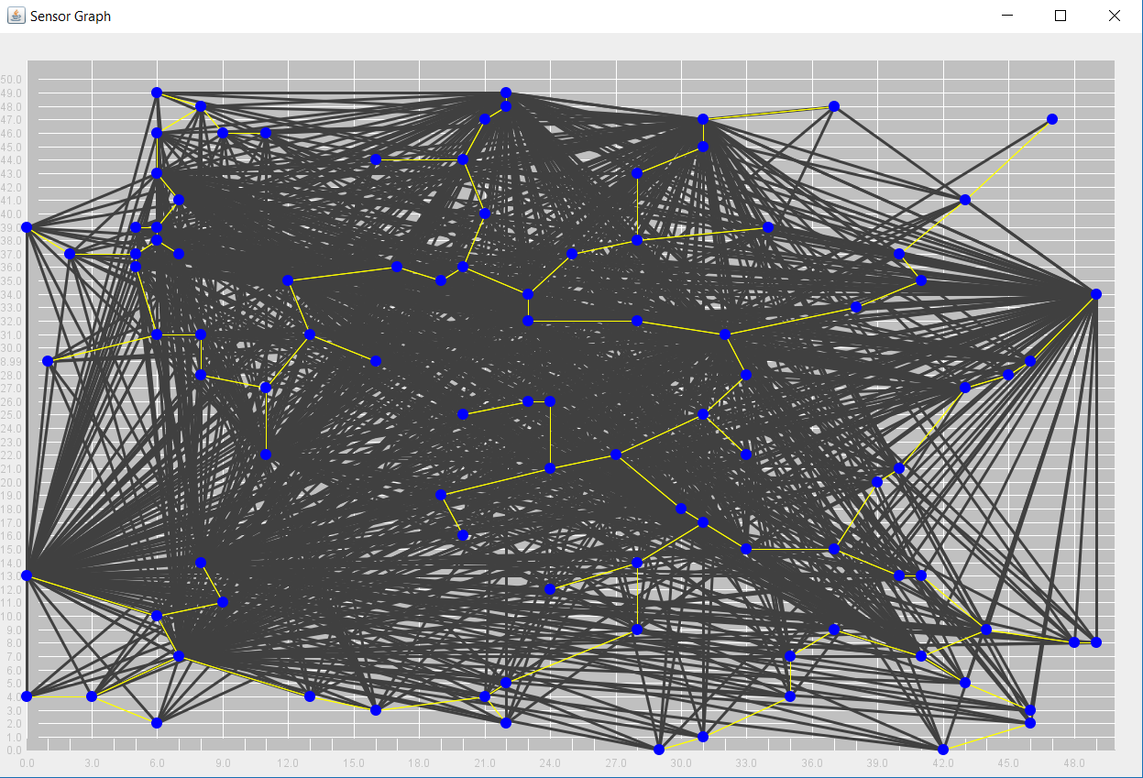

1. **How to compile and test your program**

* Execute on eclipse IDE:

Copy the source code from

src-> kruskals_algo->Kruskal.java into the java IDE compile and execute.