**Name : Rohan More.**

**Contact : 9324867073.**

**Email : rohan110620@gmail.com**

**LinkedIn :** [**www.linkedin.com/in/nameisrohan**](http://www.linkedin.com/in/nameisrohan)**.**

**GitHub :** [**https://github.com/rohanSnippet/**](https://github.com/rohanSnippet/)

1. **Project Overview.**

* This project is designed to manage and display a table of chemical properties, allowing users to interact with data through icons for adding, deleting, saving, sorting and refreshing the content. The design emphasizes ease of use, responsiveness, and accessibility across devices, particularly focusing on small, medium, and large screens.

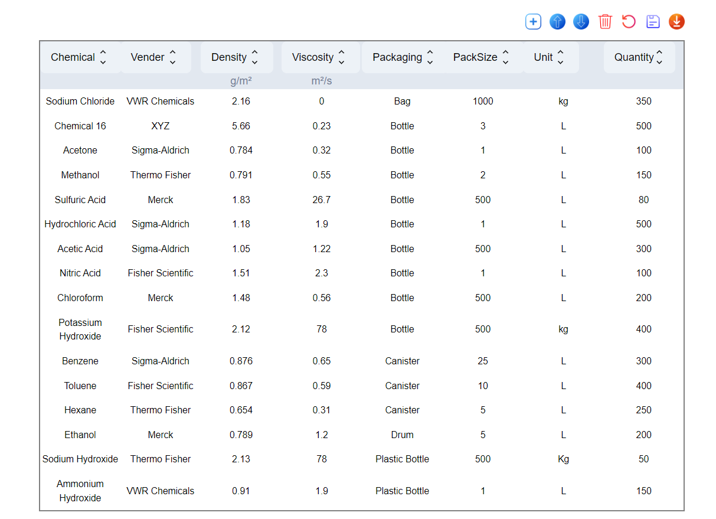

1. Adding New Row .

* User has to click on the add  icons to create a new input row.
* After adding data to input , user can click on save  button to add a new row in table.
* Note: new row will be added at the end of the table.

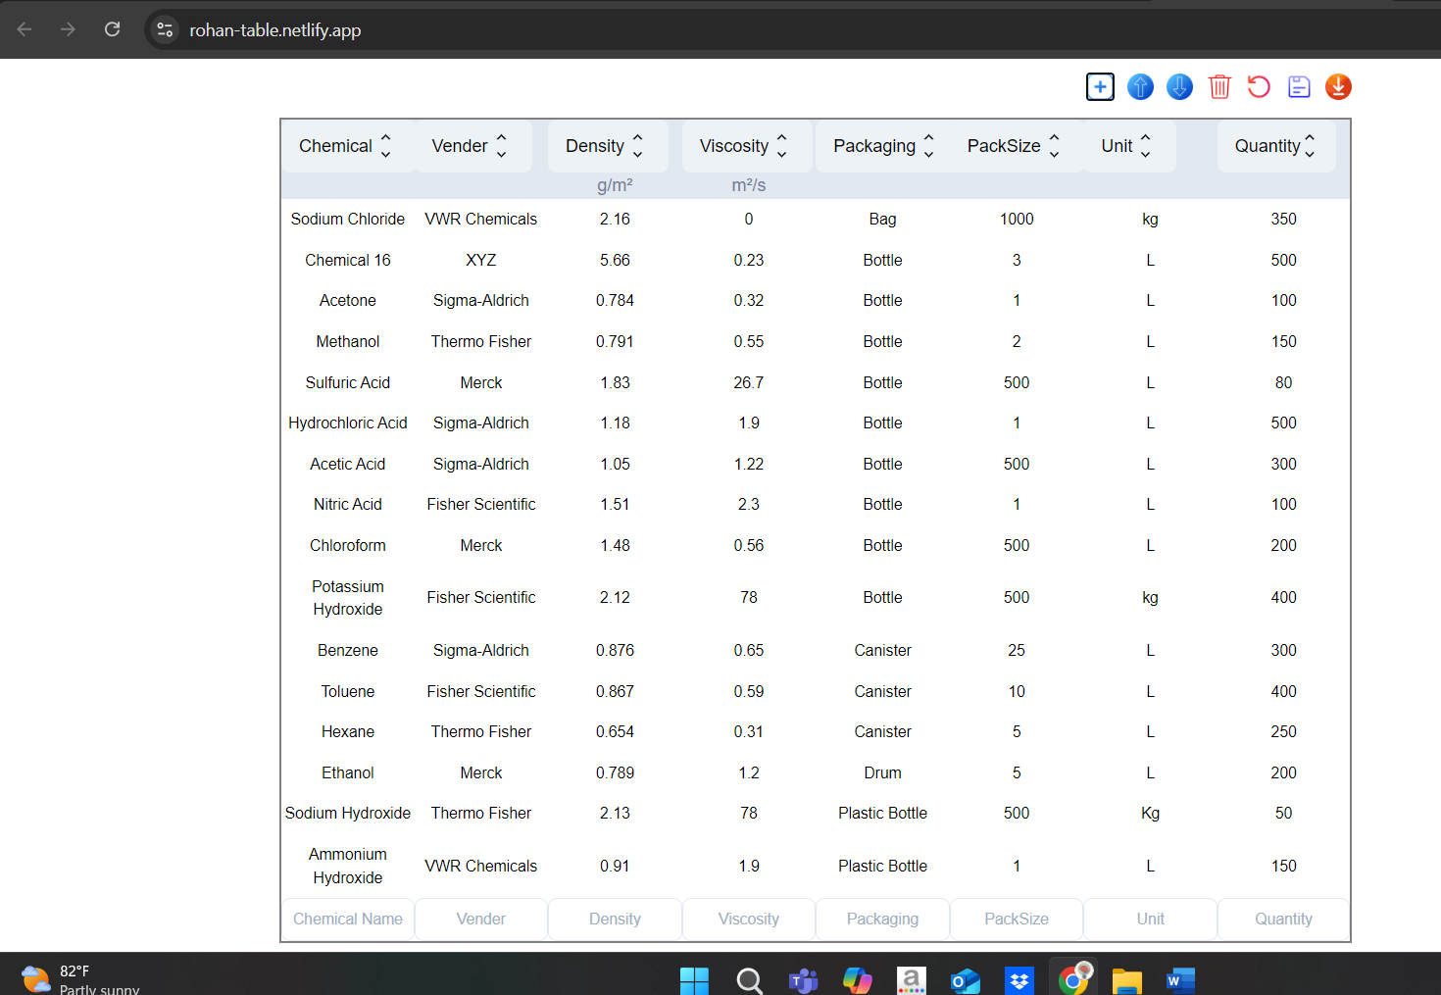

3.Sorting rows one at a time.

User can click on a row and move the row up and down by clicking on  and respectively.

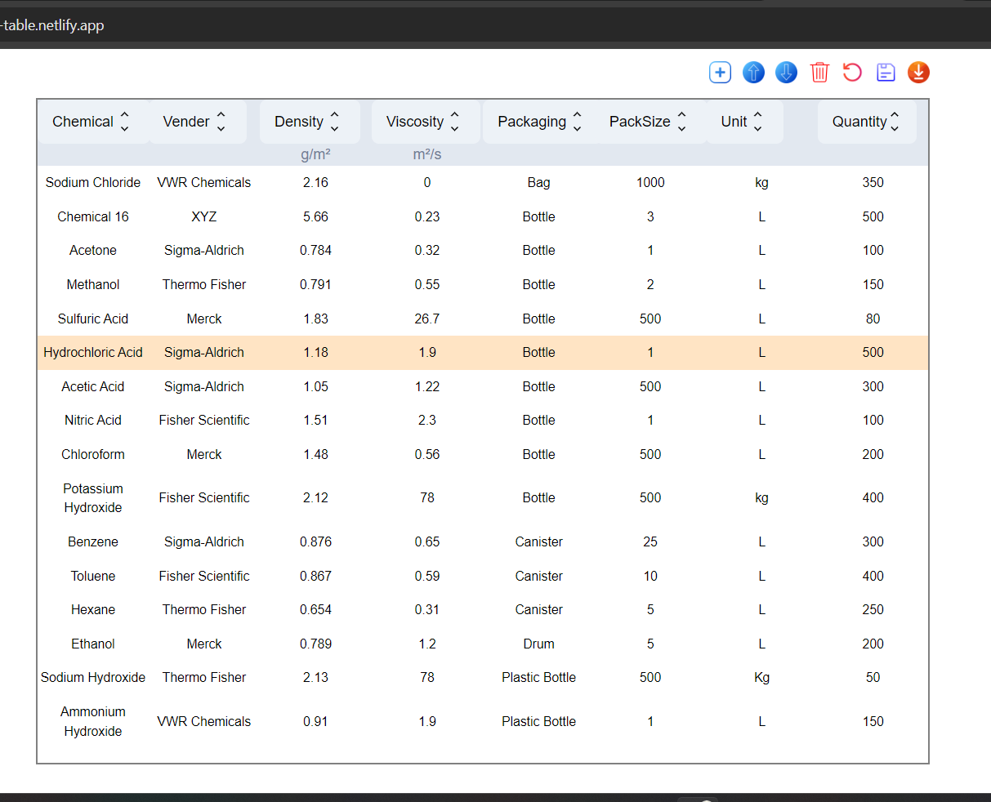

1. Sorting in ascending and descending order.

* The column headers can be clicked to sort the rows lexicographically(String data) and max-min & min-max order(Number data).

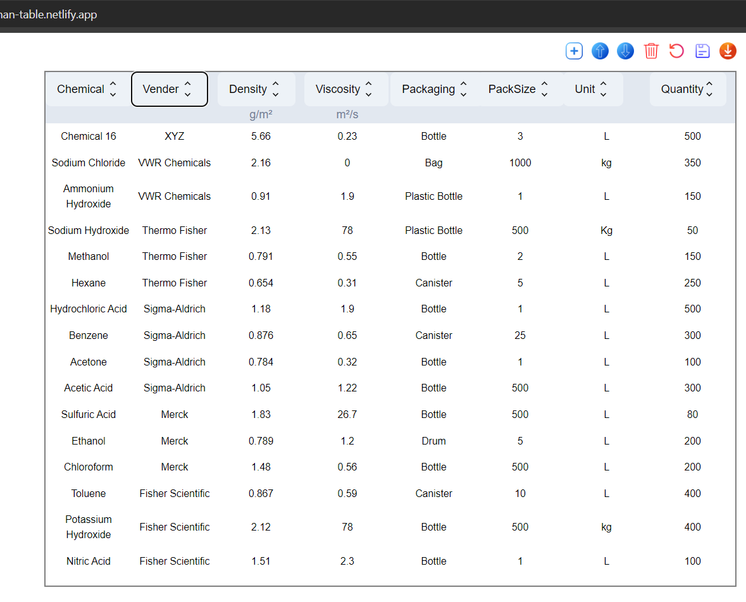

1. Deleting row.

* User can delete a row by selecting a row and clicking on  icon.

1. Downloading table in Excel.

* User can also download an instance of a table by clicking on  icon.

1. **Links.**

* **The project repository is created on Github.**
* **The project is hosted on Netlify.com.**
* **Link to the github repository -** [**https://github.com/rohanSnippet/IIT_Table/tree/main**](https://github.com/rohanSnippet/IIT_Table/tree/main)
* **Link to the project -** [**https://rohan-table.netlify.app/**](https://rohan-table.netlify.app/)