1 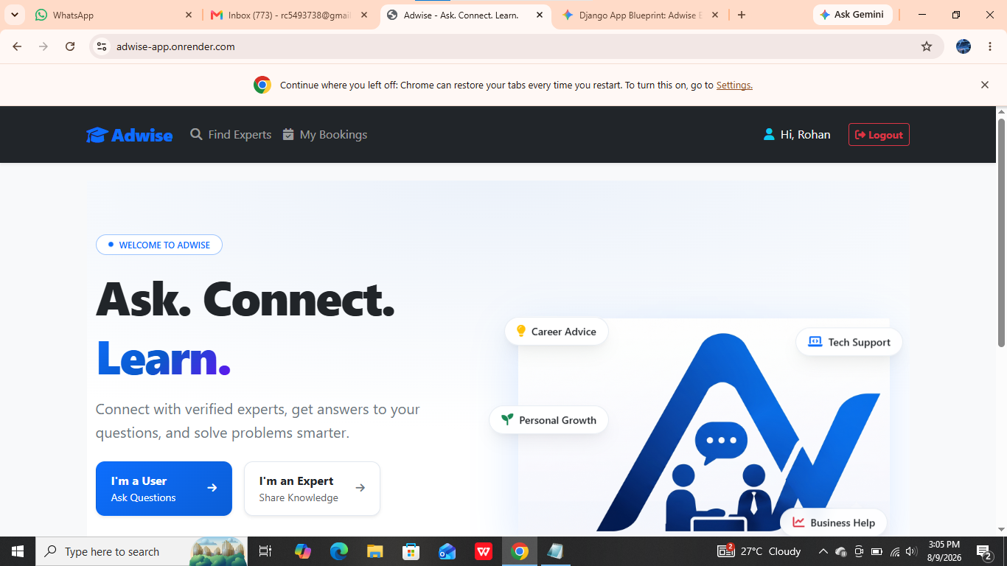
The user name is showing in home page if you are loged in before it should redirect to appropriate dashboard if the user is authenticated before or he not loged out

2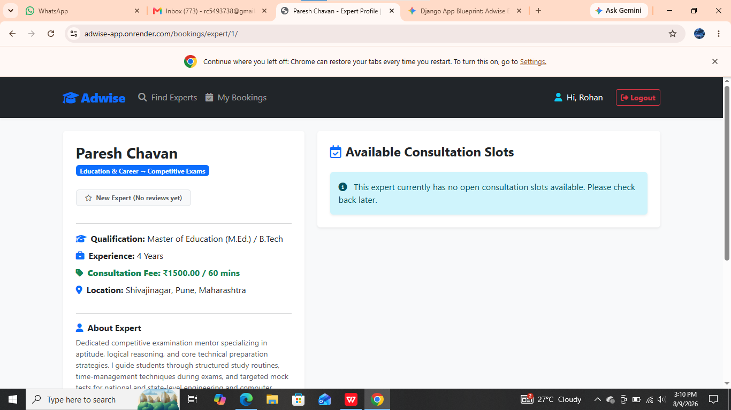
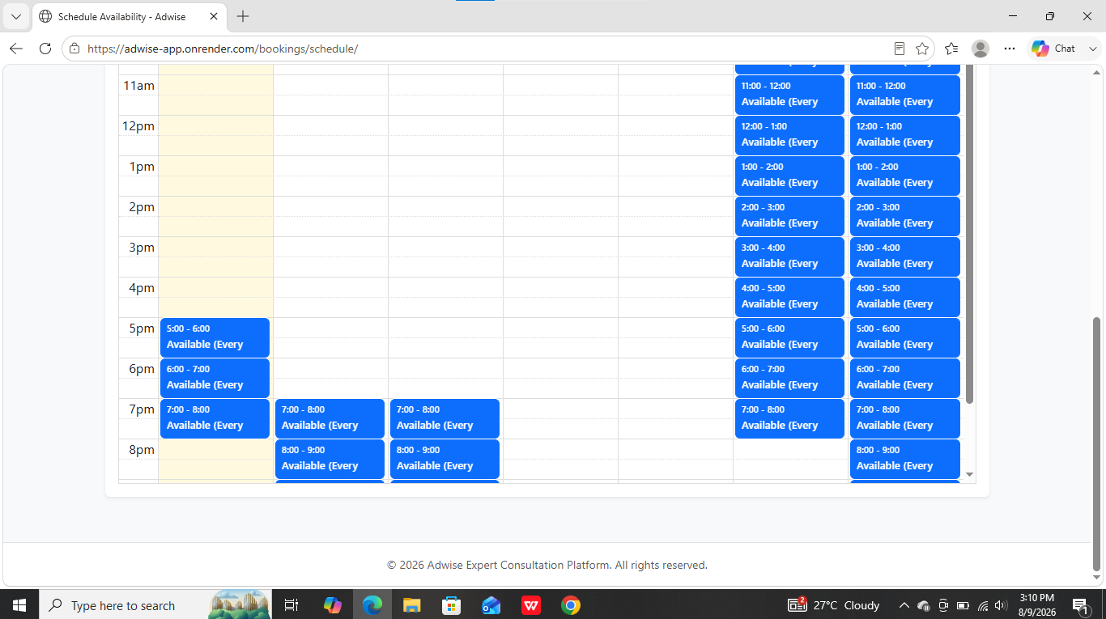
The available expert is not showing

3 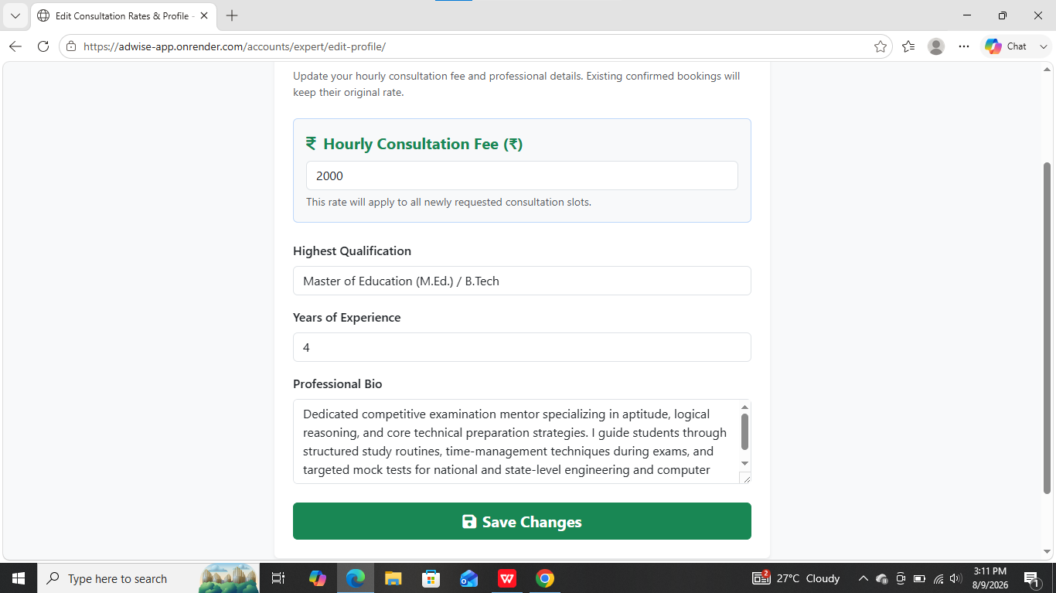
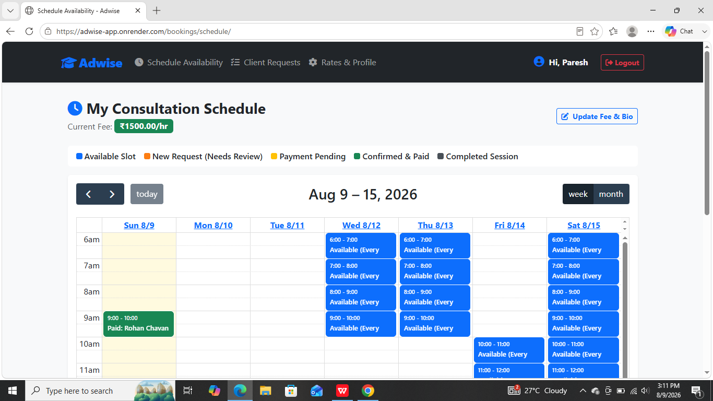the save changes buton is not working

4 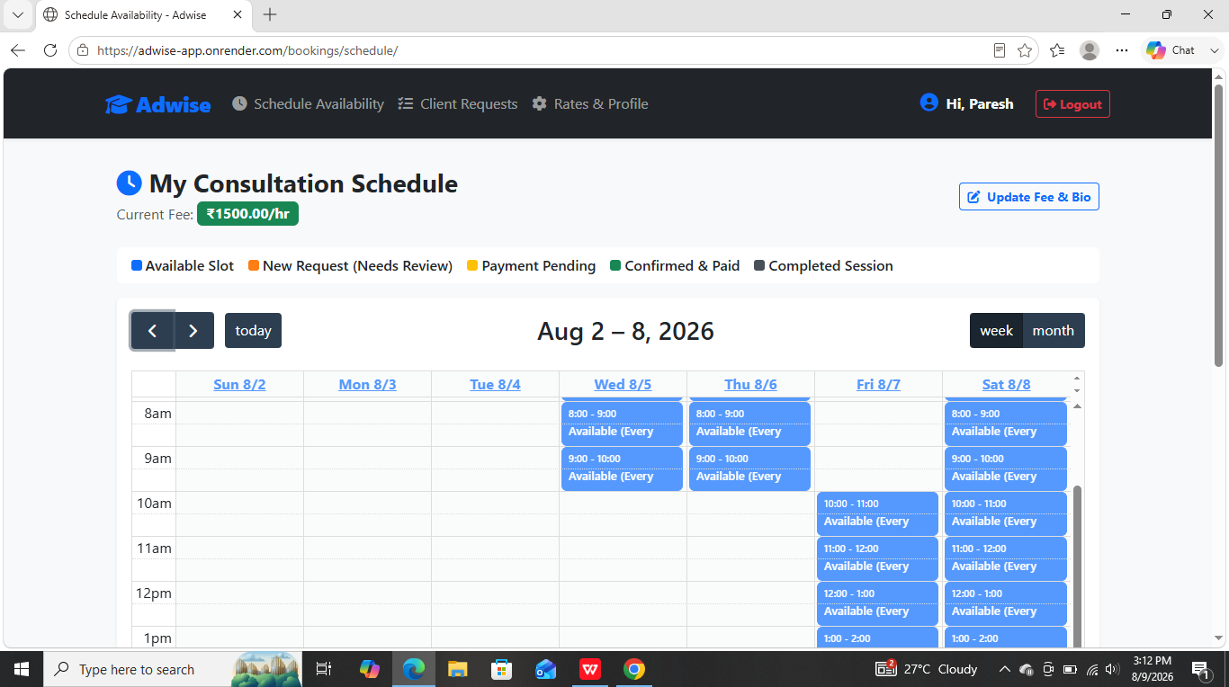still showing the past slots available if the we should color them according to conditions like if that slot was booked and completed then it should be green also if he click on it he should get the info about that slot like who was the user and all

5
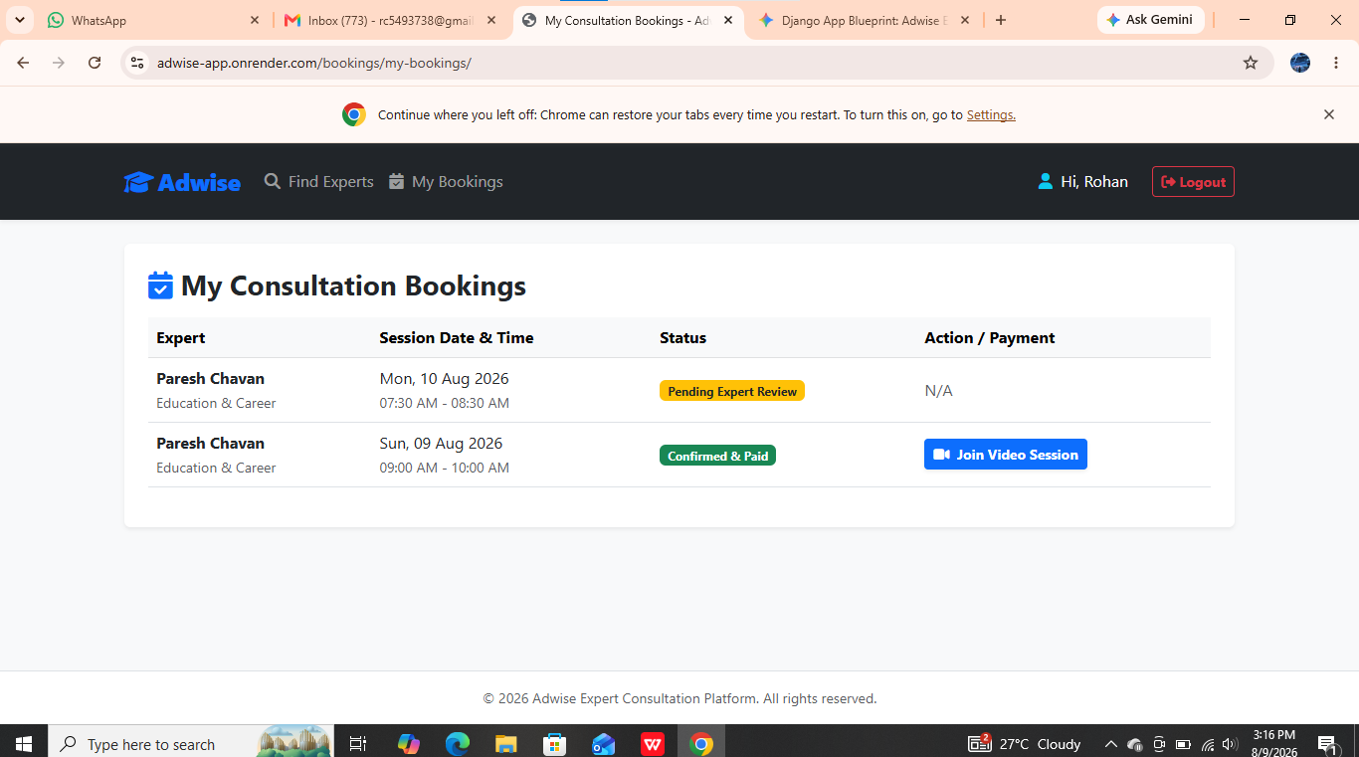
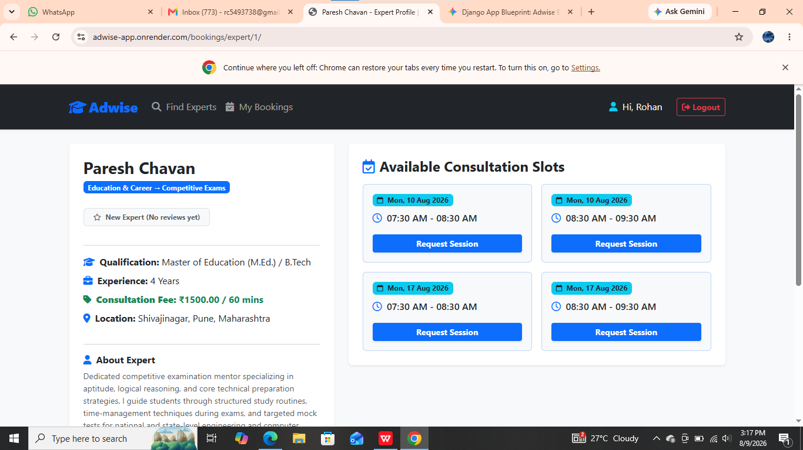 if an client sends a request to pertucular slot the slot should show as locked for the clients for 12hr if the expert not respond to it then the slot should unlocked
6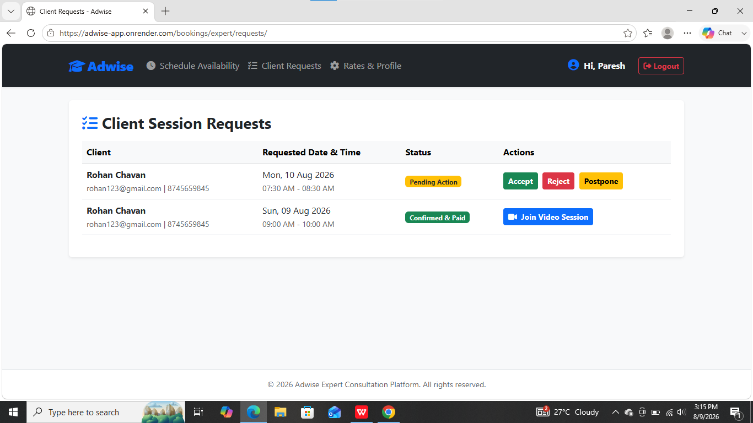
If the expert accept the the request then the slot should locked and the user resive an notification to complete the transaction if the user not paid the fee within 24hr then the slot should unlocked if the expert wants to reject the request then an pop up will appear asking the reason like am not available or like not a suitanle match or other and then for postpone if the slot is already booked that the exprt want to postpone then an pop will desplayed that this slot is book or when he want to postpone he should see the slot is booked on the availability tab

Also during sign in for expert we shoud connect his social account like linkdin , insta whatsapp also when we collect the phone number we shoud also collect a whatsapp phone number and the whatsapp phone number is same as the phone then we should give him a button to select that also ask him that in case of emergency we sould provide your phone number or not

7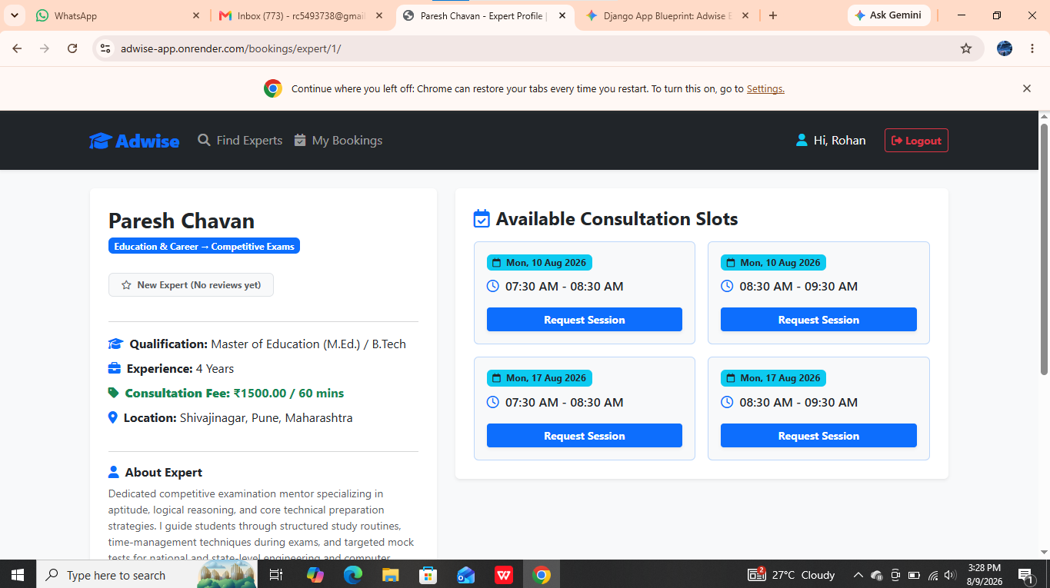 when we click on request session an pop up will shown with provide a title and a description to get clarity about the conversation for the expert

- 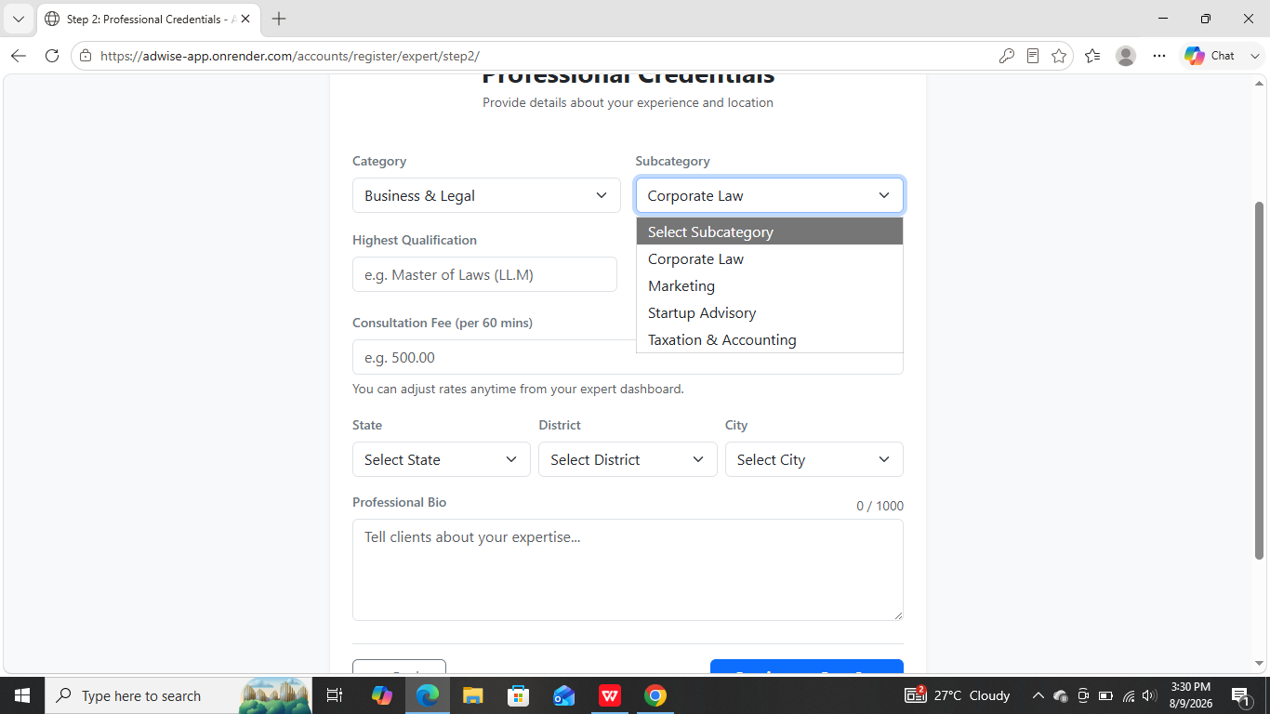 the expert can select multiple subcategoies
- 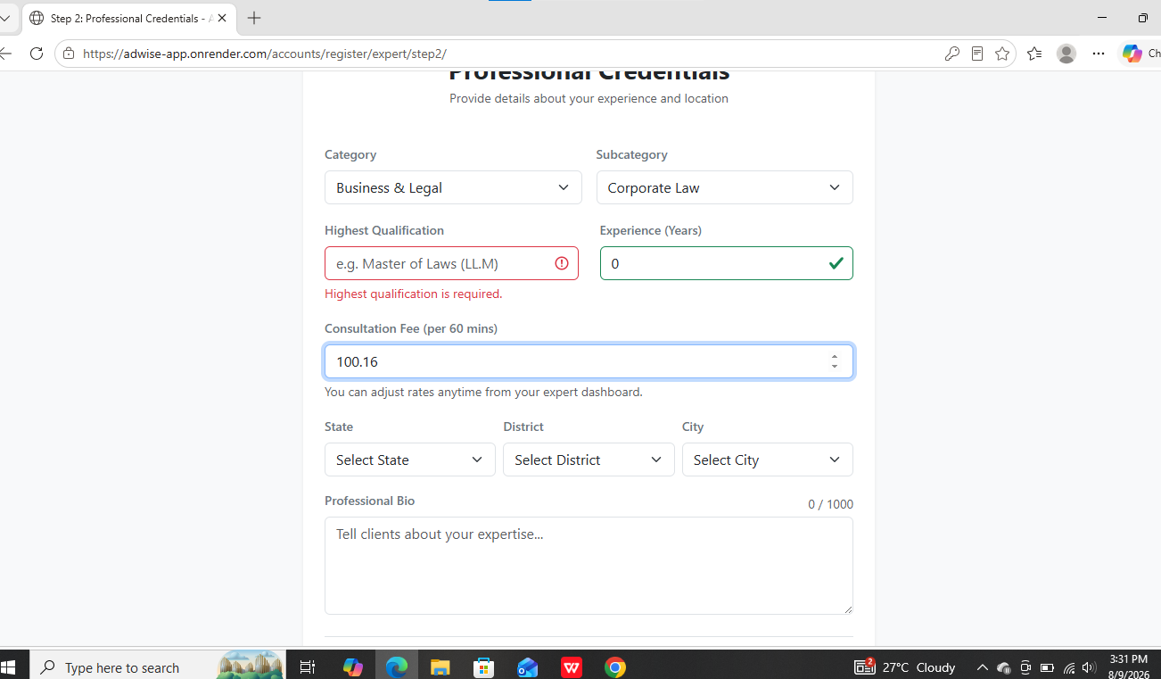the consultation fee should not be in points
- 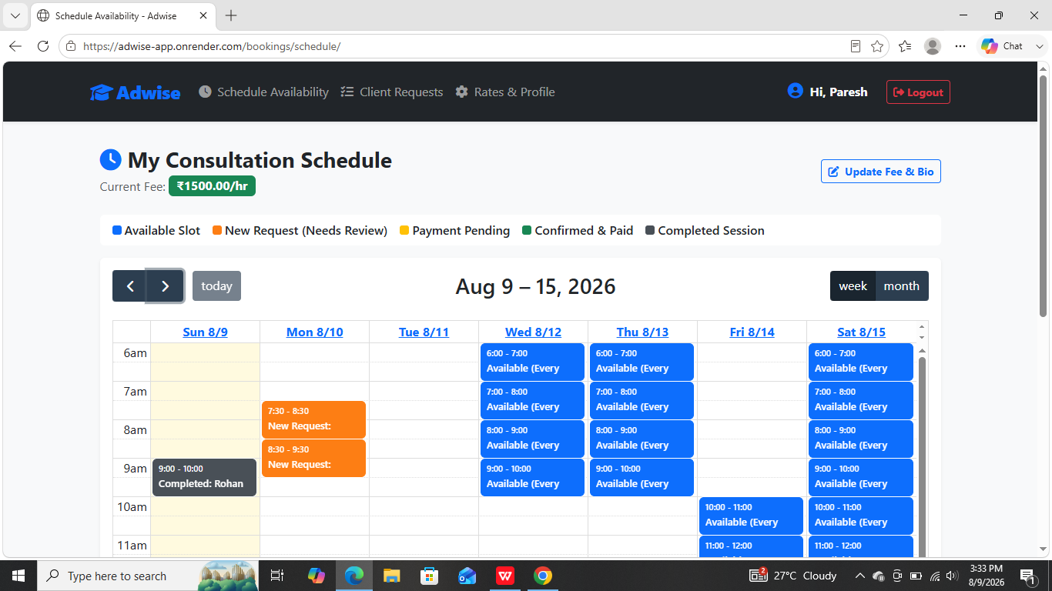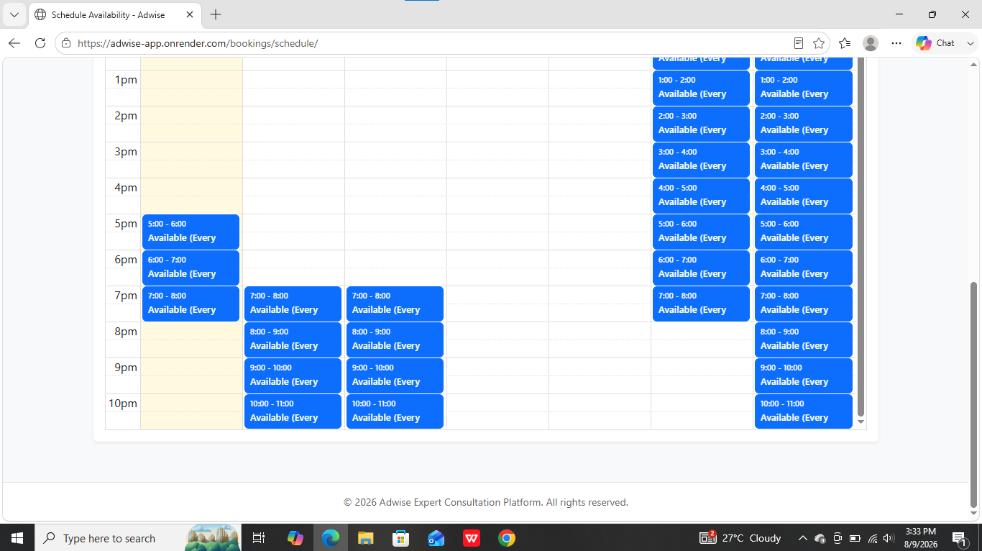this UI is littile bit confusing and the hours also are not showned completely we need to upgrade this also
- 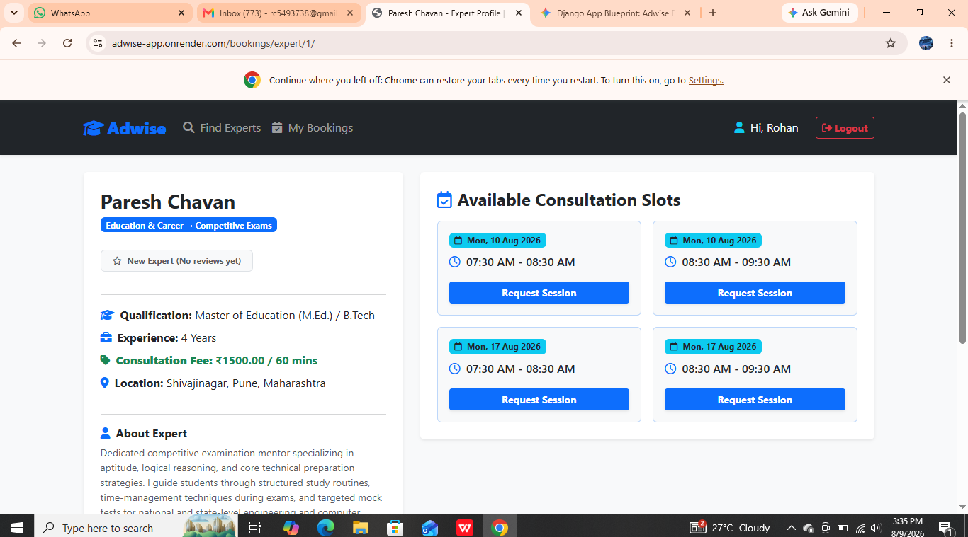when an user wants to book for multiple slotes he should get an option for that

