#include <stdio.h>
#include <stdlib.h>

struct Node {
int data;
struct Node* next;
};

struct Node* head = NULL;

void push(int value) {
struct Node* newNode = (struct Node*)malloc(sizeof(struct Node));
newNode->data = value;
newNode->next = head;
head = newNode;
}

int pop() {
if (head == NULL) return -1;
struct Node* temp = head;
int val = temp->data;
head = head->next;
free(temp);
return val;
}

void enqueue(int value) {
struct Node* newNode = (struct Node*)malloc(sizeof(struct Node));
newNode->data = value;
newNode->next = NULL;

if (head == NULL) {
head = newNode;
return;
}

struct Node* temp = head;
while (temp->next != NULL)
temp = temp->next;
temp->next = newNode;
}

int dequeue() {
if (head == NULL) return -1;
struct Node* temp = head;
int val = temp->data;
head = head->next;
free(temp);
return val;
}

void display() {
struct Node* temp = head;
while (temp != NULL) {
printf("%d -> ", temp->data);
temp = temp->next;
}
printf("NULL\n");
}

int main() {
int choice, value;

while (1) {
printf("\n1. Push (Stack)\n2. Pop (Stack)\n3. Enqueue (Queue)\n4. Dequeue (Queue)\n5. Display\n6. Exit\n");
scanf("%d", &choice);

switch (choice) {
case 1:
printf("Enter value:\n");
scanf("%d", &value);
push(value);
break;

case 2:
value = pop();
if (value == -1) printf("Stack Empty\n");
else printf("Popped: %d\n", value);
break;

case 3:
printf("Enter value:\n");
scanf("%d", &value);
enqueue(value);
break;

case 4:
value = dequeue();
if (value == -1) printf("Queue Empty\n");
else printf("Dequeued: %d\n", value);
break;

case 5:
display();
break;

case 6:
return 0;
}
}
}
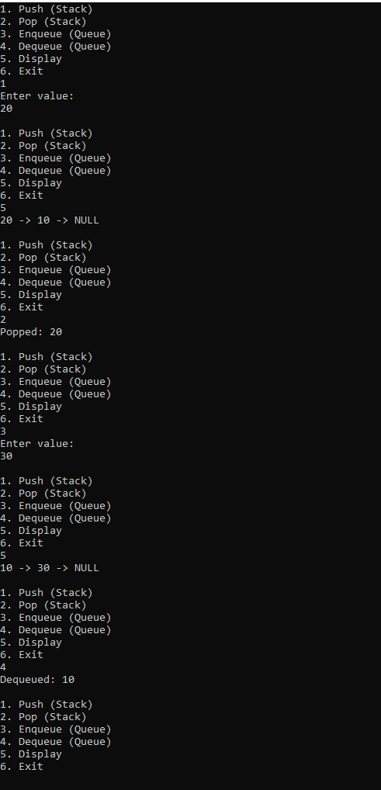v

