Orientation Tuning Heterogeneity and Population Decoding
in Mouse Primary Visual Cortex
BENG 2800 Final Project Report
Rohan Aryagondi
April 2026

1. Introduction and Background
Neurons in the primary visual cortex (V1) respond selectively to the orientation of visual stimuli, a property first described by Hubel and Wiesel (1962). This orientation selectivity is considered a fundamental building block of visual processing, enabling the brain to represent edges, contours, and textures. Understanding how orientation is encoded across populations of neurons remains a central question in systems neuroscience, with implications for sensory prosthetics and brain-computer interfaces.
Recent advances in two-photon calcium imaging now allow simultaneous recording from tens of thousands of neurons. Stringer, Michaelos, and Pachitariu (2021) leveraged this technology to record from approximately 23,000 neurons in mouse V1, demonstrating that neural populations encode orientation with remarkably high precision. Their dataset provides a unique opportunity to investigate the diversity of orientation tuning at the single-neuron level and the efficiency of population-level encoding.
In this project, we address four interrelated questions:
- How much do preferred orientation and tuning sharpness vary across neurons in mouse V1?
- Are neurons with sharper orientation tuning also more reliable across repeated trials?
- How accurately can a simple linear population decoder predict stimulus orientation from neural activity?
- How does decoder performance change as the number of neurons increases?
These questions are significant because they bridge single-neuron physiology (tuning curves) with population-level computation (decoding), using two core analytical methods covered in this course: nonlinear least-squares curve fitting and linear least-squares regression.

2. Methodology

2.1 Dataset
We analyzed publicly available two-photon calcium imaging data from Stringer et al. (2021), consisting of simultaneous recordings from 23,589 neurons in V1 of a single head-fixed mouse during passive viewing of static oriented gratings. A total of 4,598 trials were presented, with stimulus orientations approximately uniformly distributed across 0–180°. Neural responses were provided as deconvolved calcium activity (one scalar per neuron per trial), extracted using Suite2p. Stimulus directions (0–360°) were mapped to orientations (0–180°) since static gratings at 0° and 180° are physically identical.

2.2 Orientation Tuning Curve Estimation
For each neuron, we estimated an empirical orientation tuning curve by binning trials into 36 bins of 5° each (approximately 128 trials per bin) and computing the mean response per bin. Split-half reliability was assessed by computing the Pearson correlation between tuning curves from odd- and even-indexed trials.

2.3 Nonlinear Least-Squares Tuning Model
We fit a von Mises orientation tuning function to each neuron’s binned tuning curve using nonlinear least squares (scipy.optimize.curve_fit):
r(θ) = b + a · exp(κ · cos(2(θ − θ₀)))
where b is baseline activity, a is response amplitude, κ (kappa) is tuning sharpness (higher values indicate narrower tuning, bounded [0, 20]), and θ₀ is preferred orientation. The cos(2(θ − θ₀)) form provides 180° periodicity appropriate for orientation. Initial parameters were derived from the empirical tuning curve. Goodness of fit was assessed using R².

2.4 Reliability Analysis
To test whether tuning sharpness predicts reliability, we fit an ordinary least-squares (OLS) linear model via np.linalg.lstsq:
reliability = β₀ + β₁ · κ + β₂ · mean_response
Standard errors were computed from the residual variance and (XᵀX)⁻¹. We also computed Pearson and Spearman correlations with 95% bootstrap confidence intervals (5,000 resamples).

2.5 Linear Population Decoder
We implemented an OLS linear decoder (np.linalg.lstsq) that regresses the trial-by-neuron response matrix X onto target vectors y_cos = cos(2θ) and y_sin = sin(2θ). Predicted orientation was recovered as θ_pred = arctan2(sin_pred, cos_pred) / 2. We used 5-fold cross-validation with circular mean absolute error (MAE, modulo 180°) as the primary metric.
To assess scaling, we evaluated decoder performance for neuron counts of 10, 25, 50, 100, 250, 500, and 1,000 (the top 1,000 most reliable neurons). For each count, 20 random neuron subsets were drawn and 5-fold CV was run on each. A shuffle control (permuted orientation labels, 10 repeats at 100 neurons) established the chance baseline.

3. Results and Analysis

3.1 Heterogeneity of Orientation Tuning
The von Mises model was successfully fit to all 23,589 neurons (100% convergence rate), with a median R² of 0.750 (IQR: [0.530, 0.893]). A total of 18,299 neurons (77.6%) achieved R² > 0.5, and 5,543 (23.5%) exceeded R² > 0.9.
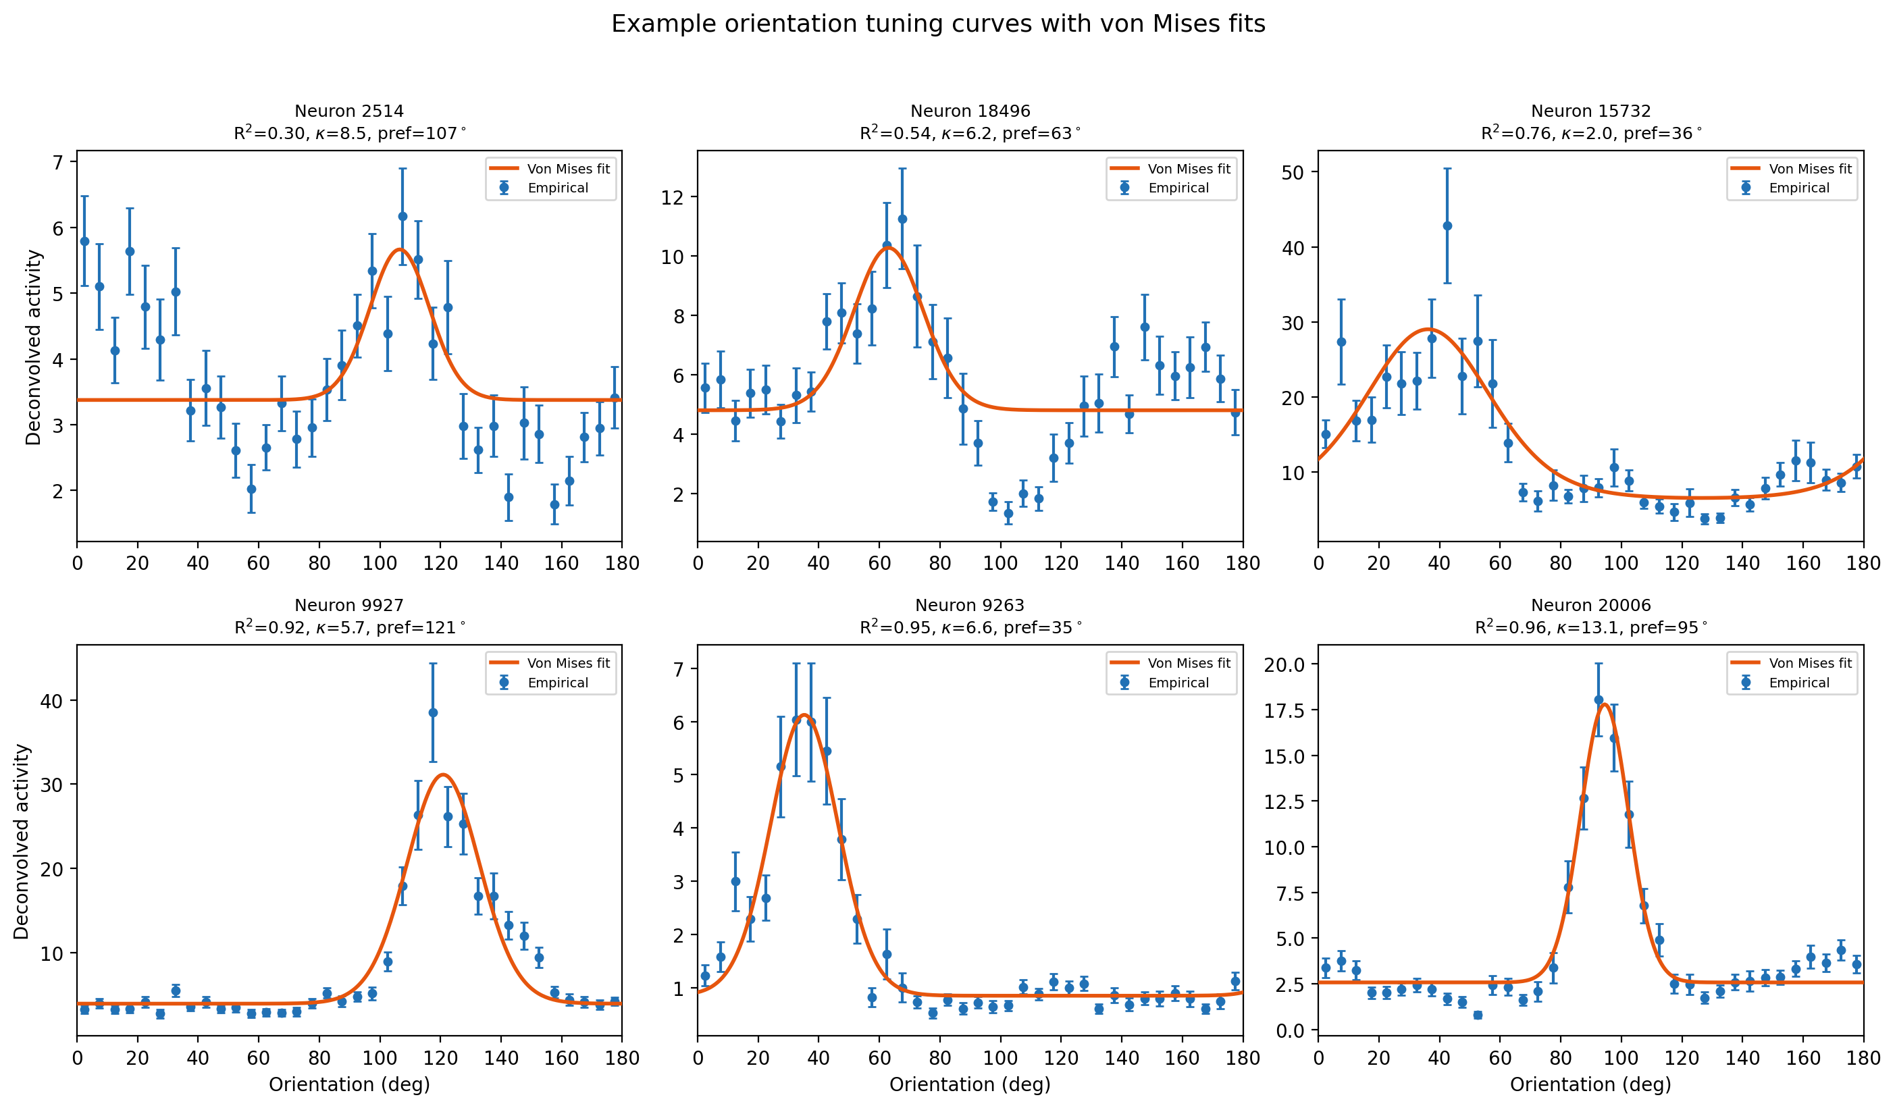
Figure 1. Example orientation tuning curves with von Mises fits for six neurons spanning the range of fit quality. Blue circles: empirical bin means (± SEM). Orange curves: fitted von Mises model.
Preferred orientations were distributed approximately uniformly across 0–180° (Figure 2, left), indicating no population-level orientation bias. Tuning sharpness (κ) varied substantially, with a median of 3.83 (IQR: [1.31, 8.23]) (Figure 2, right). Approximately 22% of neurons were broadly tuned (κ < 1), while 20% were very sharply tuned (κ ≥ 10), demonstrating the heterogeneous nature of orientation selectivity in mouse V1.
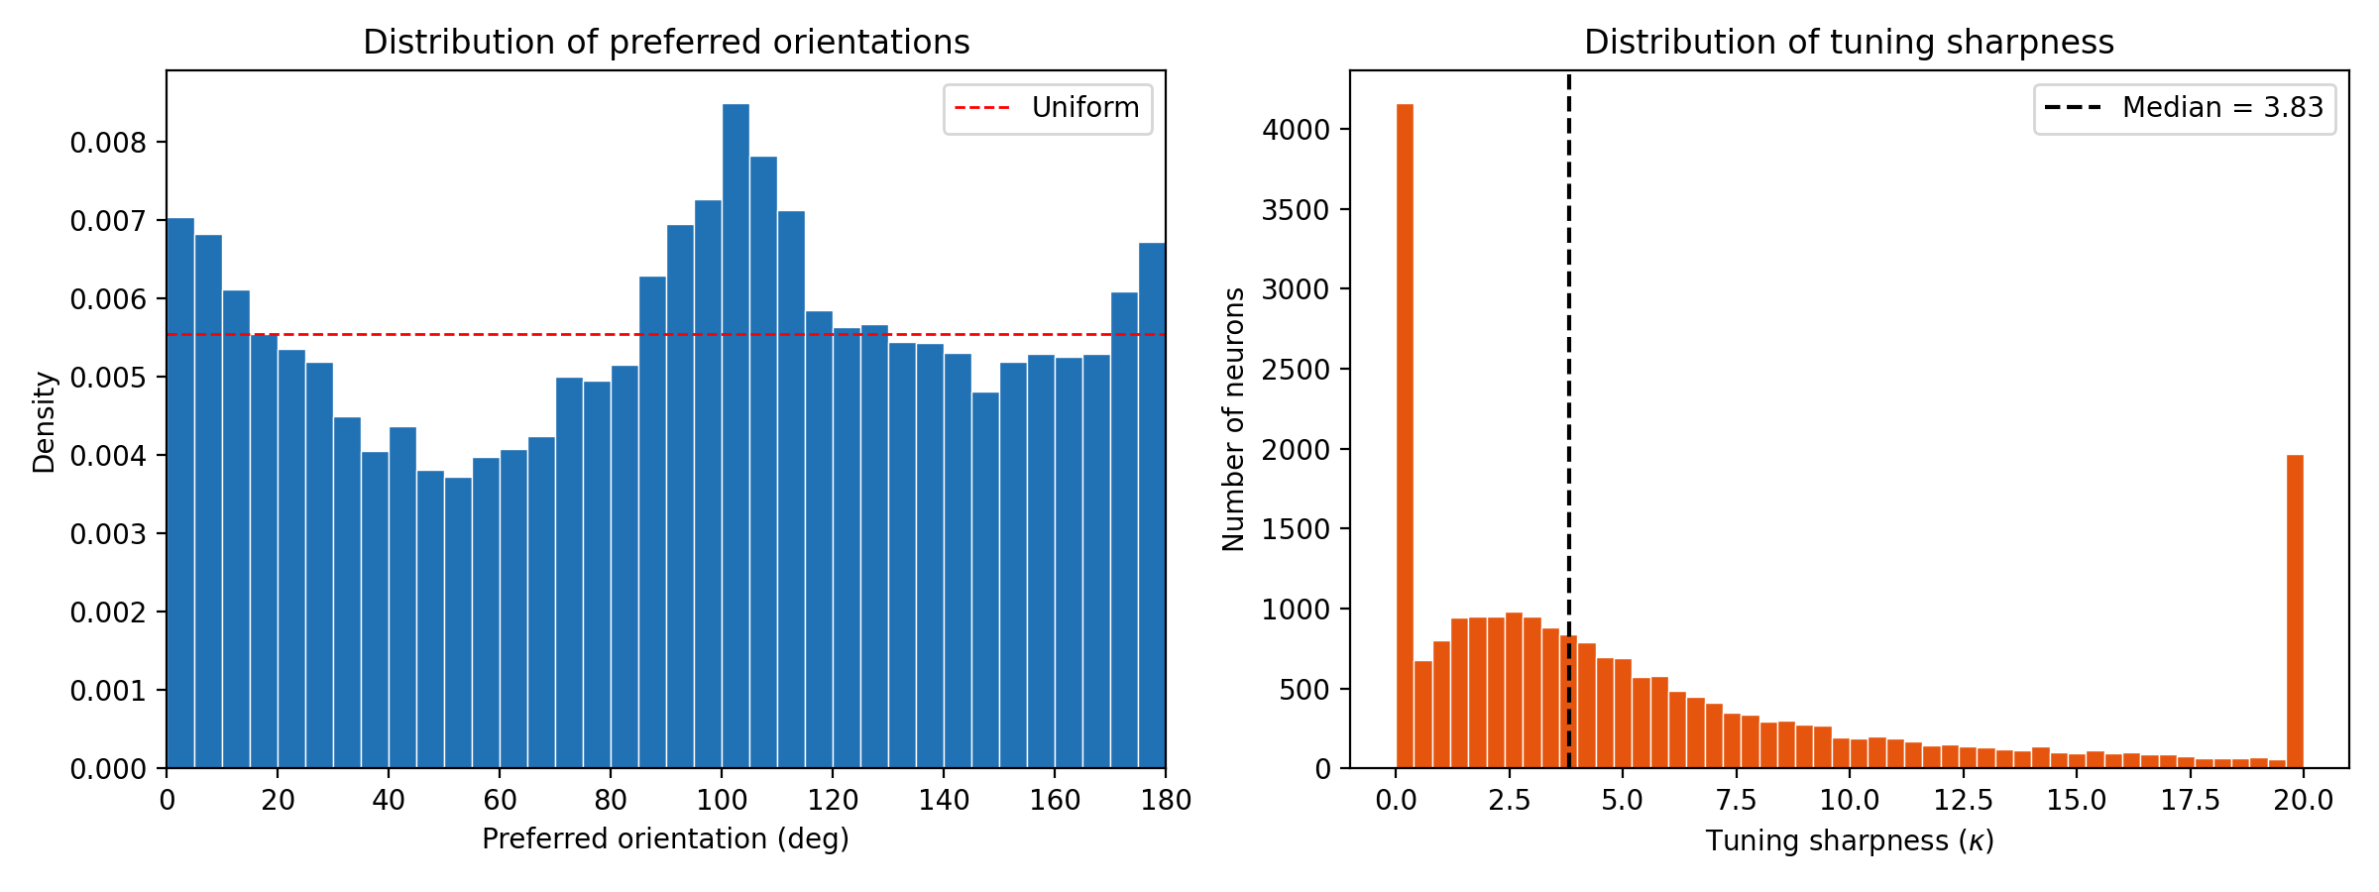
Figure 2. Distributions of fitted tuning parameters. Left: preferred orientations are approximately uniform (red dashed line). Right: tuning sharpness (κ) is right-skewed with wide range (median = 3.83).

3.2 Tuning Sharpness and Trial-to-Trial Reliability
We found a significant positive association between tuning sharpness and reliability. The Spearman rank correlation was 0.239 (95% CI: [0.227, 0.252]; p < 10⁻³⁰⁰), and the Pearson correlation was 0.109 (Figure 3).
Table 1. OLS regression results: reliability ~ κ + mean_response
Parameter | Coefficient | Std Error | t-statistic | p-value
Intercept | 0.670 | 0.0022 | 307.6 | < 10⁻³⁰⁰
κ (kappa) | 0.0040 | 0.0002 | 18.2 | < 10⁻⁷⁰
Mean response | 0.0040 | 0.0001 | 32.6 | < 10⁻²⁰⁰

The OLS model (R² = 0.055) confirmed that κ has a significant independent effect on reliability after controlling for mean response (Table 1). Both κ (t = 18.2) and mean response (t = 32.6) were significant predictors. The binned analysis (Figure 3, right) shows a monotonic increase in mean reliability with κ, particularly for κ > 5. However, the modest R² indicates that other factors dominate reliability variance.
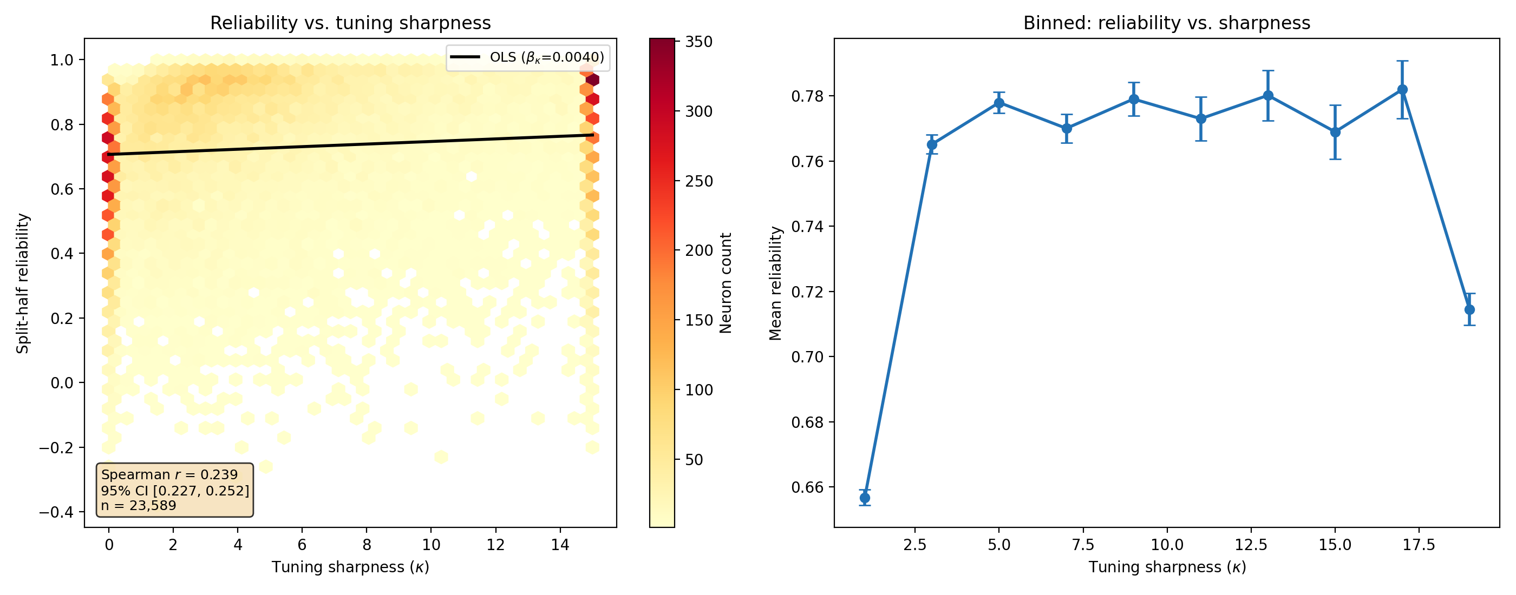
Figure 3. Relationship between tuning sharpness and reliability. Left: hexbin density scatter with OLS regression line. Right: binned mean reliability (± SEM) shows monotonic positive trend. Spearman r = 0.239, 95% CI [0.227, 0.252].

3.3 Population Decoder Performance
The OLS linear decoder achieved a mean circular MAE of 2.80° with 1,000 neurons (median AE = 2.28°), far below the chance level of ~45° (Figure 4). The shuffle control confirmed this: permuted labels yielded MAE of 45.1 ± 0.3°, matching the theoretical random baseline.
Table 2. Decoder performance by neuron count (5-fold CV, 20 random subsets).
Neurons | MAE (deg) | Median AE (deg) | Repeats
10 | 19.96 ± 4.30 | 12.05 | 20
25 | 10.27 ± 1.53 | 6.62 | 20
50 | 6.33 ± 0.66 | 4.67 | 20
100 | 4.48 ± 0.24 | 3.51 | 20
250 | 3.44 ± 0.10 | 2.80 | 20
500 | 2.98 ± 0.09 | 2.43 | 20
1000 | 2.80 (single) | 2.28 | 1

Performance improved monotonically with neuron count (Figure 4). The largest gains occurred between 10 and 100 neurons (MAE decreased from 20.0° to 4.5°). Beyond 250 neurons, improvements became more gradual, suggesting partial saturation of orientation information. Even at 1,000 neurons, performance had not fully plateaued, indicating that additional neurons could further improve decoding.
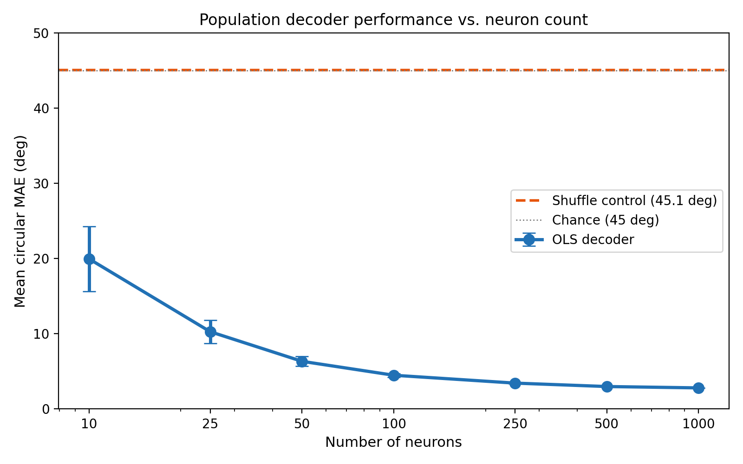
Figure 4. Decoder error vs. neuron count (log scale). Error bars: ± 1 SD across random neuron subsets. Orange dashed: shuffle control. Gray dotted: chance level (45°).
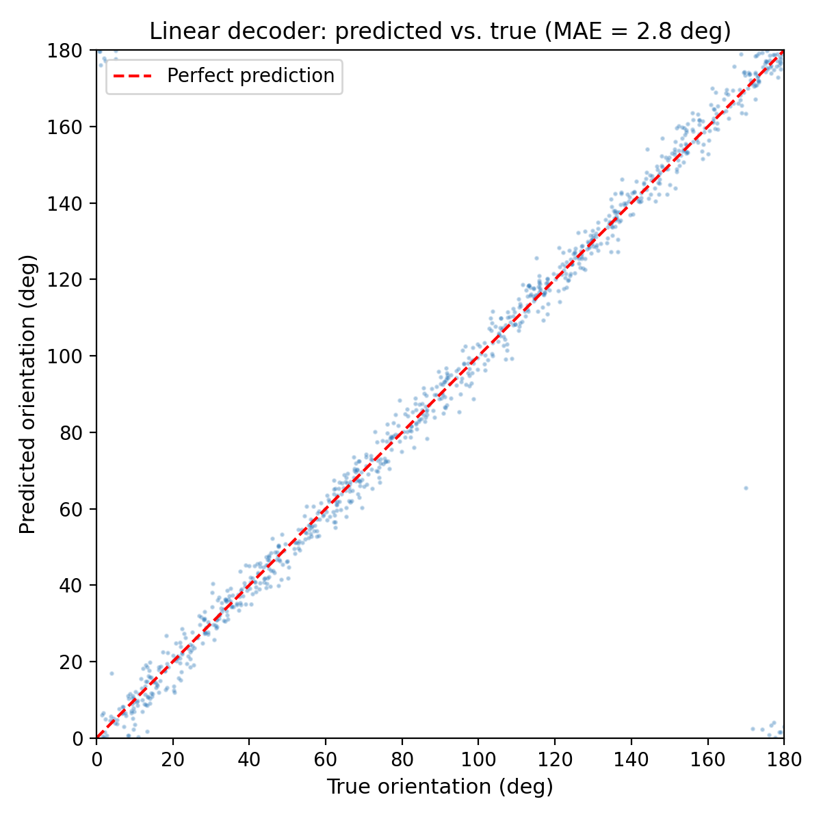
Figure 5. Predicted vs. true stimulus orientation for the 1,000-neuron OLS decoder (80/20 train/test split). Tight clustering around the identity line reflects high accuracy (MAE = 2.8°).

4. Discussion and Conclusion

4.1 Summary of Findings
This analysis of 23,589 simultaneously recorded mouse V1 neurons revealed three main findings. First, orientation tuning properties are highly heterogeneous: preferred orientations tile the full 0–180° range uniformly, while tuning sharpness spans over an order of magnitude. This diversity is consistent with theoretical models of efficient population coding, where a mixture of broadly and narrowly tuned neurons supports both coarse and fine orientation discrimination (Ganguli and Simoncelli, 2014).
Second, sharper tuning is moderately associated with higher trial-to-trial reliability (Spearman r = 0.239), even after controlling for overall response magnitude. This suggests that more selective neurons produce more consistent signals, though the modest effect size (R² ≈ 0.055) indicates that noise sources beyond tuning sharpness—such as shared variability, behavioral state, and intrinsic noise—dominate reliability.
Third, a simple OLS linear decoder achieves remarkably accurate orientation prediction (2.8° MAE with 1,000 neurons, compared to 45° chance), consistent with Stringer et al.’s (2021) finding of “high-precision coding” in visual cortex. The monotonic improvement with neuron count, with diminishing returns above ~250 neurons, suggests that orientation information is distributed across many neurons but with significant redundancy.

4.2 Limitations
- Single recording: All results are from one mouse; replication across animals would strengthen generalizability.
- Neuron selection: The decoder used the top 1,000 most reliable neurons, a biased subset. Performance with randomly selected neurons from the full population may differ.
- Model simplicity: The von Mises model assumes a single peak; neurons with complex tuning (multi-peaked, inhibitory) are not well captured. Similarly, the OLS decoder is linear—nonlinear decoders might extract additional information.
- Reliability metric: Split-half reliability depends on the specific trial-splitting method and is influenced by signal-to-noise ratio, partially confounding the sharpness–reliability relationship.
- Calcium imaging: Deconvolved calcium activity is an indirect measure of spiking, which may introduce biases in estimated tuning properties.

4.3 Conclusion
This project demonstrates that mouse V1 contains a diverse population of orientation-tuned neurons whose collective activity supports high-precision orientation decoding. The combination of nonlinear least-squares fitting for single-neuron characterization and linear least-squares regression for population decoding provides complementary views of neural coding: the former reveals the building blocks (individual tuning curves), while the latter shows how these building blocks combine to represent sensory information. Future work could extend this analysis to multiple recordings, explore nonlinear decoders, and investigate how tuning heterogeneity relates to the spatial organization of V1.

5. Individual Reflection
[To be completed individually by each team member. Include reflection on: technical skills gained (Python, statistical modeling, data analysis), understanding of neural coding concepts, challenges encountered and how they were resolved, and areas for further learning.]

References
Ganguli, D., & Simoncelli, E.P. (2014). Efficient sensory encoding and Bayesian inference with heterogeneous neural populations. Neural Computation, 26(10), 2103–2134.
Hubel, D.H., & Wiesel, T.N. (1962). Receptive fields, binocular interaction and functional architecture in the cat’s visual cortex. The Journal of Physiology, 160(1), 106–154.
Stringer, C., Michaelos, M., & Pachitariu, M. (2021). High-precision coding in visual cortex. Cell, 184(10), 2767–2778. DOI: 10.1016/j.cell.2021.03.042.

