Orientation Tuning Heterogeneity and Population Decoding
in Mouse Primary Visual Cortex
BENG 2800 Final Project Report
Rohan Aryagondi
April 2026

1. Introduction and Background
Neurons in the primary visual cortex (V1) respond selectively to the orientation of visual stimuli, a property first described by Hubel and Wiesel (1962). This orientation selectivity is a fundamental building block of visual processing. Understanding how orientation is encoded across large neural populations remains a central question in systems neuroscience, with implications for sensory prosthetics and brain-computer interfaces.
Two-photon calcium imaging now enables simultaneous recording from tens of thousands of neurons. Stringer, Michaelos, and Pachitariu (2021) recorded from ~23,000 neurons in mouse V1, demonstrating high-precision population coding of orientation. Their publicly available dataset provides a unique opportunity to investigate both the diversity of single-neuron tuning and the efficiency of population-level encoding.
In this project, we address four questions:
- How much do preferred orientation and tuning sharpness vary across neurons in this V1 recording?
- Are neurons with sharper orientation tuning also more reliable across repeated trials?
- How accurately can a simple linear population decoder predict stimulus orientation?
- How does decoder performance change as the number of neurons increases?
These questions bridge single-neuron physiology with population computation using two methods from this course: nonlinear least-squares curve fitting and linear least-squares regression.

2. Methodology

2.1 Dataset
We analyzed two-photon calcium imaging data from Stringer et al. (2021), consisting of 23,589 simultaneously recorded neurons in V1 of a single head-fixed mouse during passive viewing of 4,598 static oriented gratings (0–180°, approximately uniformly distributed). Neural responses were provided as deconvolved calcium activity (one scalar per neuron per trial) extracted using Suite2p. Stimulus directions (0–360°) were mapped to orientations (0–180°) since static gratings at 0° and 180° are physically identical.

2.2 Nonlinear Least-Squares Tuning Model
Empirical tuning curves were computed by binning trials into 36 bins of 5° each (~128 trials/bin) and computing the mean response per bin. We fit a von Mises orientation tuning function using nonlinear least squares (scipy.optimize.curve_fit):
r(θ) = b + a · exp(κ · cos(2(θ − θ₀)))
where b is baseline activity, a is amplitude, κ (kappa) is tuning sharpness (bounded [0, 20]), and θ₀ is preferred orientation. Goodness of fit was assessed using R² computed on binned means. We note that R² on trial-averaged tuning curves will be higher than single-trial predictive accuracy due to the noise reduction from averaging ~128 trials per bin.

2.3 Reliability Analysis
Split-half reliability was defined as the Pearson correlation between tuning curves from odd- and even-indexed trials. We assessed the κ–reliability relationship using: (1) an OLS linear model (reliability = β₀ + β₁·κ + β₂·mean_response) solved via np.linalg.lstsq, with standard errors from the residual variance and (XᵀX)⁻¹; and (2) Pearson/Spearman correlations with 95% bootstrap CIs (5,000 resamples). Because both κ and reliability derive from the same tuning curves, we also ran a simulation to quantify the mathematically expected correlation between them.

2.4 Linear Population Decoder
An OLS linear decoder (np.linalg.lstsq) regressed the trial-by-neuron response matrix onto targets y_cos = cos(2θ) and y_sin = sin(2θ). Orientation was recovered as θ_pred = arctan2(sin_pred, cos_pred)/2. We used 5-fold cross-validation with circular MAE (modulo 180°) as the primary metric.
Neuron-count scaling was evaluated at 10, 25, 50, 100, 250, 500, 1,000, 2,000, and 5,000 neurons (10 random subsets each, drawn from all 23,589 neurons). We also evaluated the top 1,000 most reliable neurons as an upper bound. A shuffle control (permuted labels, 10 repeats at 100 neurons) established the chance baseline. Because OLS is unregularized, we anticipated potential overfitting when the number of neurons exceeds the number of training samples (~3,678 in each CV fold).

3. Results and Analysis

3.1 Heterogeneity of Orientation Tuning
The von Mises fitting algorithm converged for all 23,589 neurons. However, 2,218 (9.4%) produced R² < 0.3 with κ near zero, indicating these neurons are not meaningfully orientation-selective and are better characterized as “untuned” rather than “broadly tuned.” Among the remaining 21,371 neurons with R² ≥ 0.3, the median R² was 0.750 (IQR: [0.530, 0.893]).
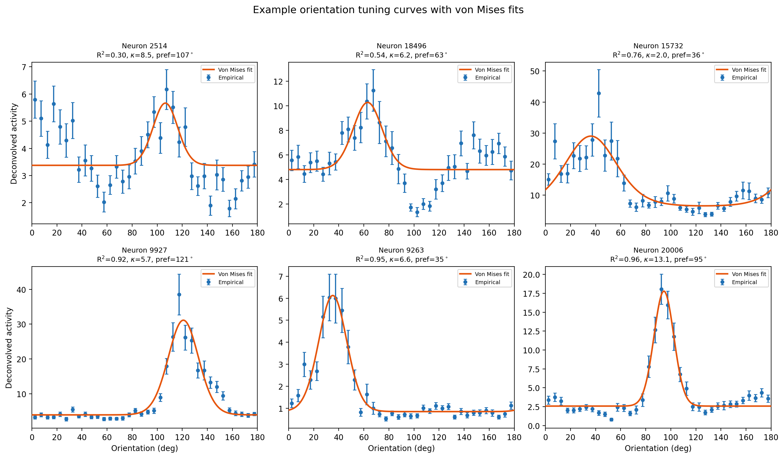
Figure 1. Example orientation tuning curves with von Mises fits, spanning the range of fit quality. Blue: empirical bin means (± SEM). Orange: fitted von Mises model.
Preferred orientations were approximately uniformly distributed across 0–180° (Figure 2, left), consistent with the known lack of columnar orientation maps in mouse V1. Tuning sharpness (κ) varied substantially, with a median of 3.83 (IQR: [1.31, 8.23]; Figure 2, right). The observed heterogeneity is consistent with the premise that diverse tuning profiles may support population coding (Ganguli and Simoncelli, 2014), though testing whether this distribution is optimal would require comparison to theoretical predictions.
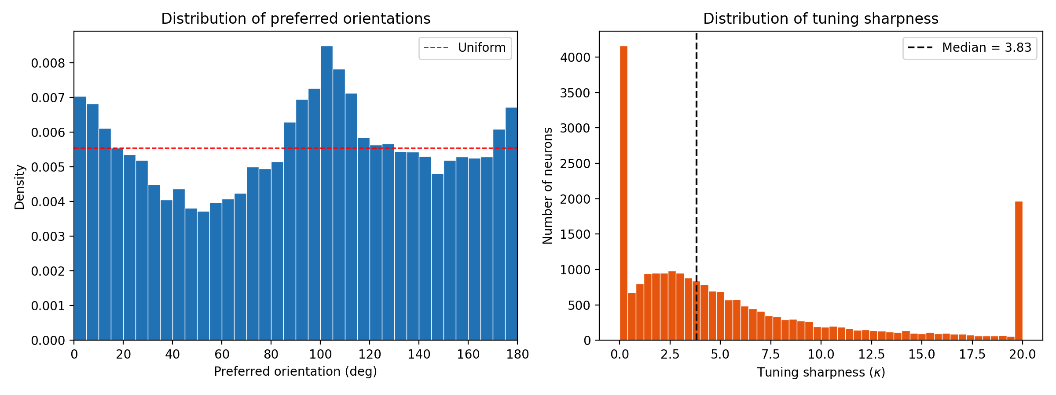
Figure 2. Left: preferred orientations are approximately uniform (red dashed line). Right: tuning sharpness is right-skewed (median κ = 3.83).

3.2 Tuning Sharpness and Trial-to-Trial Reliability
κ and split-half reliability were positively correlated (Spearman r = 0.239, 95% CI: [0.227, 0.252]). However, because both metrics derive from the same tuning curves, some positive correlation is mathematically expected regardless of biology: neurons with higher κ have more structured tuning curves, which are inherently more correlated across trial halves. A simulation in which noise was entirely independent of κ produced Spearman r = 0.906 (Figure 3, left), indicating that the real data’s weaker correlation (0.239 vs. 0.91) reflects biological noise sources that partially decouple tuning strength from measurement reliability.
Table 1. OLS regression: reliability ~ κ + mean_response (n = 23,589)
Parameter | Coefficient | SE | t | p-value
Intercept | 0.670 | 0.0022 | 307.6 | < 10⁻³⁰⁰
κ | 0.0040 | 0.0002 | 18.2 | < 10⁻⁷⁰
Mean response | 0.0040 | 0.0001 | 32.6 | < 10⁻²⁰⁰

The OLS model (R² = 0.055) confirmed the positive association (Table 1). The modest R² is consistent with the simulation analysis: the observed correlation is weaker than the mathematically expected coupling, and κ and mean response together explain only 5.5% of reliability variance. Note that because reliability is bounded [−1, 1], the OLS homoscedasticity assumption is violated; standard errors should be interpreted with caution.
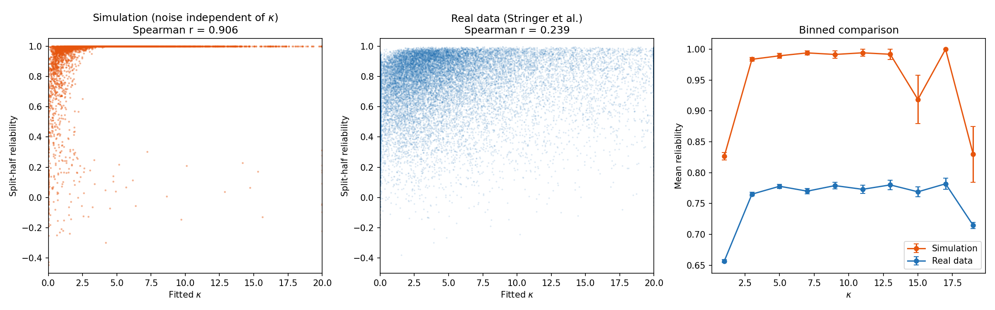
Figure 3. Left: simulation with noise independent of κ yields r = 0.906. Center: real data yields r = 0.239, substantially lower. Right: binned comparison shows the real data’s κ–reliability coupling is attenuated relative to the mathematical expectation.

3.3 Population Decoder Performance
With 1,000 randomly selected neurons, the OLS decoder achieved MAE = 4.94°, far below the chance level of ~45°. Pre-selecting the 1,000 most reliable neurons (top 4.2% by split-half reliability) reduced MAE to 2.80°—a 76% improvement that quantifies how neuron quality affects decoding accuracy (Table 2, Figure 4).
Table 2. Decoder MAE by neuron count: random population vs. top-1000 pool.
Neurons | Random MAE (deg) | Top-1000 MAE (deg)
10 | 31.00 ± 3.59 | 19.96 ± 4.30
25 | 21.60 ± 1.61 | 10.27 ± 1.53
50 | 16.42 ± 2.11 | 6.33 ± 0.66
100 | 10.60 ± 0.99 | 4.48 ± 0.24
250 | 6.45 ± 0.44 | 3.44 ± 0.10
500 | 5.40 ± 0.32 | 2.98 ± 0.09
1000 | 4.94 ± 0.15 | 2.80
2000 | 5.53 ± 0.16 | —
5000 | 7.71 ± 0.14 | —

Performance improved with neuron count up to ~1,000 random neurons (Figure 4). However, at 2,000 and 5,000 neurons, MAE increased to 5.53° and 7.71° respectively. This degradation occurs because OLS is unregularized: when the number of neurons exceeds the number of training samples per fold (~3,678), the system becomes underdetermined and overfits. Regularized methods (e.g., ridge regression) would likely maintain or improve performance at higher neuron counts.
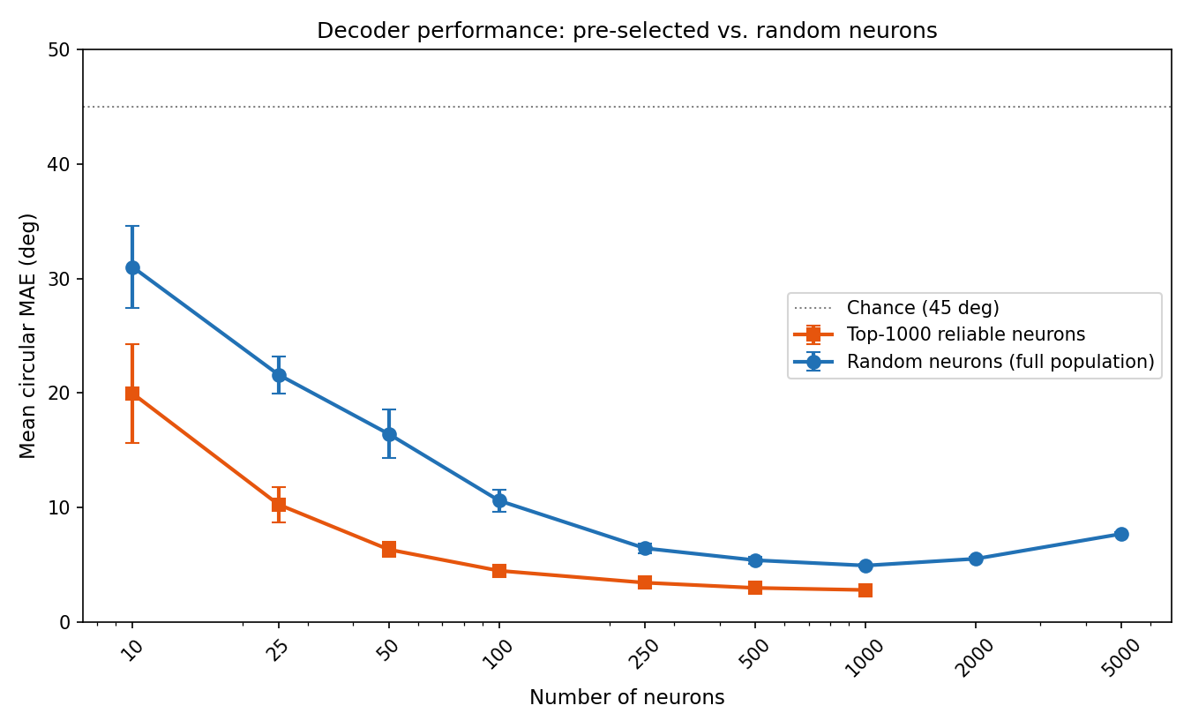
Figure 4. Decoder MAE vs. neuron count. Blue: random neurons from full population. Orange: top-1000 most reliable neurons. Note the upturn at >1,000 random neurons due to OLS overfitting when features exceed training samples.
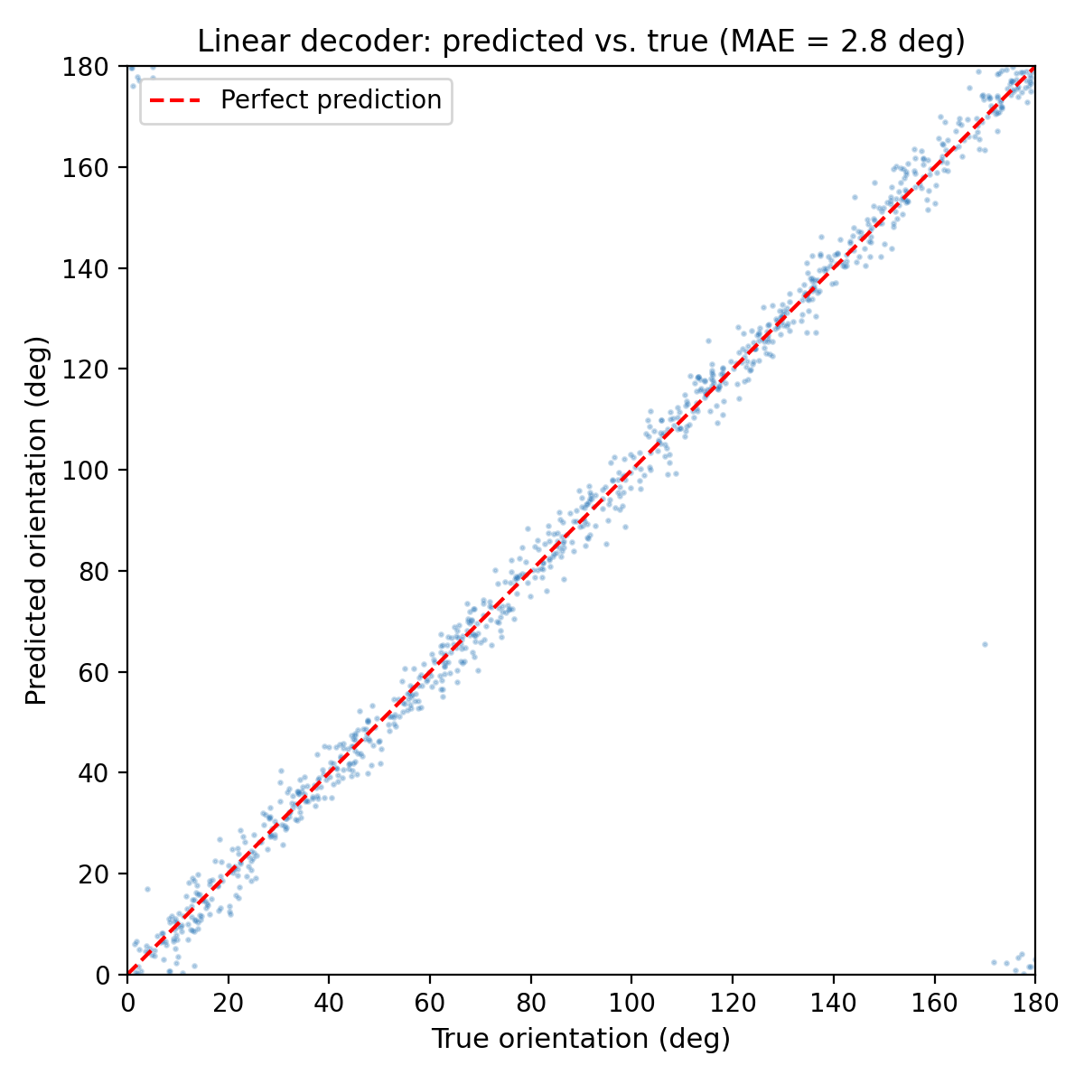
Figure 5. Predicted vs. true orientation for the top-1000 decoder (MAE = 2.8°).

4. Discussion and Conclusion

4.1 Summary of Findings
This analysis of 23,589 simultaneously recorded neurons revealed substantial heterogeneity in orientation tuning: preferred orientations tile the full 0–180° range uniformly, while tuning sharpness spans over an order of magnitude. Approximately 9.4% of recorded neurons showed no meaningful orientation tuning (R² < 0.3), consistent with the known presence of non-orientation-selective cells in mouse V1.
The positive κ–reliability correlation (Spearman r = 0.239) is substantially weaker than the r = 0.91 expected from signal structure alone. This reframes the finding: rather than demonstrating a novel biological relationship, the attenuation from the expected value suggests that biological noise sources (shared variability, behavioral state, non-stationarity) partially decouple tuning strength from measurement reliability.
The OLS linear decoder achieved 4.9° MAE with 1,000 random neurons (2.8° with pre-selected reliable neurons), both far exceeding chance (~45°). The 76% gap between random and pre-selected neurons demonstrates that neuron quality substantially affects decoding. The degradation at >1,000 random neurons highlights OLS overfitting, suggesting that regularization would be needed to leverage larger populations.

4.2 Limitations
- All data are from a single recording in one mouse; replication across animals is needed for generalizability.
- 9.4% of neurons are non-orientation-selective despite converging fits; the 100% convergence rate reflects a lenient failure criterion.
- R² values reflect fits to trial-averaged tuning curves (~128 trials/bin), not single-trial predictions.
- The κ–reliability correlation is largely a mathematical consequence of shared tuning curve structure, limiting its biological interpretability.
- OLS reliability standard errors may be biased due to the bounded nature of reliability [−1, 1].
- OLS decoding overfits when neurons exceed training samples; ridge regression would be a natural extension.
- Deconvolved calcium activity is an indirect measure of spiking that may bias tuning estimates.

4.3 Conclusion
This project demonstrates that V1 neurons in this recording exhibit diverse orientation tuning whose collective activity supports high-precision decoding. The combination of nonlinear least-squares fitting for single-neuron characterization and linear least-squares regression for population decoding provides complementary views: the former reveals the building blocks (individual tuning curves), while the latter shows how they combine for population-level readout. The OLS overfitting at high neuron counts motivates future work with regularized methods, and the attenuated κ–reliability relationship points to interesting noise structure in V1 populations.

5. Individual Reflection
[To be completed individually by each team member.]

References
Ganguli, D., & Simoncelli, E.P. (2014). Efficient sensory encoding and Bayesian inference with heterogeneous neural populations. Neural Computation, 26(10), 2103–2134.
Hubel, D.H., & Wiesel, T.N. (1962). Receptive fields, binocular interaction and functional architecture in the cat’s visual cortex. The Journal of Physiology, 160(1), 106–154.
Stringer, C., Michaelos, M., & Pachitariu, M. (2021). High-precision coding in visual cortex. Cell, 184(10), 2767–2778. DOI: 10.1016/j.cell.2021.03.042.

