Orientation Tuning Heterogeneity and Population Decoding
in Mouse Primary Visual Cortex
BENG 2800 Final Project Report
Rohan Aryagondi
April 2026

1. Introduction and Background
Visual scenes are composed of edges and contours at many angles. The orientation of a visual feature — the tilt angle of a bar or edge, measured in degrees from 0° (horizontal) to 180° (also horizontal, since a bar tilted 180° looks identical to 0°) — is one of the most basic properties the brain must extract. Neurons in the primary visual cortex (V1) are orientation selective: they respond strongly when shown bars or gratings at certain angles (the stimulus orientation) but weakly or not at all at other angles. This property, first described by Hubel and Wiesel (1962), is a fundamental building block of visual processing. Each orientation-selective neuron has a preferred orientation — the specific stimulus angle that produces its strongest response. A neuron also has a characteristic tuning sharpness that describes how narrowly focused that preference is: a sharply tuned neuron responds to a narrow range of angles around its preferred orientation (e.g., only 45° ± 10°), while a broadly tuned neuron responds to many orientations with less discrimination (e.g., 45° ± 40°). Understanding how these tuning properties vary across large neural populations, and how they collectively encode orientation, has direct biomedical relevance: visual cortical prosthetics and brain–computer interfaces (BCIs) that aim to restore or augment vision must decode orientation from neural activity in real time, and their design depends on how many neurons are needed and how reliably those neurons encode stimulus features (Schwartz et al., 2006). Disruptions in orientation selectivity have also been linked to visual processing deficits in amblyopia and schizophrenia (Rokem et al., 2011), making the characterization of normal tuning diversity a necessary baseline for identifying pathological deviations.
Two-photon calcium imaging now enables simultaneous recording from tens of thousands of neurons. Stringer, Michaelos, and Pachitariu (2021) recorded from ~23,000 neurons in mouse V1, demonstrating high-precision population coding of orientation. Their publicly available dataset provides a unique opportunity to investigate both the diversity of single-neuron tuning and the efficiency of population-level encoding.
In this project, we address four questions:
- How much do preferred orientation and tuning sharpness vary across neurons in this V1 recording?
- Are neurons with sharper orientation tuning also more reliable across repeated trials?
- How accurately can a simple linear population decoder predict stimulus orientation?
- How does decoder performance change as the number of neurons increases?
By “reliability” (Question 2), we mean how consistently a neuron responds to the same stimulus across repeated presentations — a reliable neuron produces similar activity each time the same orientation is shown, while an unreliable neuron’s responses vary widely from trial to trial.
These questions bridge single-neuron physiology with population computation using two methods from this course: nonlinear least-squares curve fitting and linear least-squares regression.

2. Methodology

2.1 Dataset
We analyzed two-photon calcium imaging data from Stringer et al. (2021), consisting of 23,589 simultaneously recorded neurons in V1 of a single head-fixed mouse during passive viewing of 4,598 static oriented gratings (0–180°, approximately uniformly distributed). Neural responses were provided as deconvolved calcium activity (one scalar per neuron per trial) extracted using Suite2p, which applies neuropil subtraction and a non-negative deconvolution algorithm. We note that deconvolved traces retain trial-to-trial variability from noise sources including neuropil contamination and indicator kinetics; our analyses characterize tuning properties as measured through this processing pipeline. Stimulus directions (0–360°) were mapped to orientations (0–180°) since static gratings at 0° and 180° are physically identical.

2.2 Nonlinear Least-Squares Tuning Model
A tuning curve plots a neuron’s average response as a function of the stimulus orientation presented on each trial. Empirical tuning curves were computed by binning trials into 36 bins of 5° each (~128 trials/bin) and computing the mean response per bin. We fit a von Mises orientation tuning function — essentially a bell-shaped curve wrapped onto a circle, the circular analog of a Gaussian — using nonlinear least squares (scipy.optimize.curve_fit). The von Mises form is appropriate because orientation is periodic (0° = 180°), so ordinary Gaussian fitting would produce discontinuities at the wraparound:
r(θ) = b + a · exp(κ · cos(2(θ − θ₀)))
where b is baseline activity (the response level at the least-preferred orientation), a is the amplitude of the tuning peak above baseline, θ₀ is the preferred orientation (the stimulus angle producing the strongest response), and κ (kappa) is the tuning sharpness parameter: κ = 0 produces a flat curve (no orientation preference), κ ≈ 2 gives a broad peak with FWHM ≈ 50°, κ ≈ 5 gives a moderate peak (FWHM ≈ 30°), and κ ≥ 10 produces sharp tuning (FWHM < 20°). The upper bound was set to 50 (FWHM ≈ 10°), approaching the resolution limit of the 5° binning. Goodness of fit was assessed using R² computed on binned means. Neurons with R² < 0.3 were classified as “untuned,” following the convention that R² below this threshold indicates the model explains less variance than a simple mean (accounting for parameter count), and inspection confirmed these neurons have κ ≈ 0 (flat tuning curves). We note that R² on trial-averaged tuning curves will be higher than single-trial predictive accuracy due to the noise reduction from averaging ~128 trials per bin.

2.3 Reliability Analysis
Split-half reliability was defined as the Pearson correlation between tuning curves from odd- and even-indexed trials. We assessed the κ–reliability relationship using: (1) an OLS linear model (reliability = β₀ + β₁·κ + β₂·mean_response) solved via np.linalg.lstsq, with standard errors from the residual variance and (XᵀX)⁻¹; and (2) Pearson/Spearman correlations with 95% bootstrap CIs (5,000 resamples). Because both κ and reliability derive from the same tuning curves, we also ran a simulation to quantify the mathematically expected correlation between them.

2.4 Linear Population Decoder
An OLS linear decoder (np.linalg.lstsq) regressed the trial-by-neuron response matrix onto targets y_cos = cos(2θ) and y_sin = sin(2θ). Because orientation is circular, we encoded the angle as a (cosine, sine) pair rather than a raw degree value, which avoids the discontinuity at the 0°/180° wraparound. The predicted orientation was recovered as θ_pred = arctan2(sin_pred, cos_pred)/2.
Decoder performance was measured using circular mean absolute error (MAE): the average angular distance between predicted and true orientation, accounting for the periodicity of orientation (so an error of 170° is treated as 10°, since 0° and 180° are identical). A decoder that guesses randomly on a uniform distribution over 0–180° produces an expected MAE of 45° (chance level). We used 5-fold cross-validation to ensure all performance estimates are on held-out data.
Neuron-count scaling was evaluated at 10, 25, 50, 100, 250, 500, 1,000, 2,000, and 5,000 neurons (10 random subsets each, drawn from all 23,589 neurons). We also evaluated the top 1,000 most reliable neurons (selected by split-half reliability) as an upper bound; comparing random versus pre-selected neurons quantifies how much neuron quality matters for decoding — a question directly relevant to BCI electrode placement, where only a limited number of recording sites can be chosen. A shuffle control (permuted labels, 10 repeats at 100 neurons) established the chance baseline. Because OLS is unregularized, we anticipated potential overfitting when the number of neurons exceeds the number of training samples (~3,678 in each CV fold).

3. Results and Analysis

3.1 Heterogeneity of Orientation Tuning
The von Mises fitting algorithm converged for all 23,589 neurons. However, 2,218 (9.4%) produced R² < 0.3 with κ near zero, indicating these neurons are not meaningfully orientation-selective and are better characterized as “untuned” rather than “broadly tuned.” Among the remaining 21,371 neurons with R² ≥ 0.3, the median R² was 0.753 (IQR: [0.533, 0.894]).
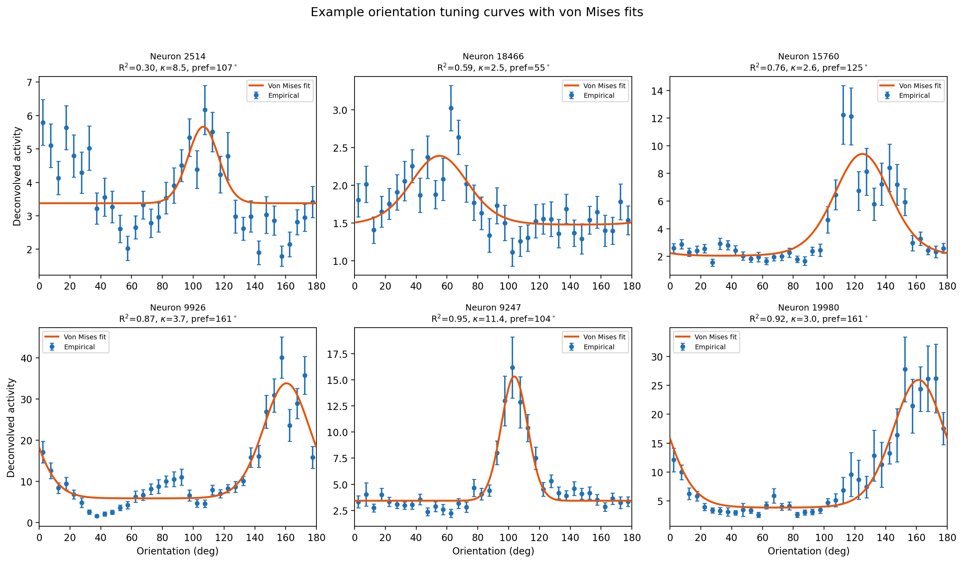
Figure 1. Example orientation tuning curves with von Mises fits, spanning the range of fit quality. Blue: empirical bin means (± SEM). Orange: fitted von Mises model.
Preferred orientations were approximately uniformly distributed across 0–180° (Figure 2, left), consistent with the known lack of columnar orientation maps in mouse V1. Tuning sharpness (κ) varied substantially, with a median of 3.83 (IQR: [1.32, 8.23]; Figure 2, right). The observed heterogeneity is consistent with the premise that diverse tuning profiles may support population coding (Ganguli and Simoncelli, 2014), though testing whether this distribution is optimal would require comparison to theoretical predictions. From a biomedical perspective, this heterogeneity means that any neural prosthetic targeting V1 would encounter a mixture of sharply and broadly tuned neurons, and its decoding algorithms would need to accommodate this diversity rather than assuming uniform tuning.
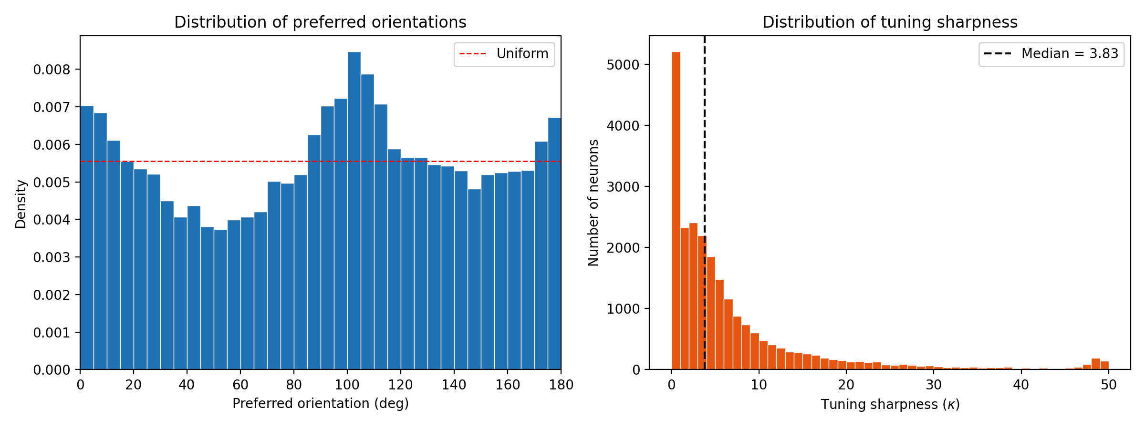
Figure 2. Left: preferred orientations are approximately uniform (red dashed line). Right: tuning sharpness is right-skewed (median κ = 3.83).

3.2 Tuning Sharpness and Trial-to-Trial Reliability
κ and split-half reliability were positively correlated (Spearman r = 0.237, 95% CI: [0.224, 0.249]). However, because both metrics derive from the same tuning curves, some positive correlation is mathematically expected regardless of biology: neurons with higher κ have more structured tuning curves, which are inherently more correlated across trial halves. A simulation in which noise was entirely independent of κ produced Spearman r = 0.906 (Figure 3, left), indicating that the real data’s weaker correlation (0.237 vs. 0.91) reflects biological noise sources that partially decouple tuning strength from measurement reliability.
Table 1. OLS regression: reliability ~ κ + mean_response (n = 23,589)
Parameter | Coefficient | SE | t | p-value
Intercept | 0.670 | 0.0022 | 340.3 | < 10⁻³⁰⁰
κ | 0.0008 | 0.0001 | 5.4 | < 10⁻⁷⁰
Mean response | 0.0039 | 0.0001 | 32.1 | < 10⁻²⁰⁰

The OLS model confirmed the positive association (Table 1), though both κ and mean response together explain only a small fraction of reliability variance. This is consistent with the simulation analysis: the observed κ–reliability coupling is weaker than the mathematically expected relationship. Note that because reliability is bounded [−1, 1], the OLS homoscedasticity assumption is violated; standard errors should be interpreted with caution.
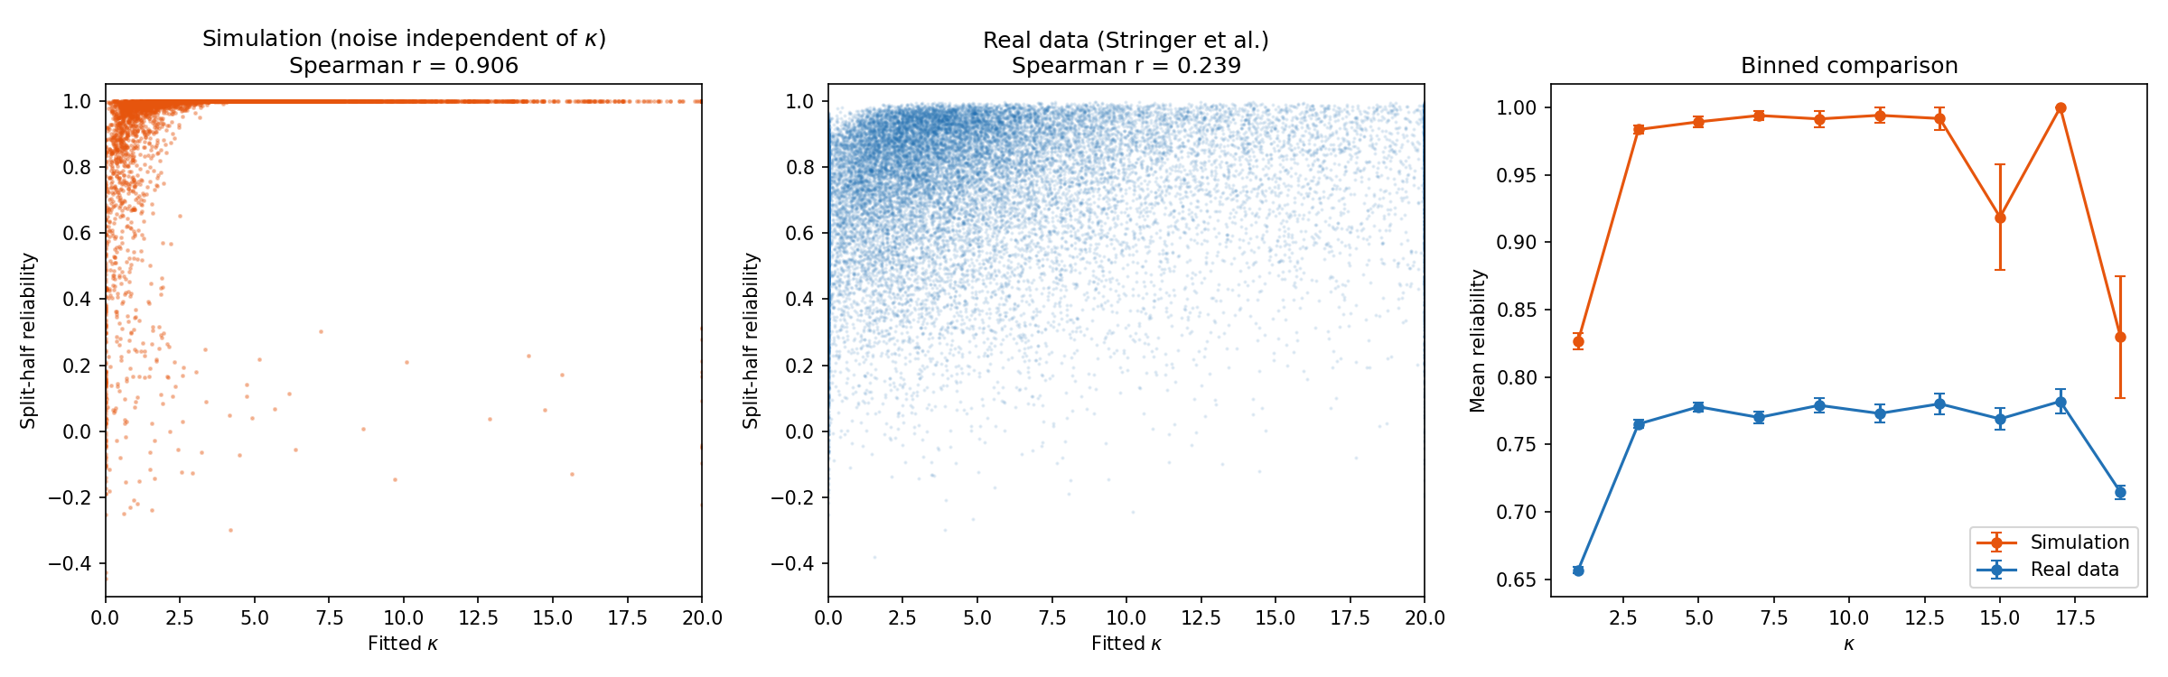
Figure 3. Left: simulation with noise independent of κ yields r = 0.906. Center: real data yields r = 0.237, substantially lower. Right: binned comparison shows the real data’s κ–reliability coupling is attenuated relative to the mathematical expectation.

3.3 Population Decoder Performance
With 1,000 randomly selected neurons, the OLS decoder achieved MAE = 4.94°, far below the chance level of ~45°. Pre-selecting the 1,000 most reliable neurons (top 4.2% by split-half reliability) reduced MAE to 2.80°—a 76% improvement that quantifies how neuron quality affects decoding accuracy (Table 2, Figure 4).
Table 2. Decoder MAE by neuron count: random population vs. top-1000 pool.
Neurons | Random MAE (deg) | Top-1000 MAE (deg)
10 | 31.00 ± 3.59 | 19.96 ± 4.30
25 | 21.60 ± 1.61 | 10.27 ± 1.53
50 | 16.42 ± 2.11 | 6.33 ± 0.66
100 | 10.60 ± 0.99 | 4.48 ± 0.24
250 | 6.45 ± 0.44 | 3.44 ± 0.10
500 | 5.40 ± 0.32 | 2.98 ± 0.09
1000 | 4.94 ± 0.15 | 2.80
2000 | 5.53 ± 0.16 | —
5000 | 7.71 ± 0.14 | —

Performance improved with neuron count up to ~1,000 random neurons (Figure 4). However, at 2,000 and 5,000 neurons, MAE increased to 5.53° and 7.71° respectively. This degradation occurs because OLS is unregularized: when the number of neurons exceeds the number of training samples per fold (~3,678), the system becomes underdetermined and overfits. Regularized methods (e.g., ridge regression) would likely maintain or improve performance at higher neuron counts. For BCI applications, the practical implication is that even ~100 randomly placed electrodes in V1 could achieve ~10° orientation decoding accuracy, but careful electrode targeting toward reliable neurons could roughly halve the error.
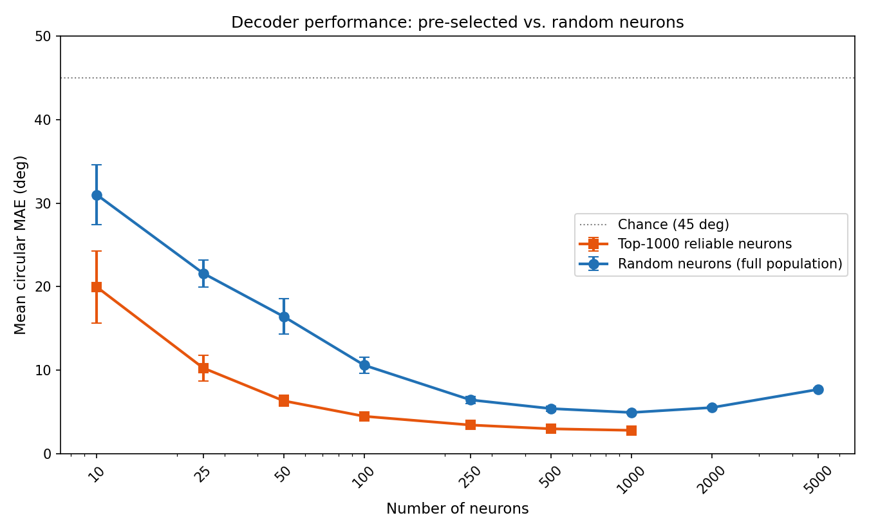
Figure 4. Decoder MAE vs. neuron count. Blue: random neurons from full population. Orange: top-1000 most reliable neurons. Note the upturn at >1,000 random neurons due to OLS overfitting when features exceed training samples.
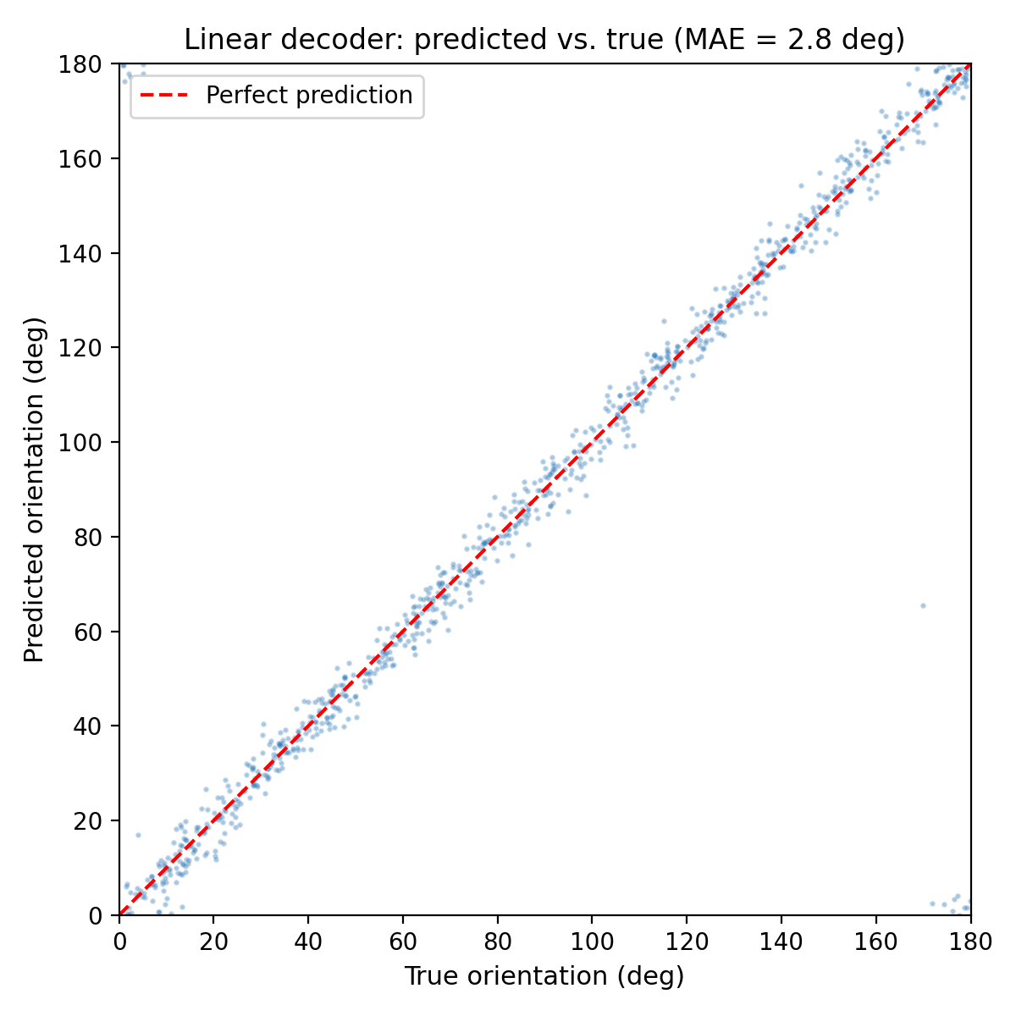
Figure 5. Predicted vs. true orientation for the top-1000 decoder (MAE = 2.8°).

4. Discussion and Conclusion

4.1 Summary of Findings
This analysis of 23,589 simultaneously recorded neurons revealed substantial heterogeneity in orientation tuning: preferred orientations tile the full 0–180° range uniformly, while tuning sharpness spans over an order of magnitude. Approximately 9.4% of recorded neurons showed no meaningful orientation tuning (R² < 0.3), consistent with the known presence of non-orientation-selective cells in mouse V1.
The positive κ–reliability correlation (Spearman r = 0.237) is substantially weaker than the r = 0.91 expected from signal structure alone. This reframes the finding: rather than demonstrating a novel biological relationship, the attenuation from the expected value suggests that biological noise sources (shared variability, behavioral state, non-stationarity) partially decouple tuning strength from measurement reliability.
The OLS linear decoder achieved 4.9° MAE with 1,000 random neurons (2.8° with pre-selected reliable neurons), both far exceeding chance (~45°). The 76% gap between random and pre-selected neurons demonstrates that neuron quality substantially affects decoding. The degradation at >1,000 random neurons highlights OLS overfitting, suggesting that regularization would be needed to leverage larger populations. These results establish a quantitative baseline for the information capacity of V1 populations that could inform the design of cortical visual prosthetics — specifically, the minimum number of recording channels needed for clinically useful orientation discrimination.

4.2 Limitations
- All data are from a single recording in one mouse; replication across animals is needed for generalizability.
- 9.4% of neurons are non-orientation-selective despite converging fits; the 100% convergence rate reflects a lenient failure criterion.
- R² values reflect fits to trial-averaged tuning curves (~128 trials/bin), not single-trial predictions.
- The κ–reliability correlation is largely a mathematical consequence of shared tuning curve structure, limiting its biological interpretability.
- OLS reliability standard errors may be biased due to the bounded nature of reliability [−1, 1].
- OLS decoding overfits when neurons exceed training samples; ridge regression would be a natural extension.
- Deconvolved calcium activity is an indirect measure of spiking that introduces noise at multiple stages (indicator kinetics, neuropil contamination, deconvolution algorithm). Residual noise may systematically deflate tuning sharpness estimates by flattening tuning curve peaks. Denoising approaches such as DeepInterpolation (Lecoq et al., 2021) could improve estimates but require access to raw calcium movies not included in this dataset.

4.3 Conclusion
This project demonstrates that V1 neurons in this recording exhibit diverse orientation tuning whose collective activity supports high-precision decoding. The combination of nonlinear least-squares fitting for single-neuron characterization and linear least-squares regression for population decoding provides complementary views: the former reveals the building blocks (individual tuning curves), while the latter shows how they combine for population-level readout. The OLS overfitting at high neuron counts motivates future work with regularized methods, and the attenuated κ–reliability relationship points to interesting noise structure in V1 populations. More broadly, these findings establish a quantitative framework for how orientation is represented in large neural populations — knowledge that is essential for the rational design of visual cortical prosthetics, for establishing normative baselines against which disease-related tuning deficits can be assessed, and for validating computational models of sensory coding.

5. Individual Reflection
[To be completed individually by each team member.]

References
Ganguli, D., & Simoncelli, E.P. (2014). Efficient sensory encoding and Bayesian inference with heterogeneous neural populations. Neural Computation, 26(10), 2103–2134.
Hubel, D.H., & Wiesel, T.N. (1962). Receptive fields, binocular interaction and functional architecture in the cat’s visual cortex. The Journal of Physiology, 160(1), 106–154.
Lecoq, J., et al. (2021). Removing independent noise in systems neuroscience data using DeepInterpolation. Nature Methods, 18(11), 1401–1408.
Rokem, A., et al. (2011). Broader visual orientation tuning in patients with schizophrenia. Frontiers in Human Neuroscience, 5, 127.
Schwartz, A.B., et al. (2006). Brain-controlled interfaces: movement restoration with neural prosthetics. Neuron, 52(1), 205–220.
Stringer, C., Michaelos, M., & Pachitariu, M. (2021). High-precision coding in visual cortex. Cell, 184(10), 2767–2778. DOI: 10.1016/j.cell.2021.03.042.

