Team - O

- Borde Rohan

- Guduri Manas

- Kale Aditya

- Soma Prabhu Pooja

**Process-Pro App**

**Design Report**

# System Model:

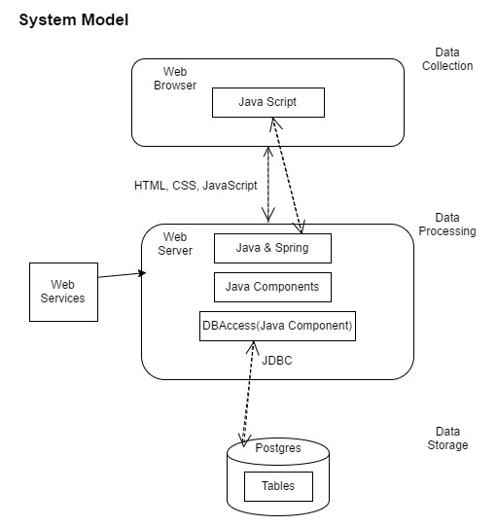

# Data Model:

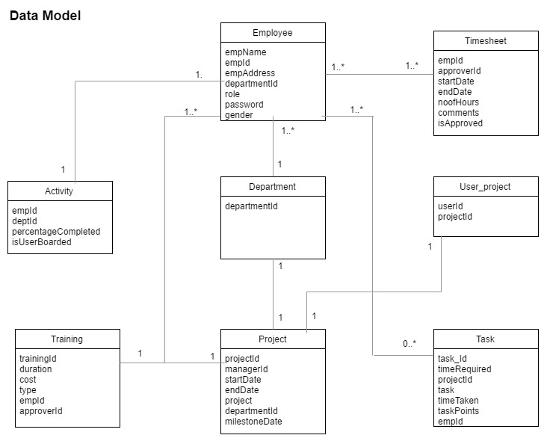

# 

# 

# State Transition Diagram:

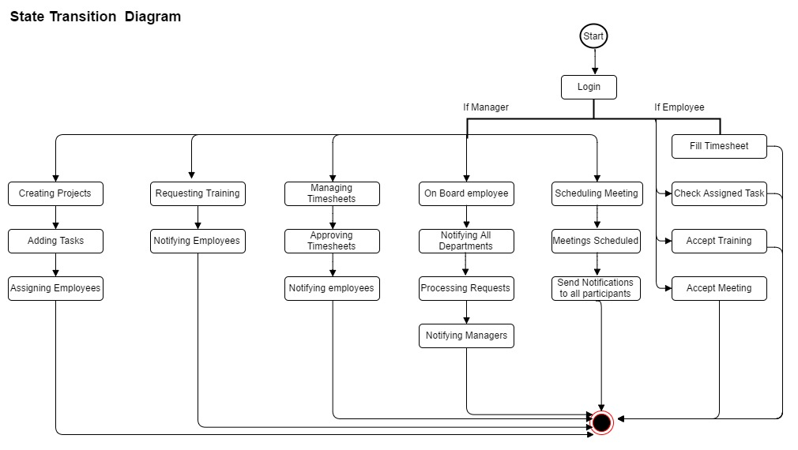

UI Prototypes:

The Login Form:

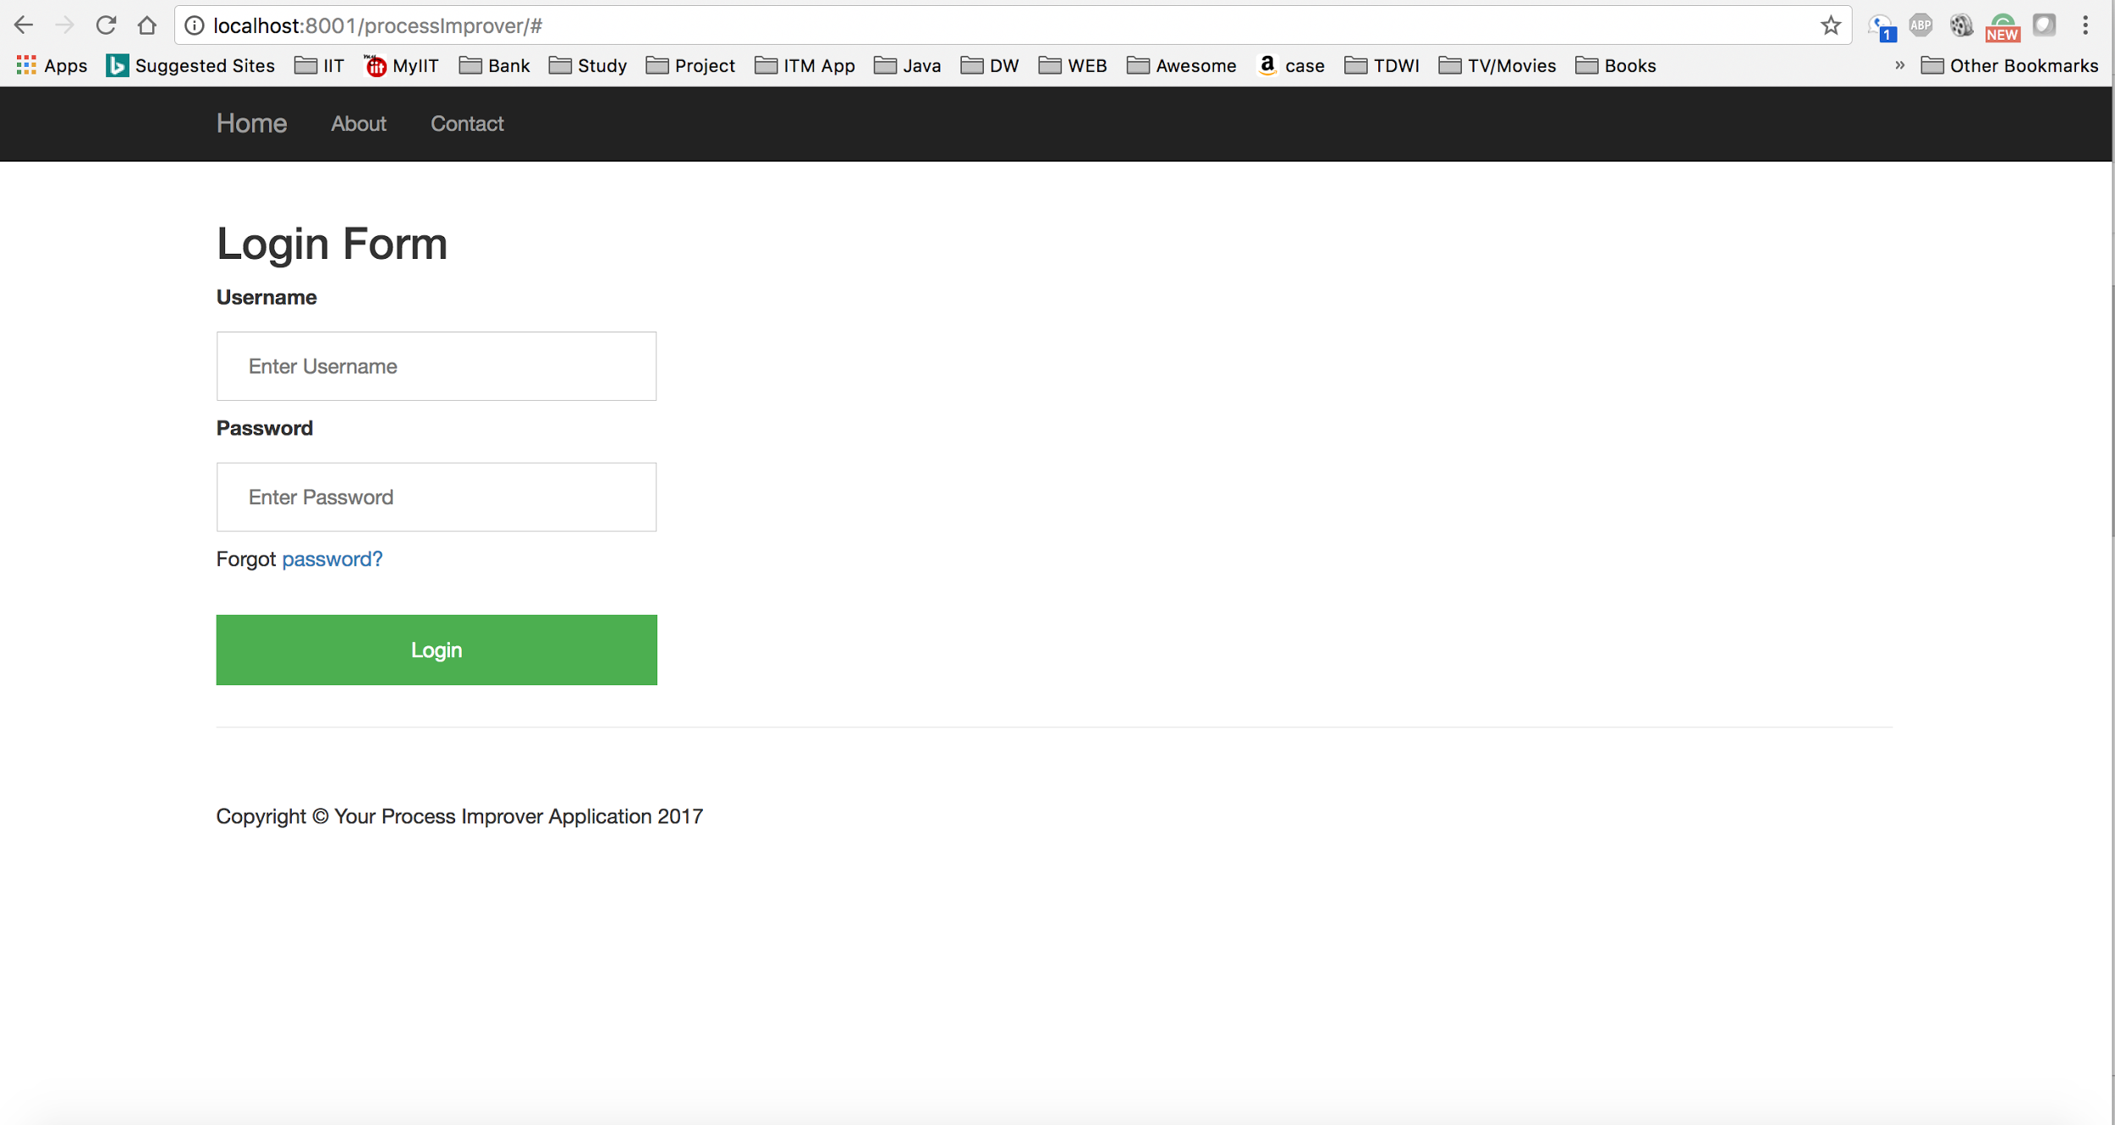

When the manager wants to on-board a new employee:

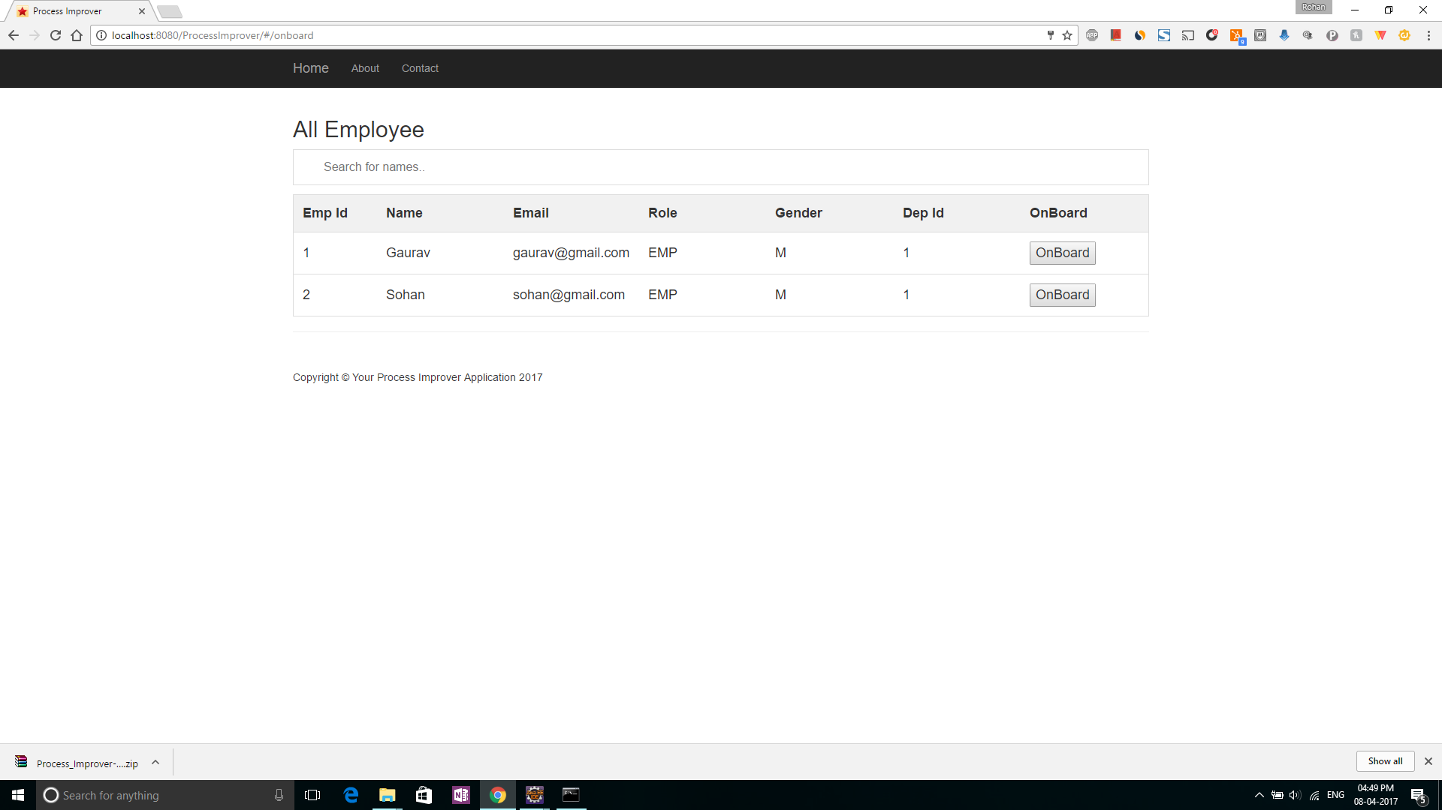

On clicking employee row, the pop up is displayed containing employee details:

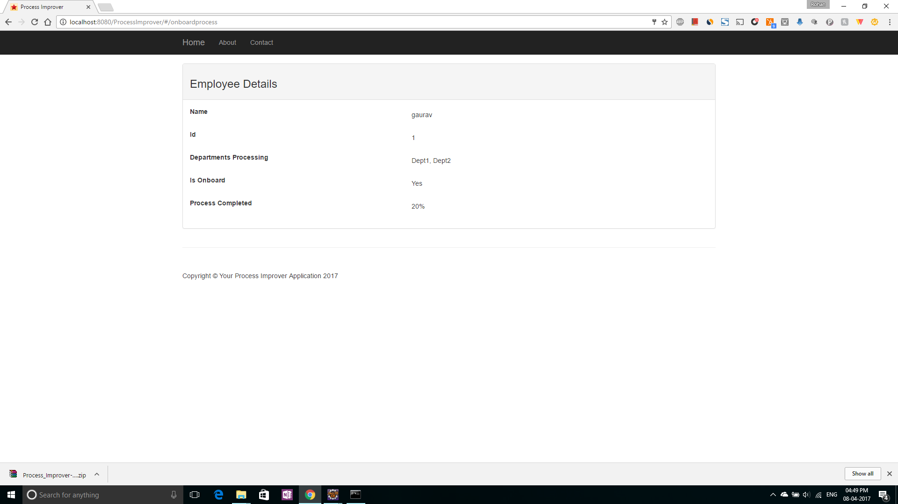

Project Management Page:

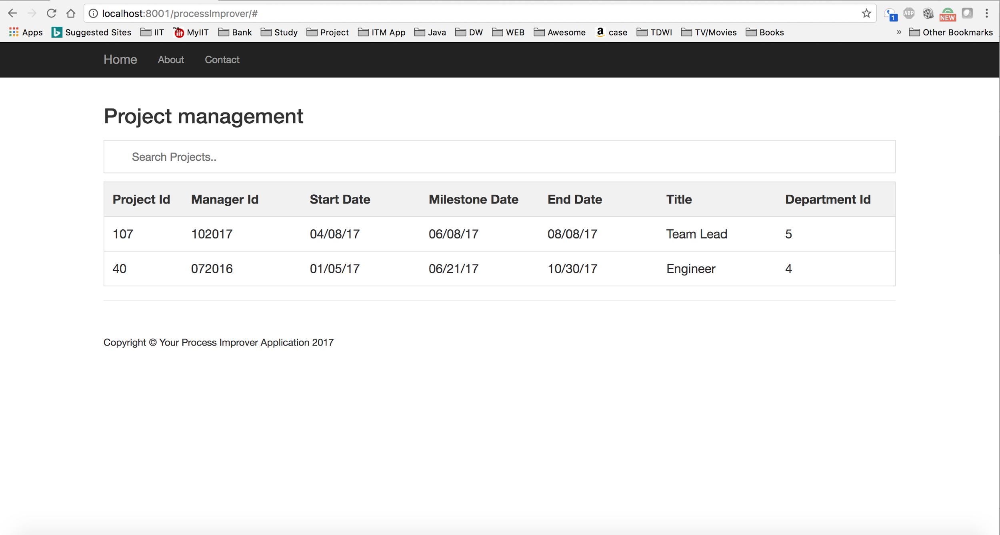

Analysis Report Generation for the project:

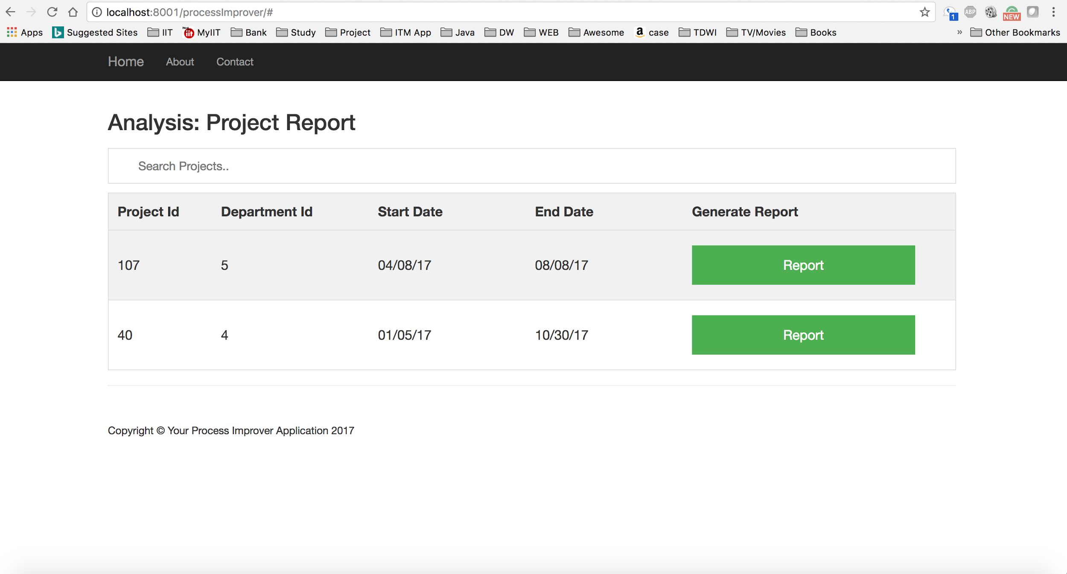

On clicking on a Report button, project report details appears:

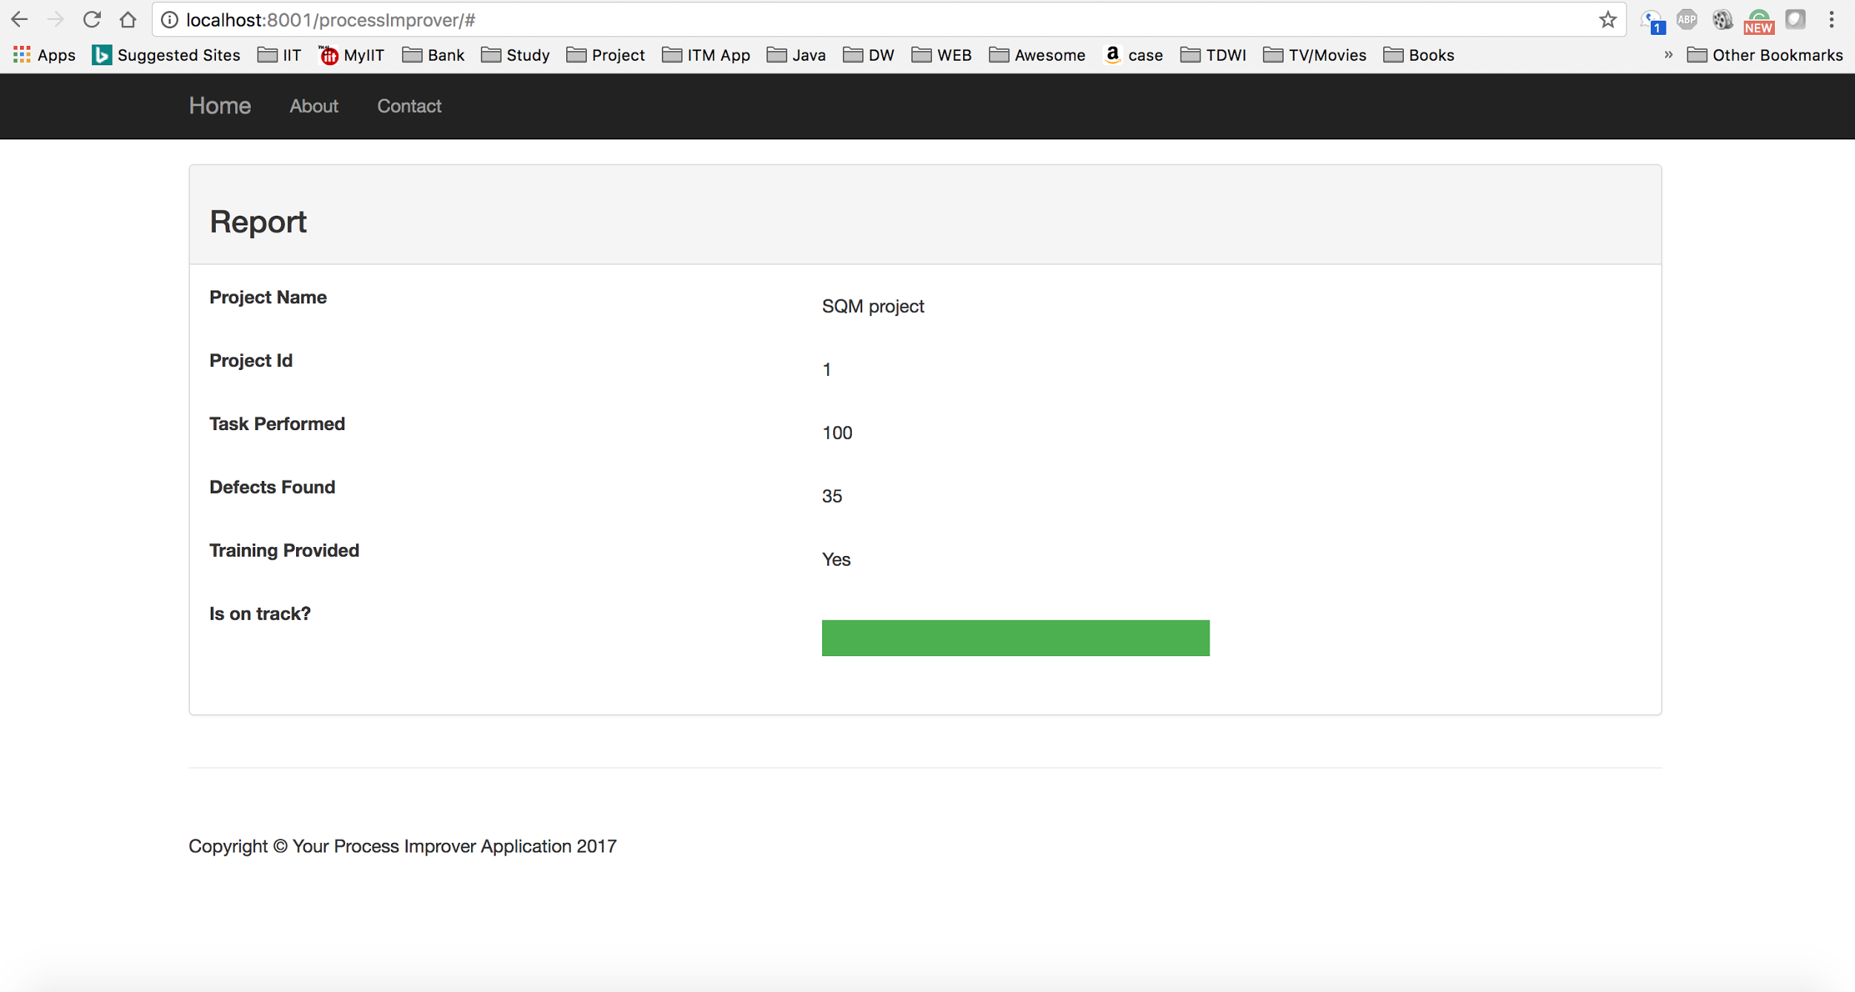

TimeSheet Management:

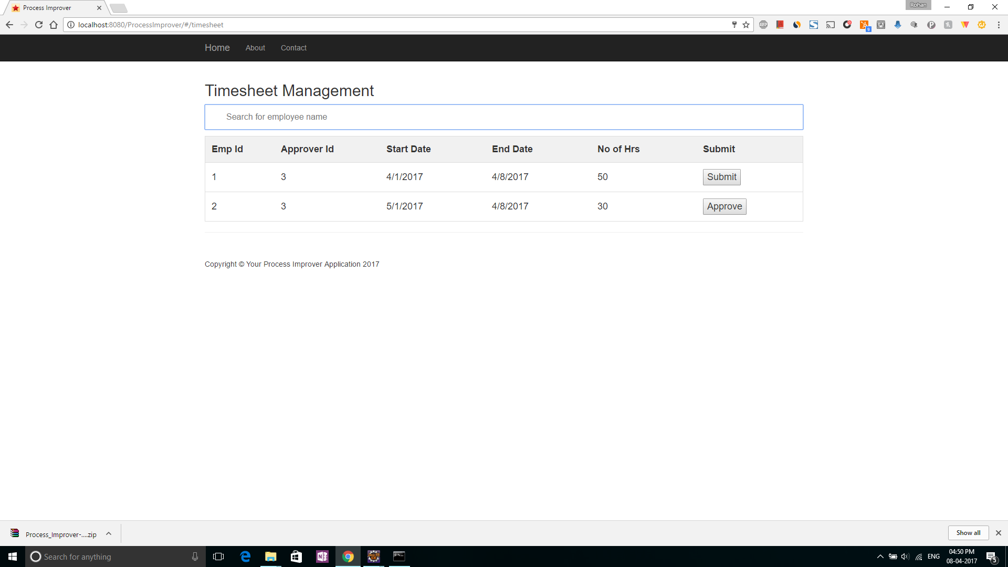

Training Management page:

