Assignment 1 Dated Mar 11th, 2026

Problem Statement
Python program to display Armstrong numbers within a specified range.
Definition: An Armstrong number is a number which is equal to the sum of each of its digit to the power of its total length.

Algorithm
Step 1: Start.
Step 2: A number N is entered by the user.
Step 3: A condition is checked to determine whether N < 0.
Step 4: If N < 0, the message “Not an Armstrong number” is displayed and the program is terminated.
Step 5: The value of N is stored in a variable named original.
Step 6: The number of digits in N is calculated and stored in the variable digits.
Step 7: A variable total is initialized with the value 0.
Step 8: Step 9 to Step 11 are run repeatedly until N becomes 0.
Step 9: The last digit of N is extracted using N % 10 and stored in the variable digit.
Step 10: The value digit raised to the power digits is added to total.
Step 11: The last digit of N is removed by performing integer division N //= 10.
Step 12: After the loop ends, a condition is checked to determine whether original == 0.
Step 13: If original == 0, the value of total is set to 0.
Step 14: A comparison is made between total and original.
Step 15: If total equals original, the message “It is an Armstrong number” is displayed; otherwise, the message “It is not an Armstrong number” is displayed.
Step 16: Stop.

Source Code
N = int(input("Enter a number: "))

if N < 0:
print("It is not an Armstrong number.")
exit(0)

original = N
digits = len(str(N))
total = 0

while N > 0:
digit = N % 10
total += digit ** digits
N //= 10

# For input 0, loop won't run; 0 is Armstrong
if original == 0:
total = 0

# Using ternary operator to cover four lines in a Pythonic way
print(f"It is {"" if total == original else "not "}an Armstrong number.")

Output
SET-1
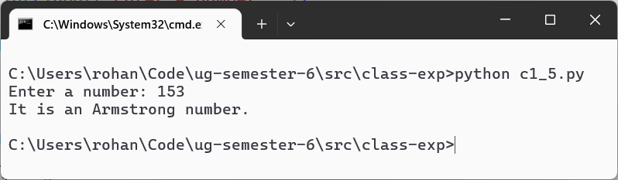
SET-2
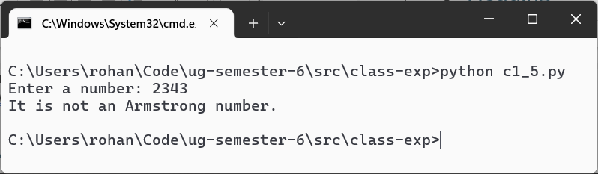
SET-3
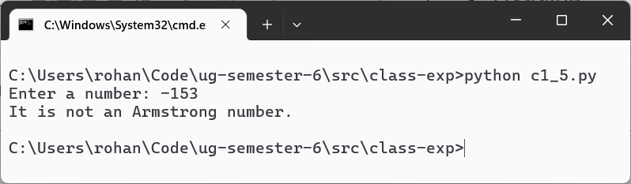
Teacher’s signature

