Assignment 2 Dated Mar 16th, 2026

Problem Statement
Python program to find the harmonic sum of specified N-1 terms, where N is an integer.
Definition: A harmonic sum is defined as:
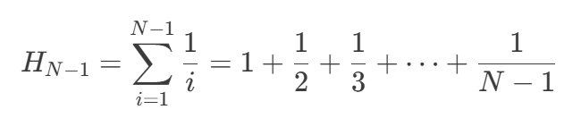

Algorithm
Step 1: Start.
Step 2: A function named harmonic_sum is defined to compute the harmonic sum for a given integer num.
Step 3: A condition is checked to determine whether num < 1.
Step 4: If num < 1, a ValueError is generated indicating that N must be a positive integer.
Step 5: A variable total_sum is initialized with the value 0.0.
Step 6: Step 7 to Step 8 are run repeatedly from i = 1 to num - 1.
Step 7: The value 1 / i is calculated.
Step 8: The calculated value is added to total_sum.
Step 9: After the loop is completed, the value stored in total_sum is returned as the harmonic sum.
Step 10: The program attempts to read an integer n from the user.
Step 11: The function harmonic_sum(n) is called and the returned value is stored in h_sum.
Step 12: The result is displayed in the format Hₙ = value, where the value is printed with 10 decimal places.
Step 13: If an invalid input occurs or the value of n is not a positive integer, the error is caught and an “Invalid input” message is displayed along with the error description.
Step 14: Stop.

Source Code
def harmonic_sum(num: int) -> float:
"""Return the harmonic sum H_N for a positive integer N."""
if num < 1:
raise ValueError("N must be a positive integer.")

total_sum = 0.0
for i in range(1, num):
total_sum += 1 / i
return total_sum

try:
n = int(input("Input the value of N: "))
h_sum = harmonic_sum(n)
print(f"H_{n} = {h_sum:.10f}")
except ValueError as err:
print(f"Invalid input: {err}")

Output
SET-1
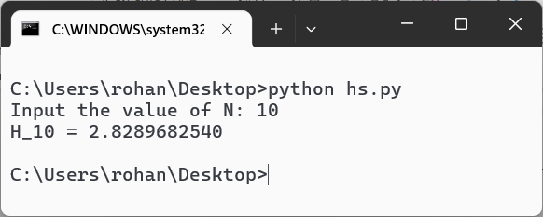
SET-2
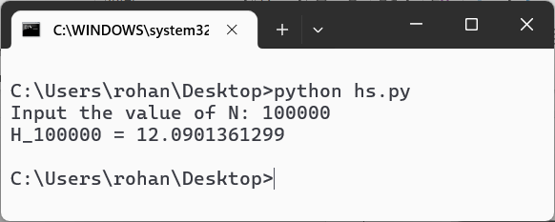
SET-3
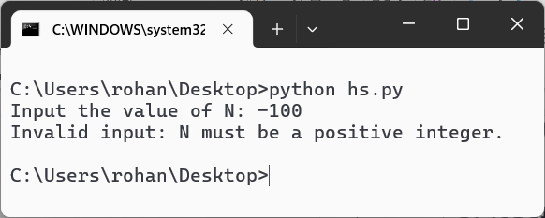
Teacher’s signature

