Assignment 3 Dated Mar 16th, 2026

Problem Statement
Python program to find factors and no. of factors of a given positive number.

Algorithm
Step 1: Start.
Step 2: A function named factors_of is defined to determine all factors of a given integer num. Number checking is applied.
Step 3: An empty list named factors is created to store the factors.
Step 4: Step 5 to Step 7 are run repeatedly from i = 1 to num.
Step 5: A value i is taken within the range 1 to num.
Step 6: A condition is checked to determine whether num % i == 0.
Step 7: If the condition is true, the value i is added to the list factors.
Step 8: After all iterations are completed, the list factors is returned by the function.
Step 9: An integer N is entered by the user.
Step 10: The function factors_of(N) is called and the returned list is stored in the variable factors.
Step 11: The list of factors is displayed.
Step 12: The number of factors is calculated using len(factors).
Step 13: The message “No. of factors:” along with the total number of factors is displayed.
Step 14: Stop.

Source Code
def factors_of(num: int) -> list:
if num < 0:
print("error: The number cannot be negative!")
exit(1)

factors = []
for i in range(1, num + 1):
if num % i == 0:
factors.append(i)

return factors

N = int(input("Input the value of N: "))
factors = factors_of(N)
print(factors)
print("No. of factors:", len(factors))

Output
SET-1
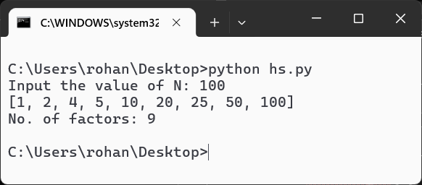
SET-2
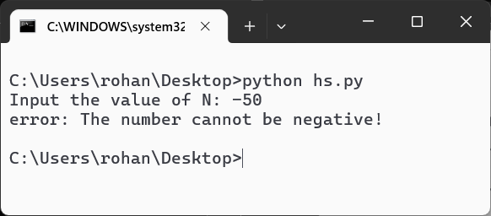
SET-3
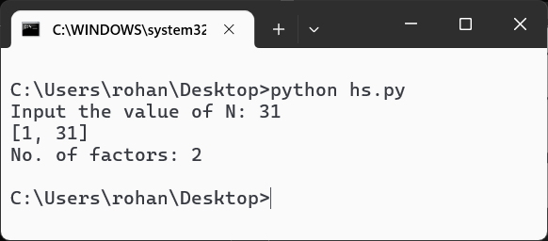
Teacher’s signature

