Assignment 7 Dated Mar 26th, 2026

Problem Statement
Write a python program to calculate the sine series.

Algorithm
Step 1: Start.
Step 2: A function named sine_series(x, terms) is defined to compute the sine value using a series.
Step 3: A condition is checked to determine whether terms ≤ 0.
Step 4: If the condition is true, an error is generated indicating that the number of terms must be greater than 0.
Step 5: A variable result is initialized with the value 0.0.
Step 6: A variable term is initialized with the value x.
Step 7: Step 8 to Step 11 are run repeatedly from n = 0 to terms − 1.
Step 8: A value of n is selected.
Step 9: A condition is checked to determine whether n = 0.
- If true, term is set to x.
- Otherwise, term is updated using the relation:
multiply the previous term by −x² / ((2n)(2n + 1)).
Step 10: The current value of term is added to result.
Step 11: The loop continues until all terms are processed.
Step 12: After completion of the loop, the value of result is returned.

Step 13: In the main program, an angle in degrees is entered by the user and stored in x_degrees.
Step 14: The number of terms is entered by the user and stored in terms.
Step 15: The angle is converted from degrees to radians and stored in x_radians.
Step 16: The function sine_series(x_radians, terms) is called and the result is stored in approx.
Step 17: The computed sine value is displayed.
Step 18: Stop.

Source Code
import math

def sine_series(x: float, terms: int) -> float:
if terms <= 0:
raise ValueError("Number of terms must be greater than 0.")

result = 0.0
term = x

for n in range(terms):
if n == 0:
term = x
else:
term *= -1 * x * x / ((2 * n) * (2 * n + 1))
result += term

return result

def main() -> None:
x_degrees = float(input("Enter angle in degrees: "))
terms = int(input("Enter number of terms: "))

x_radians = math.radians(x_degrees)
approx = sine_series(x_radians, terms)

print(f"sin({x_degrees}) using sine series = {approx:.5f}")

if __name__ == "__main__":
main()

Output
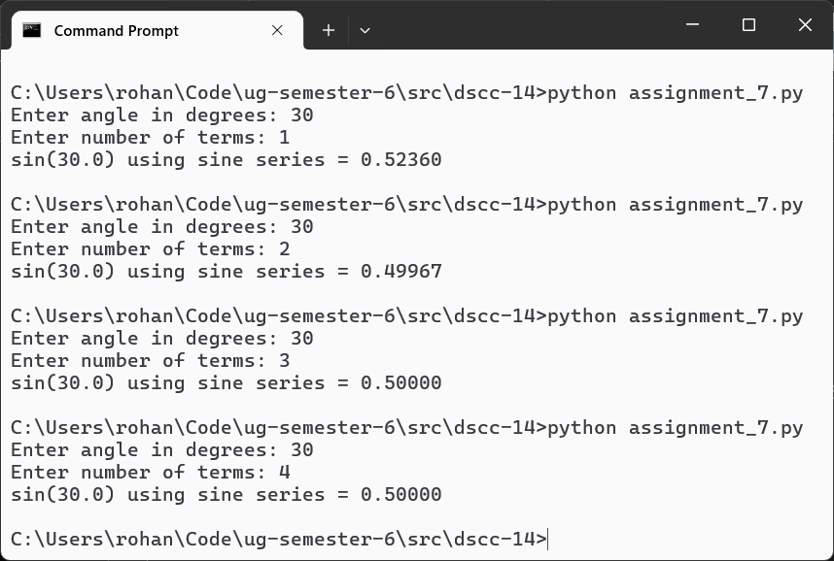

Teacher’s signature

