Assignment 8 Dated Mar 18th, 2026

Problem Statement
Python program to run a binary search over a list. Values for the list should be provided by the user and target also.

Algorithm
Step 1: Start.
Step 2: A function named binarySearch(array, target) is defined.
Step 3: A variable lo is initialized with value 0.
Step 4: A variable hi is initialized with value length of array − 1.
Step 5: Step 6 to Step 12 are run repeatedly until lo becomes greater than hi.
Step 6: The middle index mid is calculated using
mid = lo + (hi − lo) // 2.
Step 7: A condition is checked to determine whether array[mid] is equal to target.
- If true, the value mid is returned.
Step 8: A condition is checked to determine whether array[mid] is greater than target.
Step 9: If true, the value of hi is updated to mid − 1.
Step 10: Otherwise, the value of lo is updated to mid + 1.
Step 11: The loop continues until the condition lo ≤ hi becomes false.
Step 12: If the element is not found, the value −1 is returned.

Step 13: In the main program, a sequence of values is entered by the user as a string.
Step 14: An empty list numbers is created.
Step 15: Step 16 to Step 18 are run repeatedly for each value in the input string.
Step 16: A value is selected from the input.
Step 17: An attempt is made to convert the value into an integer.
- If successful, it is added to the list numbers.
- Otherwise, the value is ignored.
Step 18: The loop continues until all inputs are processed.
Step 19: A target element is entered by the user.
Step 20: The function binarySearch(numbers, target) is called and the result is stored in idx.
Step 21: A condition is checked to determine whether idx = −1.
- If true, a message indicating that the element is not found is displayed.
- Otherwise, the index of the element is displayed.
Step 22: Stop.

Source Code
def binarySearch(array: list[int], target: int) -> int:
lo = 0
hi = len(array) - 1

while lo <= hi:
mid = lo + (hi - lo) // 2
if array[mid] == target:
return mid
elif array[mid] > target:
hi = mid - 1
else:
lo = mid + 1

return -1

def main() -> None:
userInput = input("Input an array of integers (sep. by space): ")
numbers = []

for num in userInput.split():
try:
numbers.append(int(num))
except ValueError:
# This will ensure only valid numbers are inserted.
pass

target = int(input("Element to search: "))
idx = binarySearch(numbers, target)

if idx == -1:
print("The element wasn't found in the array.")
else:
print(f"Index {idx} contains the element.")

if __name__ == "__main__":
main()

Output
SET-1
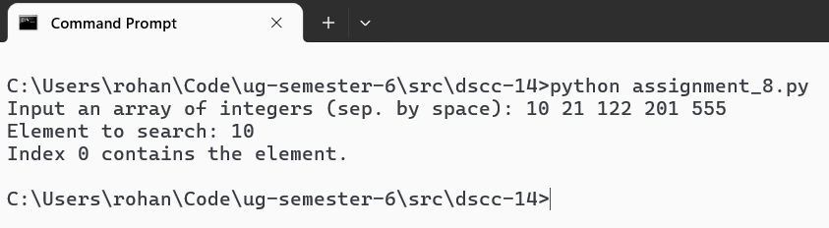
SET-2
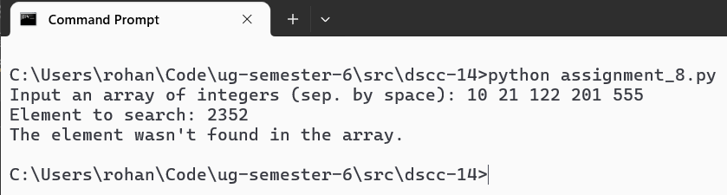

Teacher’s signature

