Assignment 9 Dated Mar 18th, 2026

Problem Statement
Python program to run a bubble sort over a list provided by the user and display the sorted values in ascending order.

Algorithm
Step 1: Start.
Step 2: A function named bubbleSort(array) is defined.
Step 3: The length of the array is determined and stored in n.
Step 4: Step 5 to Step 8 are run repeatedly from i = 0 to n − 1.
Step 5: A value of i is selected.
Step 6: Step 7 to Step 8 are run repeatedly from j = 0 to n − i − 2.
Step 7: A value of j is selected and a comparison is made between array[j] and array[j + 1].
Step 8: If array[j] > array[j + 1], the two elements are swapped.
Step 9: The process is continued until all passes are completed and the array becomes sorted.

Step 10: In the main program, a sequence of values is entered by the user as a string.
Step 11: An empty list numbers is created.
Step 12: Step 13 to Step 15 are run repeatedly for each value in the input string.
Step 13: A value is selected from the input.
Step 14: An attempt is made to convert the value into an integer.
- If successful, it is added to the list numbers.
- Otherwise, the value is ignored.
Step 15: The loop continues until all inputs are processed.
Step 16: The list before sorting is displayed.
Step 17: The function bubbleSort(numbers) is called to sort the list.
Step 18: The sorted list is displayed.
Step 19: Stop.

Source Code
def bubbleSort(array: list[int]) -> None:
n = len(array)
for i in range(n):
for j in range(n - i - 1):
if array[j] > array[j + 1]:
array[j], array[j + 1] = array[j + 1], array[j]

def main() -> None:
userInput = input("Input an array of integers (sep. by space): ")
numbers = []

for num in userInput.split():
try:
numbers.append(int(num))
except ValueError:
# This will ensure only valid numbers are inserted.
pass

print("Before sort:", numbers)
bubbleSort(numbers)
print("After sort:", numbers)

if __name__ == "__main__":
main()

Output
SET-1
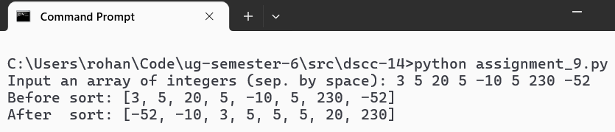
SET-2
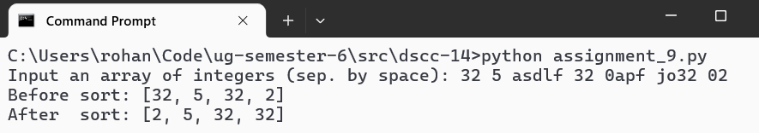

Teacher’s signature

