Assignment 1 Apr 16, 2026

Problem Description
Create a function that acts as a simple calculator. If the operation is not specified, default to addition. If the operation is an unexpected operation, return an error message.

Solution
Step 1. Start the program and define a function calc(a, b, operation) with a default value of "add" for the operation.
Step 2. Check if the operation is "add" or if no operation is provided, then return the sum of a and b.
Step 3. If the operation is "subtract", return the difference of a and b.
Step 4. If the operation is "multiply", return the product of a and b.
Step 5. If the operation is "divide", first check if b is zero; if yes, return an error message, otherwise return the division of a by b.
Step 6. If the operation does not match any valid option, return an error message indicating an invalid operation.
Step 7. Define the main() function to call the calc function with different test cases.
Step 8. Display the results of the test cases.
Step 9. End the program.

Code
def calc(a, b, operation="add"):
if operation == "add":
return a + b
elif operation == "subtract":
return a - b
elif operation == "multiply":
return a * b
elif operation == "divide":
if b == 0:
return "Error: Division by zero"
return a / b
else:
return "Error: Invalid operation"

def main():
# Test cases
print("Test Case 1:", calc(4, 5, "multiply")) # Expected: 20
print("Test Case 2:", calc(3, 5)) # Expected: 8
print("Test Case 3:", calc(1, 2, "something")) # Expected: Error

if __name__ == "__main__":
main()

Output
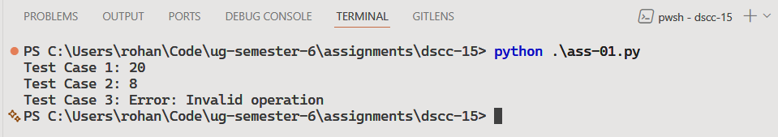

Discussion
The solution can be further improved by allowing case-insensitive inputs or supporting symbolic operators.

Teacher’s signature

