Assignment 2 Apr 16, 2026

Problem Description
Given a list of numbers, return a list where all adjacent duplicate elements have been reduced to a single element. You may create a new list or modify the passed in list.

Solution
Step 1. Start the program and define a function that takes a list of numbers as input.
Step 2. Create an empty list to store the result.
Step 3. Add the first element of the input list to the result list (if the list is not empty).
Step 4. Traverse the list from the second element to the end using a loop.
Step 5. For each element, compare it with the previous element.
Step 6. If the current element is not equal to the previous element, append it to the result list.
Step 7. Continue this process until all elements are checked.
Step 8. Return the final list containing no adjacent duplicates.
Step 9. Define the main() function to test the function with sample inputs and display outputs.
Step 10. End the program.

Code
def remove_adj_dups(elements):
if not elements:
return []

result = [elements[0]]

# Removal of adjacent elements
# Note: It does not removes ALL duplicates but closest ones!
for i in range(1, len(elements)):
if elements[i] != elements[i - 1]:
result.append(elements[i])

return result

def main():
# Test cases
print("Test Case 1:", remove_adj_dups([1, 2, 2, 3, 2])
print("Test Case 2:", remove_adj_dups([4, 4, 4, 4]))
print("Test Case 3:", remove_adj_dups([1, 2, 3, 4]))

if __name__ == "__main__":
main()

Output
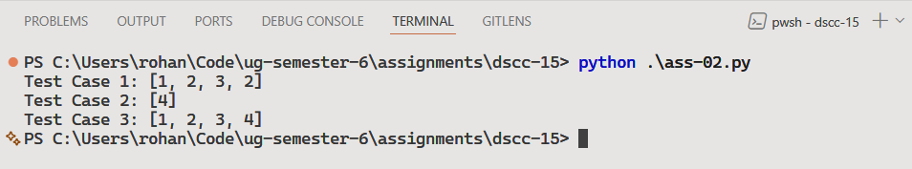

Discussion
To enhance the solution, it can be modified to handle non-adjacent duplicates if required by using sets or additional data structures.
The function can also be improved to work in-place (modifying the original list instead of creating a new one) to reduce memory usage.

Teacher’s signature

