Assignment 3 Apr 16, 2026

Problem Description
Copy/paste the Supervised learning Wiki page (https://en.wikipedia.org/wiki/Supervised learning) into a text file. Then perform these operations:
- Read the file and count the occurrences of each word within the file.
- Store the words’ occurrence number in a dictionary.

Solution
Step 1. Start the program and open the text file in read mode.
Step 2. Read the entire content of the file into a string.
Step 3. Convert all text to lowercase to ensure uniform counting.
Step 4. Remove punctuation and special characters from the text.
Step 5. Split the text into individual words using spaces.
Step 6. Create an empty dictionary to store word counts.
Step 7. Traverse through the list of words using a loop.
Step 8. For each word, check if it exists in the dictionary; if yes, increment its count, otherwise add it with count 1.
Step 9. After processing all words, return or display the dictionary.
Step 10. Define the main() function to read the file and print the word frequency.
Step 11. End the program.

Code
import string

def count_words(filename):
word_count = {}

with open(filename, 'r', encoding='utf-8') as file:
text = file.read().lower()

# Remove punctuation
text = text.translate(str.maketrans('', '', string.punctuation))

words = text.split()

for word in words:
if word in word_count:
word_count[word] += 1
else:
word_count[word] = 1

return word_count

def main():
filename = "ass-03-res.txt"

result = count_words(filename)

# Display first 10 word counts as sample
print("Sample word counts:")
count = 0
for word, freq in result.items():
print(word, ":", freq)
count += 1
if count == 10:
break

if __name__ == "__main__":
main()

Output
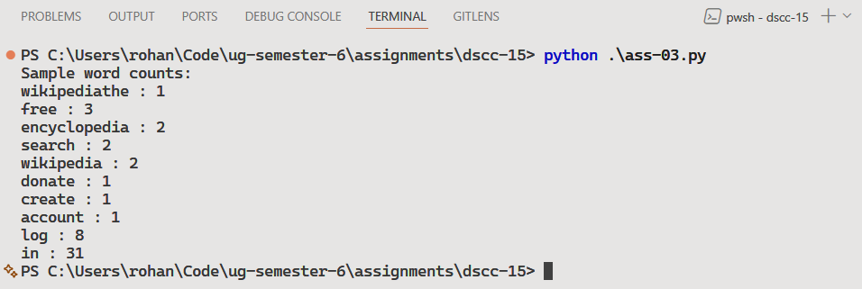
Showing top 10 results

Discussion
To enhance the solution, it can be improved by ignoring common stop words (like “the”, “is”, “and”) to focus on meaningful terms. It can also be extended to sort the output by frequency or display the most frequent words.
Teacher’s signature

