Assignment 5 Apr 16, 2026

Problem Description
Write a Python program to generate 1000 random data points and perform statistical analysis on them.
- Compute Mean
- Compute Median
- Compute Standard Deviation
Don’t use NumPy, you can use random() and math module if necessary.

Solution
Step 1. Start the program and import the required modules random and math.
Step 2. Generate 1000 random data points using a loop and store them in a list.
Step 3. Compute the mean by summing all values and dividing by the total number of elements.
Step 4. Sort the list to prepare for median calculation.
Step 5. If the number of elements is odd, select the middle element as the median; if even, take the average of the two middle elements.
Step 6. Compute the standard deviation by first calculating the variance, which is the average of squared differences from the mean.
Step 7. Take the square root of the variance using the math module to obtain the standard deviation.
Step 8. Define the main() function to perform all computations and display the results.
Step 9. Print the mean, median, and standard deviation.
Step 10. End the program.

Code
import random
import math

def generate_data(n=1000):
data = []
for _ in range(n):
data.append(random.randint(1, 100)) # random numbers between 1 and 100
return data

def compute_mean(data):
return sum(data) / len(data)

def compute_median(data):
sorted_data = sorted(data)
n = len(sorted_data)

if n % 2 == 1:
return sorted_data[n // 2]
else:
return (sorted_data[n // 2 - 1] + sorted_data[n // 2]) / 2

def compute_std(data, mean):
variance = sum((x - mean) ** 2 for x in data) / len(data)
return math.sqrt(variance)

def main():
data = generate_data()

print("First 50 generated data (not exhaustive):")
print(data[:50])

mean = compute_mean(data)
median = compute_median(data)
std_dev = compute_std(data, mean)

print("Mean:", mean)
print("Median:", median)
print("Standard Deviation:", std_dev)

if __name__ == "__main__":
main()

Output
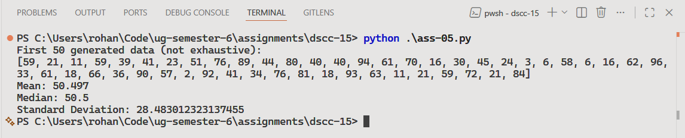

Discussion
- Results can be plotted using Matplotlib for better visualization and understanding of the pseudo-random data.
- Real numbers can also be generated instead of integers.
Teacher’s signature

