Assignment 6 Apr 20, 2026

Problem Description
Write a Python program to perform the following operations in Pandas Dataframe.
1. Read the iris dataset at - https://github.com/neurospin/pystatsml/tree/ master/datasets/iris.csv
2. Print column names.
3. Get numerical columns.
4. For each species compute the mean of numerical columns and store it in a stats table.
5. Add some missing data to the previous table.
6. Write a function fillmissing with mean(df) that fill all missing value of numerical column with the mean of the current columns.

Solution
Step 1. Start the program and import the pandas library.
Step 2. Read the Iris dataset from the given URL into a DataFrame.
Step 3. Print all column names of the DataFrame.
Step 4. Identify and extract numerical columns from the DataFrame.
Step 5. Group the dataset by species and compute the mean of numerical columns for each species.
Step 6. Store the result in a new table and display it.
Step 7. Introduce some missing values (NaN) into the DataFrame manually.
Step 8. Define a function fillmissing_with_mean(df) that replaces missing values in numerical columns with their respective column means.
Step 9. Apply the function to the DataFrame to fill missing values.
Step 10. Display the updated DataFrame.
Step 11. End the program.

Code
import pandas as pd
import numpy as np

def fillmissing_with_mean(df):
for col in df.select_dtypes(include=['number']).columns:
df[col].fillna(df[col].mean(), inplace=True)
return df

def main():
# Step 2: Read dataset
url = "https://media.githubusercontent.com/media/neurospin/pystatsml/refs/heads/master/datasets/iris.csv"
df = pd.read_csv(url)

# Step 3: Print column names
print("Columns:", df.columns.tolist())

# Step 4: Get numerical columns
num_cols = df.select_dtypes(include=['number']).columns
print("Numerical Columns:", list(num_cols))

# Step 5: Mean by species
grouped_mean = df.groupby('species')[num_cols].mean()
print("\nMean values by species:\n", grouped_mean)

# Step 7: Introduce missing values
df.iloc[0, 0] = np.nan
df.iloc[5, 2] = np.nan

print("\nData with missing values:\n", df.head())

# Step 8 & 9: Fill missing values
df = fillmissing_with_mean(df)

print("\nData after filling missing values:\n", df.head())

if __name__ == "__main__":
main()

Output
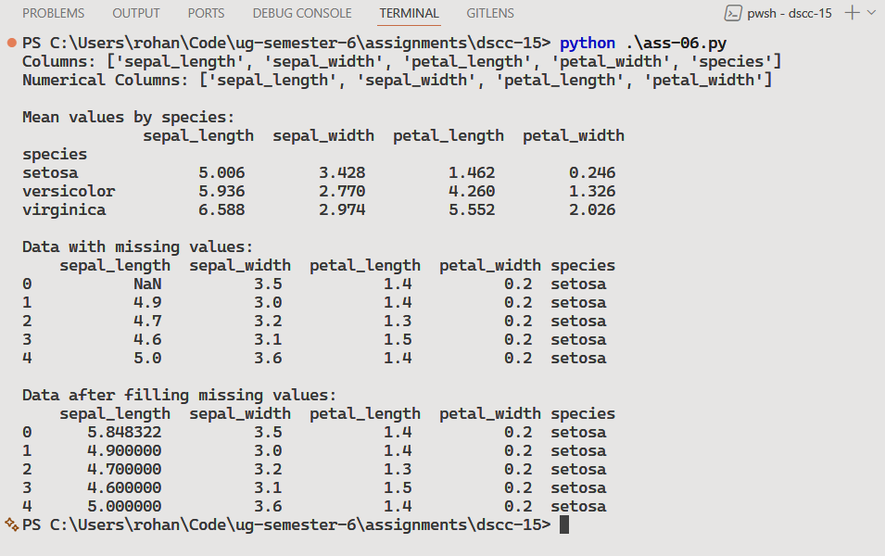

Discussion
- To enhance the solution, more robust missing value strategies can be used, such as filling based on group-wise means instead of overall column means.
- Error handling can be added for invalid URLs or missing columns.
- Additionally, visualization of results using plots (e.g., histograms or box plots) would provide better insights into the dataset.
Teacher’s signature

