Assignment 7 Apr 22, 2026

Problem Description
Write a Python program to perform the following operations on a random datasets.
1. Create a random dataset. split them into categories like male and female (male = np.random.normal(170, 8, 100)) etc.
2. Plot side-by-side boxplots.
3. Compare distributions. Median differences. Variability. Overlap.

Solution
Step 1. Start the program and import the required libraries numpy for data generation and matplotlib.pyplot for plotting graphs.
Step 2. Generate two random datasets representing categories such as male and female using normal distribution with specified mean, standard deviation, and sample size.
Step 3. Store the generated values in separate arrays for male and female datasets.
Step 4. Create a new figure and plot side-by-side boxplots for both datasets to visually compare their distribution, median, and spread.
Step 5. Label the boxplots appropriately and display the plot.
Step 6. Compute the median of both datasets using appropriate statistical functions.
Step 7. Compute the variability of both datasets by calculating their standard deviation.
Step 8. Display the computed median and standard deviation values for both categories.
Step 9. Create another figure and plot histograms for both datasets on the same axes with transparency to visualize overlap between distributions.
Step 10. Add labels, legend, and title to clearly distinguish between the two datasets in the histogram.
Step 11. Display the histogram plot to observe overlap and distribution shape.
Step 12. Compare the datasets based on median differences, variability, and degree of overlap.
Step 13. End the program.

Code
import matplotlib.pyplot as plt
import numpy as np

def main():
# Generate datasets
male = np.random.normal(170, 8, 100)
female = np.random.normal(160, 7, 100)

# Boxplot
plt.figure()
plt.boxplot([male, female], label=["Male", "Female"])
plt.title("Boxplot Comparison")
plt.ylabel("Height")
plt.show()

# Median and variability
male_median = np.median(male)
female_median = np.median(female)

male_std = np.std(male)
female_std = np.std(female)

print("Male Median:", male_median)
print("Female Median:", female_median)
print("Male Std Dev:", male_std)
print("Female Std Dev:", female_std)

# Overlapping histograms
plt.figure()
plt.hist(male, bins=15, alpha=0.5, label="Male")
plt.hist(female, bins=15, alpha=0.5, label="Female")
plt.title("Distribution Overlap")
plt.xlabel("Height")
plt.ylabel("Frequency")
plt.legend()
plt.show()

if __name__ == "__main__":
main()

Output
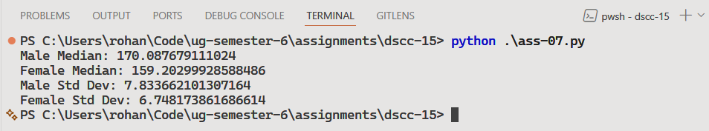
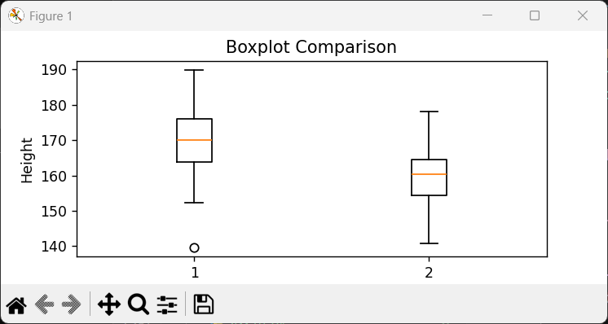
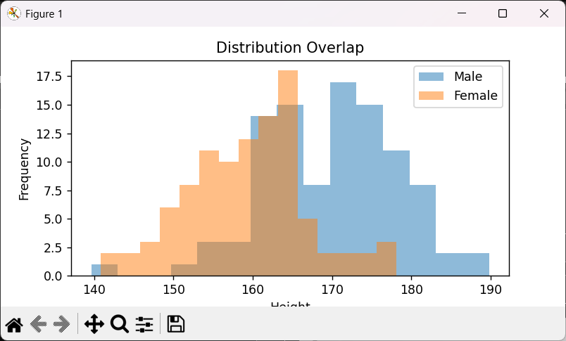

Discussion
Advanced visualization techniques like density plots can provide smoother comparisons. Increasing dataset size or using real-world data would also make the analysis more reliable.
Teacher’s signature

