Assignment 8 Apr 22, 2026

Problem Description
Write a Python program to perform the following operations on a real-world dataset (you may use a dataset from Kaggle if required):
- Read the dataset using the Pandas library.
- Clean the dataset and display both uncleaned and cleaned visualizations.
- Plot histograms and boxplots for relevant numerical features.
- Detect outliers and highlight them in the plots.
- Provide an interpretation of your observations in the discussion section.

Solution
Step 1. Start the program and import the required libraries such as pandas for data handling, numpy for numerical operations, matplotlib.pyplot and seaborn for visualization.
Step 2. Load the real-world dataset from a Titanic CSV file into a Pandas DataFrame using read_csv().
Step 3. Display the first few rows of the dataset using head() to understand the structure and contents of the data.
Step 4. Display dataset information such as column names, data types, and number of non-null values using info() to identify missing values.
Step 5. Generate statistical summary of numerical columns using describe() to understand distribution, range, and central tendencies.
Step 6. Identify all numerical columns from the dataset using appropriate selection methods such as select_dtypes().
Step 7. Choose a meaningful numerical column (e.g., Fare or Age in Titanic dataset) for analysis instead of index-like columns such as IDs.
Step 8. Plot a histogram of the selected column to visualize the distribution of the uncleaned data.
Step 9. Plot a boxplot of the same column to visually detect the presence of outliers in the uncleaned dataset.
Step 10. Check for missing values in the selected column and handle them by filling with an appropriate measure such as mean or median.
Step 11. Calculate the first quartile (Q1) and third quartile (Q3) of the column and compute the Interquartile Range (IQR).
Step 12. Determine the lower bound and upper bound for outlier detection using the formula:
Lower Bound = Q1 − 1.5 × IQR
Upper Bound = Q3 + 1.5 × IQR
Step 13. Identify outliers as data points that lie below the lower bound or above the upper bound.
Step 14. Display or store the detected outliers for reference.
Step 15. Remove or filter out the outliers from the dataset to create a cleaned dataset.
Step 16. Plot a histogram of the cleaned dataset to observe changes in distribution after removing outliers.
Step 17. Plot a boxplot of the cleaned dataset to confirm that extreme values have been reduced or eliminated.
Step 18. Optionally plot a scatter plot or overlay bounds to visually highlight outliers in the original dataset.
Step 19. Compare the uncleaned and cleaned plots to analyze the effect of data cleaning on distribution and variability.
Step 20. End the program.

Code
import matplotlib.pyplot as plt
import numpy as np
import pandas as pd
import seaborn as sns

def detect_outliers_iqr(series):
Q1 = series.quantile(0.25)
Q3 = series.quantile(0.75)
IQR = Q3 - Q1
lower = Q1 - 1.5 * IQR
upper = Q3 + 1.5 * IQR
return lower, upper

def main():
# Step 1: Read dataset
df = pd.read_csv("ass-08-res.csv")

print("First 5 rows:\n", df.head())
print("\nInfo:\n")
print(df.info())

# Select numerical columns
num_cols = df.select_dtypes(include=np.number).columns
col = num_cols[0]

print(f"\nUsing column: {col}")

# ---------------- UN-CLEANED DATA ----------------
plt.figure()
plt.hist(df[col], bins=20)
plt.title("Histogram (Uncleaned Data)")
plt.xlabel(col)
plt.ylabel("Frequency")
plt.show()

plt.figure()
sns.boxplot(x=df[col])
plt.title("Boxplot (Uncleaned Data)")
plt.show()

# ---------------- CLEANING ----------------
# Handle missing values
df[col] = df[col].fillna(df[col].median())

# Detect outliers
lower, upper = detect_outliers_iqr(df[col])

# Mark outliers
outliers = df[(df[col] < lower) | (df[col] > upper)]

print("\nOutliers detected:\n", outliers)

# Remove outliers
df_clean = df[(df[col] >= lower) & (df[col] <= upper)]

# ---------------- CLEANED DATA ----------------
plt.figure()
plt.hist(df_clean[col], bins=20)
plt.title("Histogram (Cleaned Data)")
plt.xlabel(col)
plt.ylabel("Frequency")
plt.show()

plt.figure()
sns.boxplot(x=df_clean[col])
plt.title("Boxplot (Cleaned Data)")
plt.show()

# ---------------- OUTLIER VISUALIZATION ----------------
plt.figure()
sns.scatterplot(x=range(len(df)), y=df[col])
plt.axhline(lower)
plt.axhline(upper)
plt.title("Outlier Detection (Scatter Plot)")
plt.xlabel("Index")
plt.ylabel(col)
plt.show()

if __name__ == "__main__":
main()

Output
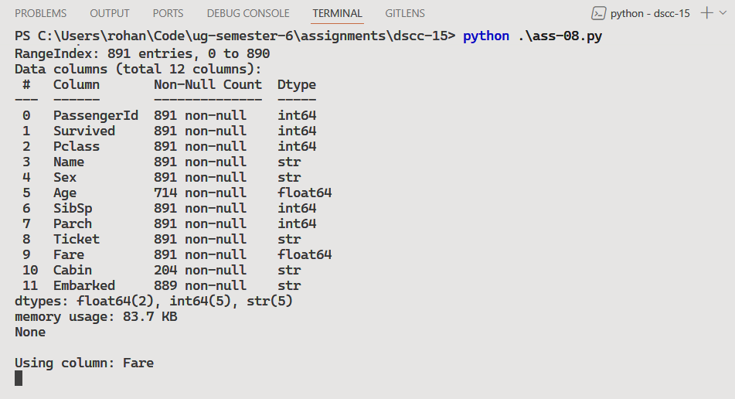
Using Titanic Disaster’s dataset from Kaggle.
Raw Data

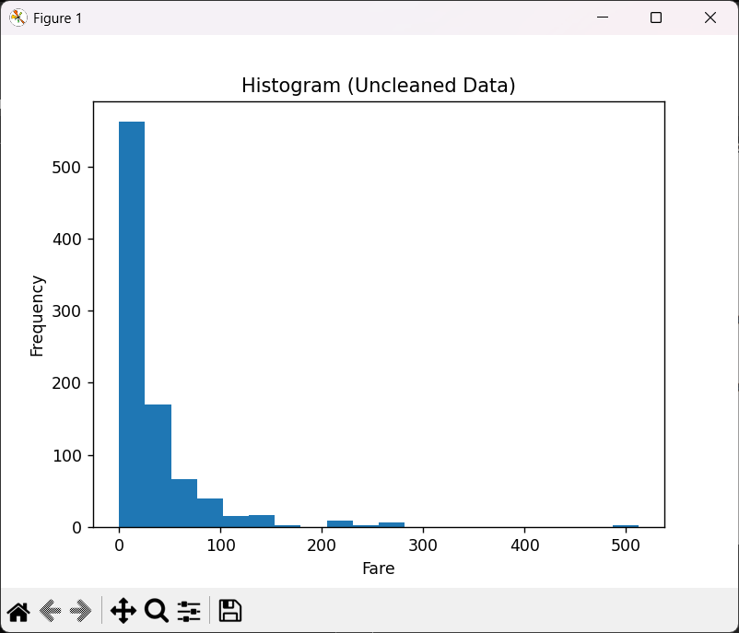 | 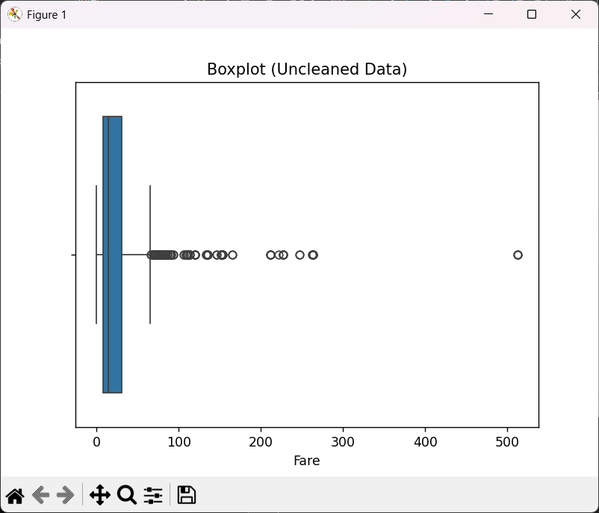
Cleaned Data

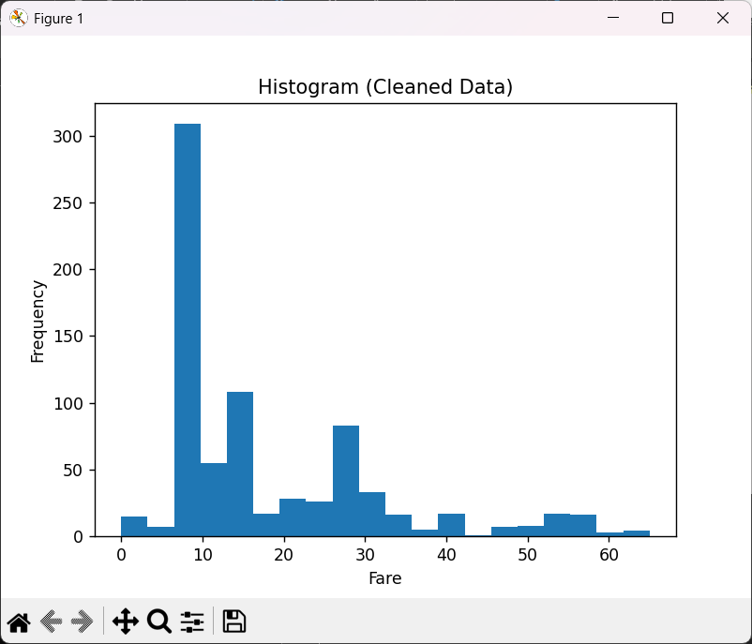 | 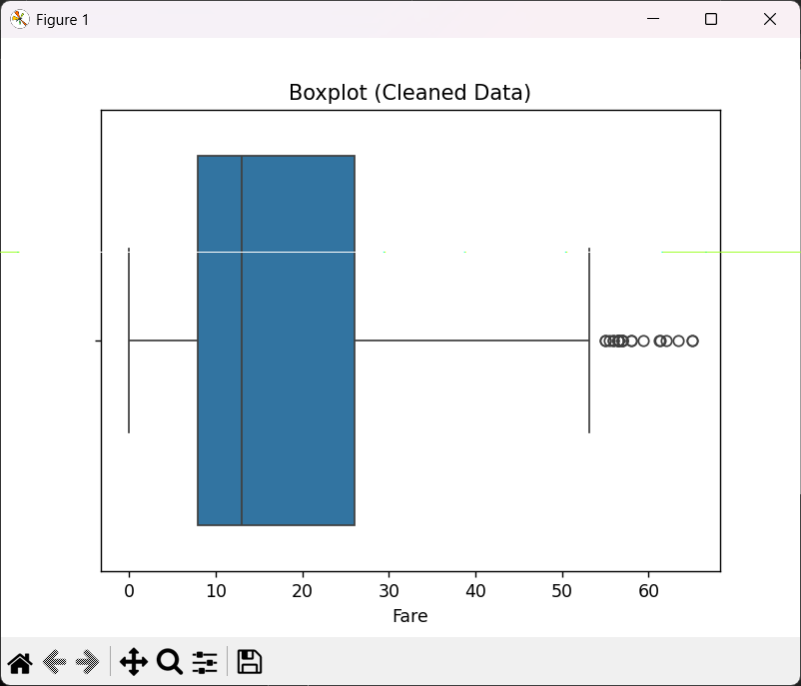
Outlier Detection

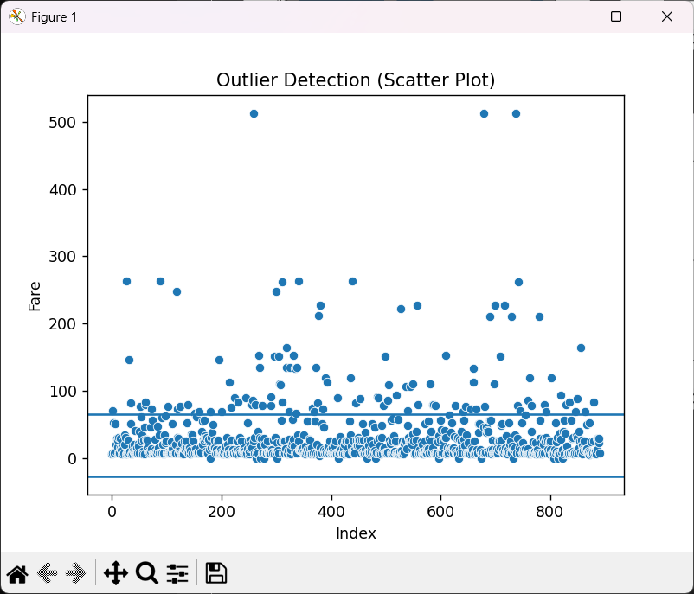

Discussion
- Columns should be chosen carefully that has some values N/A.
- Perform feature scaling or normalization to standardize data for better comparison.
Teacher’s signature

