Assignment 10 Mar 23, 2026

Problem Statement
Python program to reverse the order of words in a string.

Algorithm
Step 1. The program is started.
Step 2. A string is accepted from the user and stored in a variable.
Step 3. The string is divided into individual words using the split operation.
Step 4. The order of the words is reversed.
Step 5. The reversed words are joined together into a single string.
Step 6. The reversed string is displayed.
Step 7. The program is terminated.

Code
def reverse_words(text):
# Split the string into words
words = text.split()

# Reverse the list of words
reversed_words = words[::-1]

# Join the reversed words
result = " ".join(reversed_words)

return result

def main():
# Input string
text = input("Enter a string: ")

# Reverse word order
reversed_text = reverse_words(text)

# Display result
print("Reversed string:", reversed_text)

if __name__ == "__main__":
main()

Output
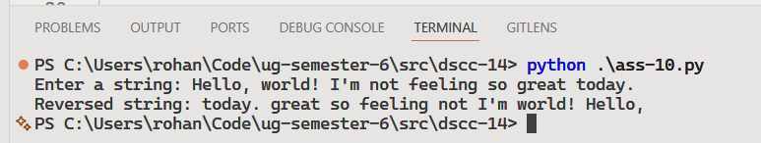

Discussion
- The program can be improved to preserve multiple spaces and special formatting.
- Additional validation can be added to handle empty input strings.

Teacher’s signature

