Assignment 11 Mar 23, 2026

Problem Statement
Python program to count the no. of occurrences of an element in an array.

Algorithm
Step 1. The program is started.
Step 2. Array elements are accepted from the user and stored in an array.
Step 3. The element to be counted is accepted from the user.
Step 4. A variable named count is initialized with value 0.
Step 5. Each element of the array is checked using a loop from the first element to the last element.
Step 6. If the current array element is equal to the required element, then the value of count is increased by 1.
[End of condition defined at Step 6.]
Step 7. The loop is repeated until all array elements are checked.
[End of loop defined at Step 5.]
Step 8. The total number of occurrences is displayed.
Step 9. The program is terminated.

Code
def count_occurrences(arr, element):
count = 0

# Count matching elements
for item in arr:
if item == element:
count += 1

return count

def main():
# Input array elements
arr = list(map(int, input("Enter elements sep. by space: ").split()))

# Input element to search
element = int(input("Enter element to count: "))

# Count occurrences
result = count_occurrences(arr, element)

# Display result
print("Number of occurrences:", result)

if __name__ == "__main__":
main()

Output
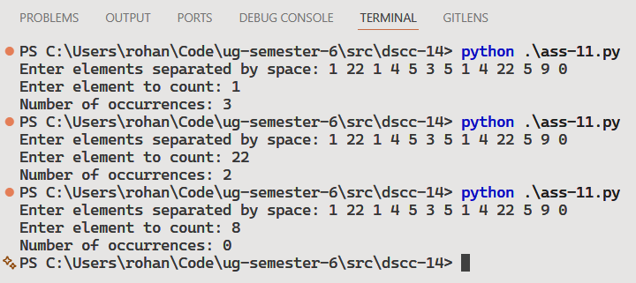

Discussion
- The program can be modified to work with strings and characters instead of only integers.
- The counting process can also be performed using built-in Python functions for shorter code.
Teacher’s signature

