Assignment 12 Mar 23, 2026

Problem Statement
Python program to find number which are divisible by 7 and ends with 6.

Algorithm
Step 1. The program is started.
Step 2. The starting number and ending number of the range are accepted from the user.
Step 3. A loop is started from the starting number to the ending number.
Step 4. Each number is checked to determine whether it is divisible by 7.
Step 5. It is checked whether the number ends with 6.
Step 6. If both conditions are satisfied, then the number is displayed.
[End of condition defined at Step 6.]
Step 7. The loop is repeated until all numbers in the range are checked.
[End of loop defined at Step 3.]
Step 8. The program is terminated.

Code
def find_numbers(start, end):
result = []

# Check numbers in the given range
for num in range(start, end + 1):
if num % 7 == 0 and num % 10 == 6:
result.append(num)

return result

def main():
# Input range
start = int(input("Enter starting number: "))
end = int(input("Enter ending number: "))

# Find required numbers
numbers = find_numbers(start, end)

# Display result
print("Numbers divisible by 7 and ending with 6:")

for num in numbers:
print(num, end=" ")

if __name__ == "__main__":
main()

Output
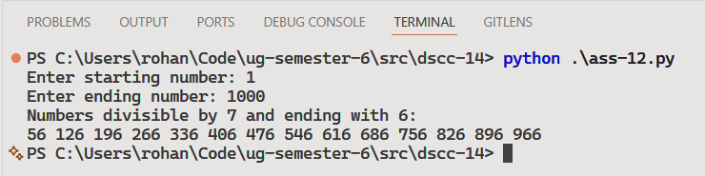

Discussion
- The program can be modified to count the total number of matching values.
- Additional validation can be added to handle invalid ranges entered by the user.
Teacher’s signature

