Assignment 13 Apr 02, 2026

Problem Statement
Python program to compute mean, median, mode, standard deviation, and variance.

Algorithm
Step 1. The program is started.
Step 2. A list of numbers is accepted from the user and stored.
Step 3. The mean of the numbers is calculated by finding the average of all elements.
Step 4. The median of the numbers is calculated by arranging the values in order and finding the middle value.
Step 5. The mode of the numbers is calculated by finding the value that occurs most frequently.
Step 6. The variance is calculated using the statistical formula for variance.
Step 7. The standard deviation is calculated by finding the square root of the variance.
Step 8. All calculated values are displayed.
Step 9. The program is terminated.

Code
import statistics

def calculate_statistics(numbers):
# Calculate statistical values
mean_value = statistics.mean(numbers)
median_value = statistics.median(numbers)
mode_value = statistics.mode(numbers)
variance_value = statistics.variance(numbers)
std = statistics.stdev(numbers)

return mean_value, median_value, mode_value, variance_value, std

def main():
# Input list elements
numbers = list(map(float, input(
"Enter numbers separated by space: ").split()))

# Calculate statistics
mean_value, median_value, mode_value, variance_value, std = (
calculate_statistics(numbers)
)

# Display results
print("Mean:", mean_value)
print("Median:", median_value)
print("Mode:", mode_value)
print("Variance:", variance_value)
print("Standard Deviation:", std)

if __name__ == "__main__":
main()

Output
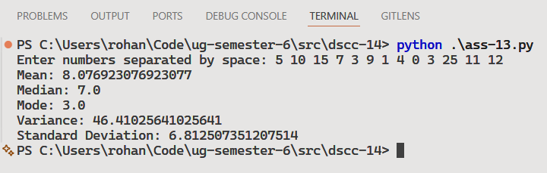


Discussion
- The program can be improved to handle multiple modes in a dataset.
- Graphical representation of the statistical values can also be added.
Teacher’s signature

