Assignment 14 Apr 02, 2026

Problem Statement
Python program to compute the roots of the quadratic equation:
$$ax^{2}+bx+c=0$$

Algorithm
Step 1. The program is started.
Step 2. The values of coefficients a, b, and c are accepted from the user.
Step 3. It is checked whether the value of a is equal to 0.
Step 4. If a is equal to 0, then a message is displayed indicating that the equation is not quadratic.
[End of condition defined at Step 4.]
Step 5. If a is not equal to 0, then the discriminant is calculated using the formula:
$$D=b^{2}-4ac$$
Step 6. It is checked whether the discriminant is greater than 0.
Step 7. If the discriminant is greater than 0, then two real and different roots are calculated and displayed.
[End of condition defined at Step 7.]
Step 8. Otherwise, it is checked whether the discriminant is equal to 0.
Step 9. If the discriminant is equal to 0, then one real and repeated root is calculated and displayed.
[End of condition defined at Step 9.]
Step 10. Otherwise, two complex roots are calculated and displayed.
[End of condition defined at Step 10.]
Step 11. The program is terminated.

Code
import math

def find_roots(a, b, c):
# Calculate discriminant
discriminant = (b ** 2) - (4 * a * c)

# Find roots based on discriminant
if discriminant > 0:
root1 = (-b + math.sqrt(discriminant)) / (2 * a)
root2 = (-b - math.sqrt(discriminant)) / (2 * a)

print("Roots are real and different.")
print("Root 1 =", root1)
print("Root 2 =", root2)

elif discriminant == 0:
root = -b / (2 * a)

print("Roots are real and equal.")
print("Root =", root)

else:
real_part = -b / (2 * a)
imaginary_part = math.sqrt(-discriminant) / (2 * a)

print("Roots are complex.")
print("Root 1 =", real_part, "+", imaginary_part, "i")
print("Root 2 =", real_part, "-", imaginary_part, "i")

def main():
# Input coefficients
a = float(input("Enter value of a: "))
b = float(input("Enter value of b: "))
c = float(input("Enter value of c: "))

# Check valid quadratic equation
if a == 0:
print("Coefficient 'a' cannot be zero.")
else:
find_roots(a, b, c)

if __name__ == "__main__":
main()

Output
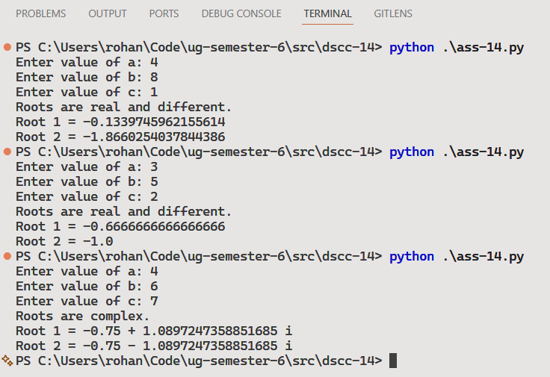

Discussion
- The program can be extended to display roots in simplified mathematical form.
- Error handling can be added for invalid user input values.
Teacher’s signature

