Assignment 15 Apr 05, 2026

Problem Statement
Python program to print Pascal’s triangle using class.

Algorithm
Step 1. The program is started.
Step 2. A class for displaying Pascal’s triangle is created.
Step 3. The number of rows is accepted from the user.
Step 4. An object of the class is created.
Step 5. A method is called to display Pascal’s triangle.
Step 6. An outer loop is started from row 0 to the required number of rows minus 1.
Step 7. The first value of each row is initialized as 1.
Step 8. Spaces are displayed using a loop for proper triangle formatting.
[End of loop defined at Step 8.]
Step 9. An inner loop is started from column 0 to the current row number.
Step 10. The current value is displayed.
Step 11. The next value is calculated using the Pascal’s triangle formula.
$$\text{Next Value}=\frac{\text{Current Value}×(i-j)}{j+1}$$
Step 12. The inner loop is repeated until all values of the current row are displayed.
[End of loop defined at Step 9.]
Step 13. The outer loop is repeated until all rows are displayed.
[End of loop defined at Step 6.]
Step 14. The program is terminated.

Code
class PascalTriangle:

# Display Pascal's triangle
def display_triangle(self, rows):
for i in range(rows):
number = 1

for j in range(rows - i - 1):
print(" ", end="")

for j in range(i + 1):
print(number, end=" ")

# Calculate next value
number = number * (i - j) // (j + 1)

print()

def main():
# Input number of rows
rows = int(input("Enter number of rows: "))

# Create object
triangle = PascalTriangle()

# Display triangle
triangle.display_triangle(rows)

if __name__ == "__main__":
main()

Output

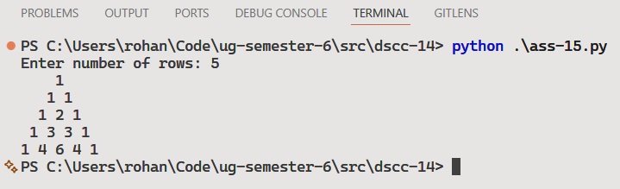

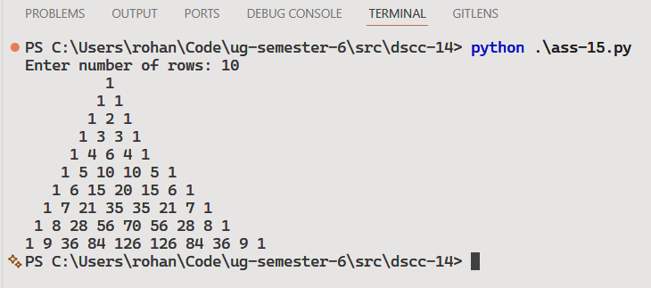

Discussion
- The program can be modified to store Pascal’s triangle values in a list for further operations.
- Additional formatting can be added to improve triangle alignment for larger rows.

Teacher’s signature

