Assignment 16 Apr 17, 2026

Problem Statement
From the following string extract the date and time and substitute the phone number with a different one (Indian code will remain the same).

Algorithm
Step 1. The program is started.
Step 2. A string containing date, time, and phone number is accepted from the user.
Step 3. A new phone number is accepted from the user.
Step 4. The date is searched and extracted from the string using a pattern.
Step 5. The time is searched and extracted from the string using a pattern.
Step 6. The phone number present in the string is searched.
Step 7. The existing phone number is replaced with the new phone number while keeping the Indian country code unchanged.
Step 8. It is checked whether the date is found.
Step 9. If the date is found, then the extracted date is displayed.
[End of condition defined at Step 9.]
Step 10. It is checked whether the time is found.
Step 11. If the time is found, then the extracted time is displayed.
[End of condition defined at Step 11.]
Step 12. The updated string is displayed.
Step 13. The program is terminated.

Code
import re

def process_string(text, new_number):
# Extract date
date = re.search(r"\d{2}/\d{2}/\d{4}", text)

# Extract time
time = re.search(r"\d{2}:\d{2}:\d{2}", text)

# Replace phone number
updated_text = re.sub(r"\+91-\d{10}", "+91-" + new_number, text)

# Display results
if date:
print("Date:", date.group())

if time:
print("Time:", time.group())

print("Updated String:")
print(updated_text)

def main():
# Input string
text = input("Enter the string: ")

# Input new phone number
new_number = input("Enter new 10-digit phone number: ")

# Process string
process_string(text, new_number)

if __name__ == "__main__":
main()

Output
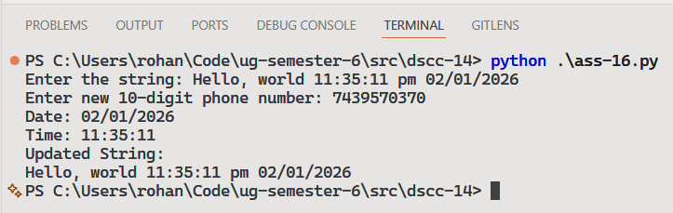

Discussion
- The program can be improved to validate the phone number before replacement.
- Different date and time formats can also be supported using modified patterns.
Teacher’s signature

