Assignment 17 Apr 18, 2026

Problem Statement
Write a program in Python to check whether a given number is Krishnamurthy or not.

Algorithm
Step 1. The program is started.
Step 2. A number is accepted from the user.
Step 3. The original number is stored in a temporary variable.
Step 4. A variable named total is initialized with value 0.
Step 5. A loop is started and repeated while the temporary number is greater than 0.
Step 6. The last digit of the number is extracted.
Step 7. The factorial of the extracted digit is calculated.
Step 8. The factorial value is added to total.
Step 9. The last digit is removed from the temporary number.
Step 10. The loop is repeated until all digits are processed.
[End of loop defined at Step 5.]
Step 11. It is checked whether the value of total is equal to the original number.
Step 12. If both values are equal, then the number is displayed as a Krishnamurthy number.
[End of condition defined at Step 12.]
Step 13. Otherwise, the number is displayed as not a Krishnamurthy number.
[End of condition defined at Step 13.]
Step 14. The program is terminated.

Code
import math

def is_krishnamurthy(number):
temp = number
total = 0

# Calculate sum of factorials of digits
while temp > 0:
digit = temp % 10
total += math.factorial(digit)
temp //= 10

return total == number

def main():
# Input number
number = int(input("Enter a number: "))

# Check Krishnamurthy number
if is_krishnamurthy(number):
print(number, "is a Krishnamurthy number.")
else:
print(number, "is not a Krishnamurthy number.")

if __name__ == "__main__":
main()

Output
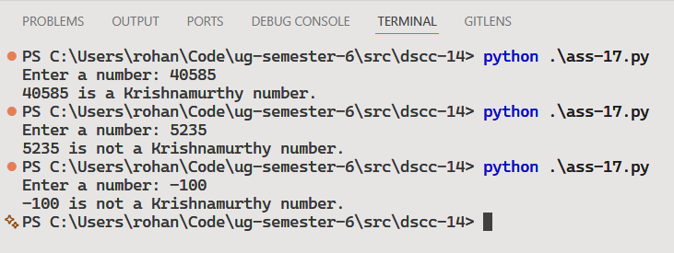

Discussion
- The program can be modified to display all Krishnamurthy numbers within a given range.
- Input validation can be added to prevent negative number entries.
Teacher’s signature

