Assignment 18 Apr 18, 2026

Problem Statement
Write a Python program to perform division of two numbers and handle the ZeroDivisionError exception using try-except.

Algorithm
Step 1. The program is started.
Step 2. Two numbers are accepted from the user.
Step 3. A try block is started.
Step 4. Division of the first number by the second number is performed.
Step 5. The result is displayed if no error occurs.
Step 6. If the denominator is equal to 0, then a ZeroDivisionError is generated and handled using the except block.
[End of condition defined at Step 6.]
Step 7. An error message is displayed.
Step 8. The program is terminated.

Code
def main():
try:
# Input numbers
a = int(input("Enter numerator: "))
b = int(input("Enter denominator: "))

# Division operation
result = a / b

print("Result =", result)

except ZeroDivisionError:
print("Error: Division by zero is not allowed.")

if __name__ == "__main__":
main()

Output

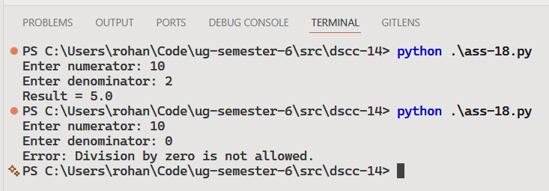

Discussion
Additional exception types can be handled using multiple except blocks. A finally block can also be used for cleanup operations like file closing.
Teacher’s signature

