Assignment 19 Apr 18, 2026

Problem Statement
Write a Python program to accept an integer input from the user and handle the ValueError exception using try-except.

Algorithm
Step 1. The program is started.
Step 2. A try block is started.
Step 3. An integer value is accepted from the user.
Step 4. The entered value is converted into integer format.
Step 5. The value is displayed if valid input is entered.
Step 6. If invalid input is entered, then a ValueError is generated and handled using the except block.
[End of condition defined at Step 6.]
Step 7. An error message is displayed.
Step 8. The program is terminated.

Code
def main():
try:
# Input integer
number = int(input("Enter an integer: "))

print("You entered:", number)

except ValueError:
print("Error: Invalid integer input.")

if __name__ == "__main__":
main()

Output
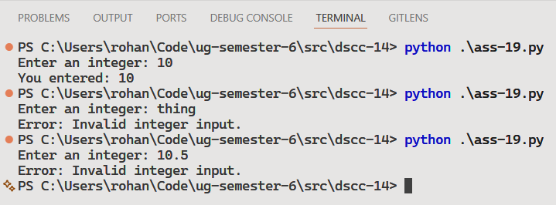

Discussion
Additional exception types can be handled using multiple except blocks. A finally block can also be used for cleanup operations like file closing.
Teacher’s signature

