Assignment 20 Apr 18, 2026

Problem Statement
Write a Python program to access an element from a list using an index entered by the user and handle the IndexError exception using try-except.

Algorithm
Step 1. The program is started.
Step 2. A list of elements is created.
Step 3. A try block is started.
Step 4. An index value is accepted from the user.
Step 5. The element corresponding to the entered index is accessed.
Step 6. The element is displayed if the index is valid.
Step 7. If the entered index is outside the list range, then an IndexError is generated and handled using the except block.
[End of condition defined at Step 7.]
Step 8. An error message is displayed.
Step 9. The program is terminated.

Code
def main():
try:
# Create list
numbers = [10, 20, 30, 40]

# Input index
index = int(input("Enter index value: "))

print("Element =", numbers[index])

except IndexError:
print("Error: Index out of range.")

if __name__ == "__main__":
main()

Output
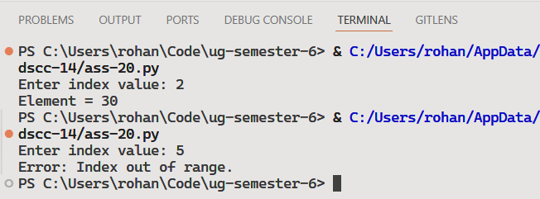

Discussion
Additional exception types can be handled using multiple except blocks. A finally block can also be used for cleanup operations like file closing.
Teacher’s signature

