Assignment 21 Apr 18, 2026

Problem Statement
Write a Python program to open and read a file and handle the FileNotFoundError exception using try-except.

Algorithm
Step 1. The program is started.
Step 2. A try block is started.
Step 3. A file is opened in read mode.
Step 4. The contents of the file are read.
Step 5. The file contents are displayed.
Step 6. The file is closed.
Step 7. If the file does not exist, then a FileNotFoundErroris handled using the except block.
[End of condition defined at Step 7.]
Step 8. An error message is displayed.
Step 9. The program is terminated.

Code
def main():
try:
# Open file
file = open("sample.txt", "r")

content = file.read()

print(content)

file.close()

except FileNotFoundError:
print("Error: File does not exist.")

if __name__ == "__main__":
main()

Output
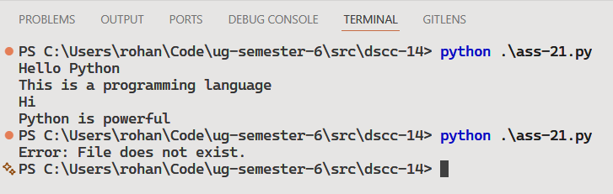

Discussion
Additional exception types can be handled using multiple except blocks. A finally block can also be used for cleanup operations like file closing.
Teacher’s signature

