Assignment 22 Apr 18, 2026

Problem Statement
Write a python program that takes a list of words from command line argument and return the smallest and longest words and lengths of each of them.

Algorithm
Step 1. The program is started.
Step 2. The list of words is accepted through command line arguments.
Step 3. It is checked whether any words are provided.
Step 4. If no words are provided, then a message is displayed and the program is terminated.
[End of condition defined at Step 4.]
Step 5. The first word is assumed as both the smallest word and the longest word.
Step 6. A loop is started from the first word to the last word in the list.
Step 7. The length of the current word is compared with the length of the smallest word.
Step 8. If the current word length is smaller, then the smallest word is updated.
[End of condition defined at Step 8.]
Step 9. The length of the current word is compared with the length of the longest word.
Step 10. If the current word length is greater, then the longest word is updated.
[End of condition defined at Step 10.]
Step 11. The loop is repeated until all words are checked.
[End of loop defined at Step 6.]
Step 12. The smallest word and its length are displayed.
Step 13. The longest word and its length are displayed.
Step 14. The program is terminated.

Code
import sys

def find_words(words):
# Find smallest and longest words
smallest_word = min(words, key=len)
longest_word = max(words, key=len)

return smallest_word, longest_word

def main():
# Get command line arguments
words = sys.argv[1:]

# Check if words are provided
if len(words) == 0:
print("Please provide words as command line arguments.")
return

# Find required words
smallest_word, longest_word = find_words(words)

# Display results
print("Smallest word:", smallest_word)
print("Length:", len(smallest_word))

print("Longest word:", longest_word)
print("Length:", len(longest_word))

if __name__ == "__main__":
main()

Output
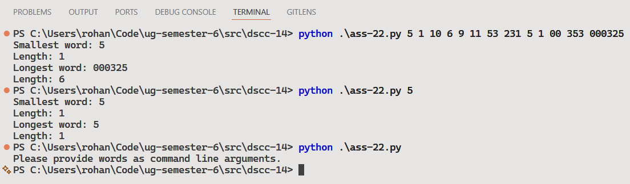

Discussion
- The program can be modified to display multiple smallest or longest words if lengths are equal.
- Additional validation can be added to ignore special characters and numbers.
Teacher’s signature

