Assignment 23 Apr 21, 2026

Problem Statement
Write a program in python that accepts a hyphen-separated sequence of words as input and prints the words in a hyphen- separated sequence after sorting them alphabetically.
Sample Items: green-red-yellow-black-white
Expected Result: black-green-red-white-yellow

Algorithm
Step 1. The program is started.
Step 2. A hyphen-separated sequence of words is accepted from the user.
Step 3. The input string is divided into individual words using the hyphen (-) separator.
Step 4. The words are stored in a list.
Step 5. The list of words is sorted in alphabetical order.
Step 6. The sorted words are joined together using hyphens.
Step 7. The sorted hyphen-separated sequence is displayed.
Step 8. The program is terminated.

Code
def sort_words(text):
# Split words using hyphen
words = text.split("-")

# Sort words alphabetically
words.sort()

# Join sorted words
result = "-".join(words)

return result

def main():
# Input hyphen-separated words
text = input("Enter hyphen-separated words: ")

# Sort words
sorted_text = sort_words(text)

# Display result
print("Sorted sequence:", sorted_text)

if __name__ == "__main__":
main()

Output
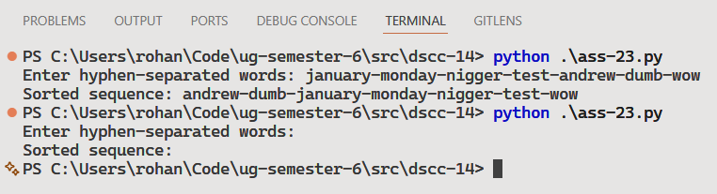

Discussion
- The program can be modified to sort words in descending alphabetical order.
- Duplicate words can also be removed before sorting if required.
Teacher’s signature

