Assignment 24 Apr 21, 2026

Problem Statement
Write a Python program to print Pythagorean triplets within a specified range.
- What is a Pythagorean triplet?
A set of Pythagorean triplet is defined as:
$$a^{2}+b^{2}=c^{2}$$
Where a, b, and c are integers in this context.

Algorithm
Step 1. The program is started.
Step 2. The range limit is accepted from the user.
Step 3. A loop is started for variable a from 1 to the given limit.
Step 4. A second loop is started for variable b from the value of a to the given limit.
Step 5. A third loop is started for variable c from the value of b to the given limit.
Step 6. The Pythagorean condition is checked.
$$a^{2}+b^{2}=c^{2}$$
Step 7. If the condition is satisfied, then the values of a, b, and c are displayed as a Pythagorean triplet.
[End of condition defined at Step 7.]
Step 8. The third loop is repeated until all values of c are checked.
[End of loop defined at Step 5.]
Step 9. The second loop is repeated until all values of b are checked.
[End of loop defined at Step 4.]
Step 10. The first loop is repeated until all values of a are checked.
[End of loop defined at Step 3.]
Step 11. The program is terminated.

Code
def print_triplets(limit):
# Find Pythagorean triplets
for a in range(1, limit + 1):
for b in range(a, limit + 1):
for c in range(b, limit + 1):
# Check Pythagorean condition
if (a ** 2) + (b ** 2) == (c ** 2):
print(a, b, c)

def main():
# Input range limit
limit = int(input("Enter the range limit: "))

# Display triplets
print("Pythagorean Triplets:")

print_triplets(limit)

if __name__ == "__main__":
main()

Output
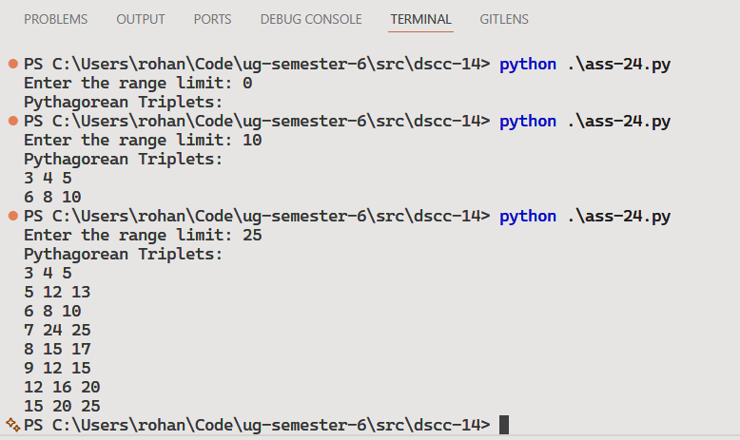

Discussion
- The program can be optimized by reducing unnecessary loop iterations.
- Primitive and non-primitive triplets can also be displayed separately.
Teacher’s signature

