Assignment 25 Apr 23, 2026

Problem Statement
Write a Python program to find the line with maximum length from a file.

Algorithm
Step 1. The program is started.
Step 2. The file name is accepted from the user and stored in variable filename.
Step 3. A try block is started.
Step 4. The file is opened in read mode using variable file.
Step 5. All lines from the file are read and stored in variable lines.
Step 6. The file is closed.
Step 7. It is checked whether the length of lines is equal to 0.
Step 8. If the file is empty, then a message is displayed and the program is terminated.
[End of condition defined at Step 8.]
Step 9. A variable named max_length is initialized with value 0.
Step 10. An empty list named largest_lines is created to store the longest lines.
Step 11. A loop is started for each line in lines.
Step 12. The length of the current line is calculated and stored in variable length.
Step 13. It is checked whether length is greater than max_length.
Step 14. If the condition is true, then the value of max_length is updated with length and largest_lines is updated with the current line.
[End of condition defined at Step 14.]
Step 15. Otherwise, it is checked whether length is equal to max_length.
Step 16. If the condition is true, then the current line is added into largest_lines.
[End of condition defined at Step 16.]
Step 17. The loop is repeated until all lines in lines are checked.
[End of loop defined at Step 11.]
Step 18. The contents of largest_lines are displayed.
Step 19. The value of max_length is displayed.
Step 20. If the file does not exist, then a FileNotFoundError is handled and an error message is displayed.
[End of condition defined at Step 20.]

Step 21. If permission to access the file is denied, then a PermissionError is handled and an error message is displayed.
[End of condition defined at Step 21.]
Step 22. Any other unexpected error is handled using a general exception block.
[End of condition defined at Step 22.]
Step 23. The program is terminated.

Code
def find_largest_lines(filename):
try:
# Open file
file = open(filename, "r")

lines = file.readlines()

file.close()

# Check empty file
if len(lines) == 0:
print("File is empty.")
return

max_length = 0
largest_lines = []

# Find maximum line length
for line in lines:
length = len(line.strip())

if length > max_length:
max_length = length
largest_lines = [line.strip()]

elif length == max_length:
largest_lines.append(line.strip())

# Display result
print("Line(s) with largest length:")

for line in largest_lines:
print(line)

print("Largest Length:", max_length)

except FileNotFoundError:
print("Error: File does not exist.")

except PermissionError:
print("Error: Permission denied.")

except Exception as error:
print("Error:", error)

def main():
# Input file name
filename = input("Enter file name: ")

# Find largest lines
find_largest_lines(filename)

if __name__ == "__main__":
main()

Output
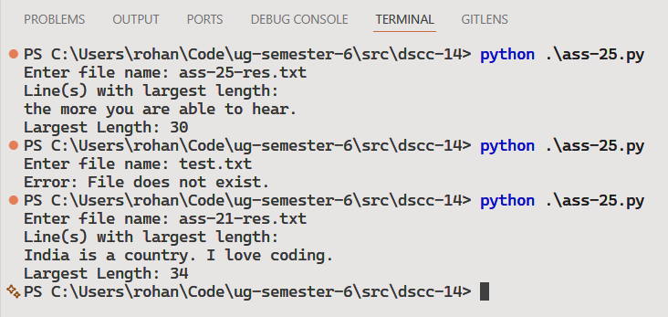

Discussion
- The program can be modified to display line numbers along with the longest lines.
- Additional processing can be added to ignore spaces while calculating line length.
Teacher’s signature

