Assignment 26 Apr 23, 2026

Problem Statement
Write a Python program to read a text file and perform the following operations:
- Check whether the character 'I' exists in the file.
- If 'I' is absent, then accept another character from the user.
- Remove every occurrence of the character 'I' from the file content and display the updated content.

Algorithm
Step 1. The program is started.
Step 2. The file name is accepted from the user.
Step 3. The file is opened in read mode.
Step 4. The contents of the file are read and stored.
Step 5. It is checked whether the character 'I' exists in the file content.
Step 6. If the character 'I' exists, then a message is displayed indicating its presence.
[End of condition defined at Step 6.]
Step 7. All occurrences of the character 'I' are removed from the file content.
Step 8. The updated content is displayed.
Step 9. Otherwise, if the character 'I' is absent, then a message is displayed.
[End of condition defined at Step 9.]
Step 10. Another character is accepted from the user.
Step 11. The entered character is displayed.
Step 12. If the file does not exist, then a FileNotFoundError is handled and an error message is displayed.
[End of condition defined at Step 12.]
Step 13. The program is terminated.

Code
def process_file(filename):
try:
# Open and read file
file = open(filename, "r")
content = file.read()
file.close()

# Check if 'I' exists
if 'I' in content:
print("'I' exists in the file.")

# Remove all occurrences of 'I'
updated_content = content.replace('I', '')

print("Updated content:")
print(updated_content)

else:
print("'I' is absent in the file.")

# Input another character
char = input("Enter another character: ")

print("Entered character:", char)

except FileNotFoundError:
print("File not found.")

def main():
# Input file name
filename = input("Enter file name: ")

# Process file
process_file(filename)

if __name__ == "__main__":
main()

Output
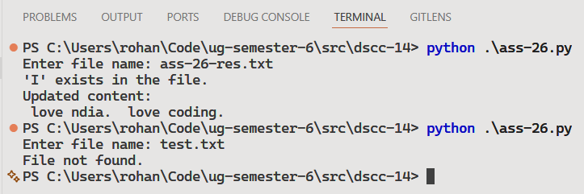

Discussion
- The program can be modified to write the updated content back into the file.
- Additional validation can be added for empty files and invalid file names.
Teacher’s signature

