Assignment 27 Apr 28, 2026

Problem Statement
Write a program in Python to copy the content of a file into another. File name must be taken as command lines argument and also provide all necessary constraints and error checking.

Algorithm
Step 1. The program is started.
Step 2. The number of command line arguments is checked.
Step 3. If the required file names are not provided, then a usage message is displayed and the program is terminated.
[End of condition defined at Step 3.]
Step 4. The source file name and destination file name are accepted from the command line arguments.
Step 5. It is checked whether both file names are the same.
Step 6. If both file names are the same, then an error message is displayed and the program is terminated.
[End of condition defined at Step 6.]
Step 7. A try block is started.
Step 8. The source file is opened in read mode.
Step 9. The contents of the source file are read and stored.
Step 10. The source file is closed.
Step 11. The destination file is opened in write mode.
Step 12. The stored content is written into the destination file.
Step 13. The destination file is closed.
Step 14. A success message is displayed.
Step 15. If the source file does not exist, then a FileNotFoundError is handled and an error message is displayed.
[End of condition defined at Step 15.]
Step 16. If permission to access the file is denied, then a PermissionError is handled and an error message is displayed.
[End of condition defined at Step 16.]
Step 17. Any other unexpected error is handled using a general exception block.
[End of condition defined at Step 17.]
Step 18. The program is terminated.

Code
def process_file(filename):
try:
# Open and read file
file = open(filename, "r")
content = file.read()
file.close()

# Check if 'I' exists
if 'I' in content:
print("'I' exists in the file.")

# Remove all occurrences of 'I'
updated_content = content.replace('I', '')

print("Updated content:")
print(updated_content)

else:
print("'I' is absent in the file.")

# Input another character
char = input("Enter another character: ")

print("Entered character:", char)

except FileNotFoundError:
print("File not found.")

def main():
# Input file name
filename = input("Enter file name: ")

# Process file
process_file(filename)

if __name__ == "__main__":
main()

Output
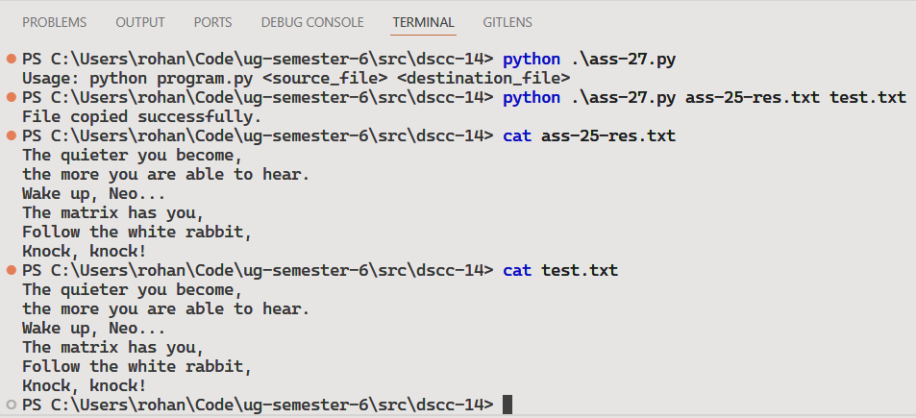

Discussion
- The program can be optimized by reducing unnecessary loop iterations.
- Primitive and non-primitive triplets can also be displayed separately.
Teacher’s signature

