Assignment 28 Apr 28, 2026

Problem Statement
Write a program in Python to convert the file content from lowercase to uppercase and vice versa using switch case option and all error checking using try exception.

Algorithm
Step 1. The program is started.
Step 2. The file name is accepted from the user.
Step 3. A menu containing conversion options is displayed.
Step 4. The user choice is accepted.
Step 5. A try block is started.
Step 6. The file is opened in read mode.
Step 7. The contents of the file are read and stored.
Step 8. The file is closed.
Step 9. A switch case operation is performed based on the user choice.
Step 10. If the choice is 1, then the file content is converted into uppercase letters and displayed.
[End of condition defined at Step 10.]
Step 11. If the choice is 2, then the file content is converted into lowercase letters and displayed.
[End of condition defined at Step 11.]
Step 12. If the entered choice does not match any valid option, then an invalid choice message is displayed.
[End of condition defined at Step 12.]
Step 13. If the file does not exist, then a FileNotFoundError is handled and an error message is displayed.
[End of condition defined at Step 13.]
Step 14. If permission to access the file is denied, then a PermissionError is handled and an error message is displayed.
[End of condition defined at Step 14.]
Step 15. Any other unexpected error is handled using a general exception block.
[End of condition defined at Step 15.]
Step 16. The program is terminated.

Code
def convert_content(filename, choice):
try:
# Open file in read mode
file = open(filename, "r")

content = file.read()

file.close()

# Switch case operation
match choice:

case 1:
# Convert lowercase to uppercase
converted_content = content.upper()
print("Uppercase Content:")
print(converted_content)

case 2:
# Convert uppercase to lowercase
converted_content = content.lower()
print("Lowercase Content:")
print(converted_content)

case _:
print("Invalid choice.")

except FileNotFoundError:
print("Error: File does not exist.")

except PermissionError:
print("Error: Permission denied.")

except Exception as error:
print("Error:", error)

def main():
# Input file name
filename = input("Enter file name: ")

# Display menu
print("1. Convert to Uppercase")
print("2. Convert to Lowercase")

# Input choice
choice = int(input("Enter your choice: "))

# Convert file content
convert_content(filename, choice)

if __name__ == "__main__":
main()

Output
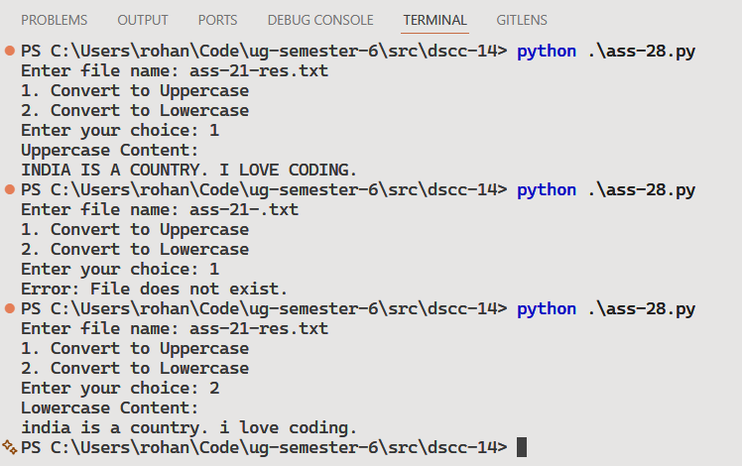

Discussion
- The program can be modified to save the converted content into another file.
- Additional options such as title case conversion can also be added.
Teacher’s signature

