Assignment 9 May 05, 2026

Problem Description
Build a simple recommendation system using a real dataset by applying dot product, Euclidean norm, and cosine similarity to analyze user similarity.
- You can use widely used dataset from GroupLens Research: https:// grouplens.org/datasets/movielens/
- It contains - User IDs, Movie IDs and Ratings (1–5). Use: ml-latest-small.
- Load dataset (ratings.csv).
- Select any 2 users. Compute dot product of their rating vectors.
- Compute Norm of each user vector, Distance between two users.
- Compute Cosine Similarity, find most similar users using cosine similarity, and Recommend movies they liked.
- Explain how you build Recommendation system in discussion section.

Solution
Step 1. The program is started.
Step 2. Required libraries such as pandas, numpy, and sklearn are imported.
Step 3. The dataset file ratings.csv is loaded and stored in variable ratings.
Step 4. A user-movie rating matrix is created using the pivot_table() function and stored in variable user_movie_matrix.
Step 5. Missing values in user_movie_matrix are replaced with 0.
Step 6. Two users are selected and their IDs are stored in variables user1 and user2.
Step 7. The rating vector of user1 is extracted from user_movie_matrix and stored in variable vector1.
Step 8. The rating vector of user2 is extracted from user_movie_matrix and stored in variable vector2.
Step 9. The dot product of vector1 and vector2 is calculated and stored in variable dot_product.
Step 10. The Euclidean norm of vector1 is calculated and stored in variable norm1.
Step 11. The Euclidean norm of vector2 is calculated and stored in variable norm2.
Step 12. The Euclidean distance between vector1 and vector2 is calculated and stored in variable distance.
Step 13. Cosine similarity between vector1 and vector2 is calculated using the formula:
$$\text{Cosine Similarity}=\frac{\text{Dot Product}}{\text{Norm1}×\text{Norm2}}$$
Step 14. The values of dot_product, norm1, norm2, distance, and cosine similarity are displayed.
Step 15. Cosine similarity for all users in user_movie_matrix is calculated using the cosine_similarity() function.
Step 16. The similarity values are stored in variable similarity_matrix.
Step 17. The similarity matrix is converted into a DataFrame and stored in variable similarity_df.
Step 18. Similarity scores of user1 with all other users are extracted from similarity_df.
Step 19. The similarity scores are sorted in descending order to identify the most similar users.
Step 20. The sorted similar users are stored in variable similar_users.
Step 21. The most similar user is selected and stored in variable most_similar_user.
Step 22. Movies rated highly by user1 are identified and stored in variable user1_movies.
Step 23. Movies rated highly by most_similar_user are identified and stored in variable similar_user_movies.
Step 24. Movies already watched by user1 are removed from similar_user_movies.
Step 25. Remaining movies are stored in variable recommended_movies.
Step 26. Recommended movies are displayed.
Step 27. The program is terminated.

Code
import numpy as np
import pandas as pd
from sklearn.metrics.pairwise import cosine_similarity

# Load datasets
ratings = pd.read_csv("ratings.csv")
movies = pd.read_csv("movies.csv")

# Create user-movie rating matrix
user_movie_matrix = ratings.pivot_table(
index="userId",
columns="movieId",
values="rating"
).fillna(0)

# Select any two users
user1 = 1
user2 = 2

# Get rating vectors
vector1 = user_movie_matrix.loc[user1].values
vector2 = user_movie_matrix.loc[user2].values

# Compute dot product
dot_product = np.dot(vector1, vector2)

# Compute Euclidean norms
norm1 = np.linalg.norm(vector1)
norm2 = np.linalg.norm(vector2)

# Compute Euclidean distance
distance = np.linalg.norm(vector1 - vector2)

# Compute cosine similarity
cosine_sim = dot_product / (norm1 * norm2)

# Display results
print("User 1 Vector:\n", vector1)
print("User 2 Vector:\n", vector2)

print("\nDot Product:", dot_product)
print("Norm of User 1:", norm1)
print("Norm of User 2:", norm2)
print("Euclidean Distance:", distance)
print("Cosine Similarity:", cosine_sim)

# Find similarity among all users
similarity_matrix = cosine_similarity(user_movie_matrix)

# Convert similarity matrix to DataFrame
similarity_df = pd.DataFrame(
similarity_matrix,
index=user_movie_matrix.index,
columns=user_movie_matrix.index
)

# Find most similar users for user1
similar_users = similarity_df[user1].sort_values(ascending=False)

print("\nMost Similar Users to User", user1)
print(similar_users.head())

# Find movies liked by similar user
most_similar_user = similar_users.index[1]

user1_movies = set(
ratings[
(ratings["userId"] == user1) &
(ratings["rating"] >= 4)
]["movieId"]
)

similar_user_movies = set(
ratings[
(ratings["userId"] == most_similar_user) &
(ratings["rating"] >= 4)
]["movieId"]
)

# Recommend unseen movies
recommended_movies = similar_user_movies - user1_movies

# Convert movie IDs to movie names
recommended_movie_names = movies[
movies["movieId"].isin(recommended_movies)
]["title"]

print("Top 10 Recommended Movies for User", user1)

for movie in recommended_movie_names.head(10):
print(" -", movie)

Output
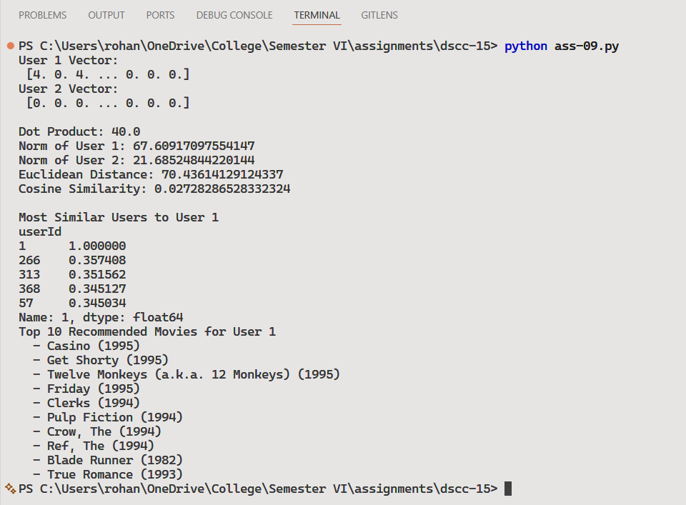

Discussion
- Missing ratings were replaced with 0 using the fillna(0) function.
- Two users were selected and their rating vectors were extracted.
- The dot product of both vectors was calculated using numpy.dot().
- Euclidean norm of each user vector was calculated using numpy.linalg.norm().
- Euclidean distance between users was calculated to measure how far apart the users are in terms of ratings.
Teacher’s signature

