Assignment 10 May 12, 2026

Problem Description
Write a menu driven program that inputs 2 vectors u and v of dimension 3 and perform the following operations: Vector addition, Scalar multiplication, Dot product, Cross product, Orthogonality, Parallelism check.

Solution
Step 1. The program is started.
Step 2. Three elements of vector u are accepted from the user and stored in list u.
Step 3. Three elements of vector v are accepted from the user and stored in list v.
Step 4. A menu containing vector operations is displayed.
Step 5. The user choice is accepted and stored in variable choice.
Step 6. It is checked whether choice is equal to 1.
Step 7. If the condition is true, then vector addition is performed using:
$$u+v$$
Step 8. The addition result is displayed.
[End of condition defined at Step 8.]
Step 9. It is checked whether choice is equal to 2.
Step 10. If the condition is true, then a scalar value is accepted from the user and stored in variable scalar.
Step 11. Scalar multiplication is performed on vector u.
Step 12. The scalar multiplication result is displayed.
[End of condition defined at Step 12.]
Step 13. It is checked whether choice is equal to 3.
Step 14. If the condition is true, then the dot product of vectors u and v is calculated using:
$$u⋅v=u_{1}v_{1}+u_{2}v_{2}+u_{3}v_{3}$$
Step 15. The dot product result is displayed.
[End of condition defined at Step 15.]
Step 16. It is checked whether choice is equal to 4.
Step 17. If the condition is true, then the cross product of vectors u and v is calculated.
Step 18. The cross product result is displayed.
[End of condition defined at Step 18.]
Step 19. It is checked whether choice is equal to 5.
Step 20. If the dot product of vectors u and v is equal to 0, then the vectors are displayed as orthogonal.
[End of condition defined at Step 20.]
Step 21. Otherwise, the vectors are displayed as not orthogonal.
[End of condition defined at Step 21.]
Step 22. It is checked whether choice is equal to 6.
Step 23. If the cross product of vectors u and v is equal to [0, 0, 0], then the vectors are displayed as parallel.
[End of condition defined at Step 23.]
Step 24. Otherwise, the vectors are displayed as not parallel.
[End of condition defined at Step 24.]
Step 25. It is checked whether choice is equal to 7.
Step 26. If the condition is true, then the program is terminated.
[End of condition defined at Step 26.]
Step 27. Otherwise, an invalid choice message is displayed.
Step 28. The menu loop is repeated until the user selects the exit option.
[End of loop defined at Step 4.]

Code
def vector_addition(u, v):
return [u[i] + v[i] for i in range(3)]

def scalar_multiplication(vector, scalar):
return [scalar * value for value in vector]

def dot_product(u, v):
return sum(u[i] * v[i] for i in range(3))

def cross_product(u, v):
return [
u[1] * v[2] - u[2] * v[1],
u[2] * v[0] - u[0] * v[2],
u[0] * v[1] - u[1] * v[0]
]

def check_orthogonal(u, v):
return dot_product(u, v) == 0

def check_parallel(u, v):
cross = cross_product(u, v)
return cross == [0, 0, 0]

def main():
# Input vectors
u = list(map(int, input("Enter vector u (3 values): ").split()))
v = list(map(int, input("Enter vector v (3 values): ").split()))

while True:
# Display menu
print("\nMenu")
print("1. Vector Addition")
print("2. Scalar Multiplication")
print("3. Dot Product")
print("4. Cross Product")
print("5. Orthogonality Check")
print("6. Parallelism Check")
print("7. Exit")

choice = int(input("Enter your choice: "))

match choice:

case 1:
result = vector_addition(u, v)
print("Vector Addition:", result)

case 2:
scalar = int(input("Enter scalar value: "))
result = scalar_multiplication(u, scalar)
print("Scalar Multiplication:", result)

case 3:
result = dot_product(u, v)
print("Dot Product:", result)

case 4:
result = cross_product(u, v)
print("Cross Product:", result)

case 5:
if check_orthogonal(u, v):
print("Vectors are orthogonal.")
else:
print("Vectors are not orthogonal.")

case 6:
if check_parallel(u, v):
print("Vectors are parallel.")
else:
print("Vectors are not parallel.")

case 7:
print("Program terminated.")
break

case _:
print("Invalid choice.")

if __name__ == "__main__":
main()

Output
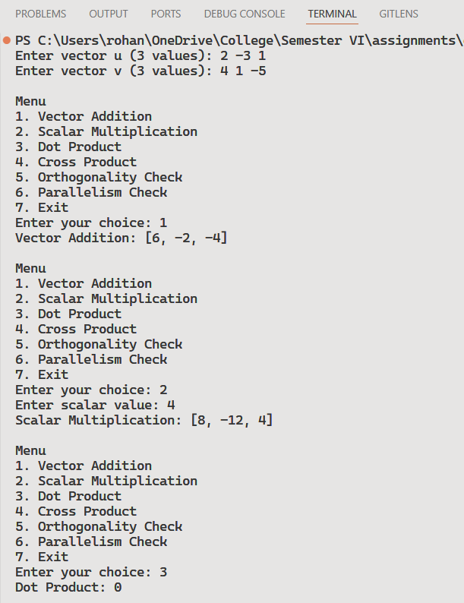 | 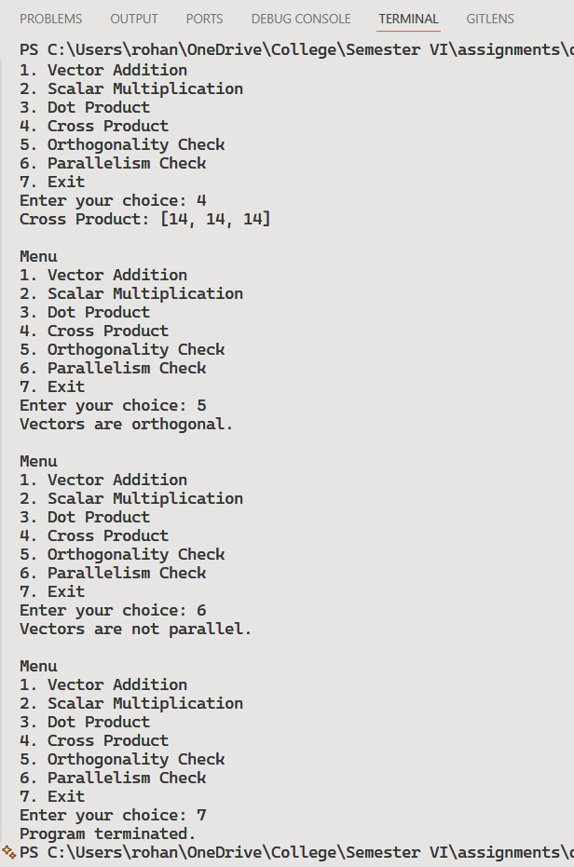

Discussion
- The program can be extended to support vectors of higher dimensions.
- Additional operations such as vector magnitude and angle between vectors can also be added.
Teacher’s signature

