Assignment 11 May 12, 2026

Problem Description
Write a menu driven program that inputs two matrices A and B and perform the following operations: Addition, subtraction, multiplication, division. Hint: Utilize np.add, np.subtract, np.matmul and np.linalg.inv for matrix operations.

Solution
Step 1. The program is started.
Step 2. The number of rows is accepted from the user and stored in variable rows.
Step 3. The number of columns is accepted from the user and stored in variable cols.
Step 4. Elements of matrix A are accepted from the user row by row and stored in list A.
Step 5. Elements of matrix B are accepted from the user row by row and stored in list B.
Step 6. Lists A and B are converted into NumPy arrays.
Step 7. A menu containing matrix operations is displayed.
Step 8. The user choice is accepted and stored in variable choice.
Step 9. It is checked whether choice is equal to 1.
Step 10. If the condition is true, then matrix addition is performed using:
$$A+B$$
Step 11. The addition result is displayed.
[End of condition defined at Step 11.]
Step 12. It is checked whether choice is equal to 2.
Step 13. If the condition is true, then matrix subtraction is performed using:
$$A-B$$
Step 14. The subtraction result is displayed.
[End of condition defined at Step 14.]
Step 15. It is checked whether choice is equal to 3.
Step 16. If the condition is true, then matrix multiplication is performed using:
$$A×B$$

Step 17. The multiplication result is displayed.
[End of condition defined at Step 17.]
Step 18. It is checked whether choice is equal to 4.
Step 19. If the condition is true, then a try block is started.
Step 20. The inverse of matrix B is calculated using np.linalg.inv() and stored in variable inverse_B.
Step 21. Matrix division is performed by multiplying matrix A with inverse_B.
Step 22. The division result is displayed.
[End of condition defined at Step 22.]
Step 23. If matrix B is singular and cannot be inverted, then a LinAlgError exception is handled and an error message is displayed.
[End of condition defined at Step 23.]
Step 24. It is checked whether choice is equal to 5.
Step 25. If the condition is true, then the program is terminated.
[End of condition defined at Step 25.]
Step 26. Otherwise, an invalid choice message is displayed.
Step 27. The menu loop is repeated until the exit option is selected.
[End of loop defined at Step 7.]

Code
import numpy as np

def main():
# Input matrices
rows = int(input("Enter number of rows: "))
cols = int(input("Enter number of columns: "))

print("Enter elements of Matrix A:")
A = []

for i in range(rows):
row = list(map(int, input().split()))
A.append(row)

print("Enter elements of Matrix B:")
B = []

for i in range(rows):
row = list(map(int, input().split()))
B.append(row)

# Convert lists to numpy arrays
A = np.array(A)
B = np.array(B)

while True:
# Display menu
print("\nMenu")
print("1. Addition")
print("2. Subtraction")
print("3. Multiplication")
print("4. Division")
print("5. Exit")

choice = int(input("Enter your choice: "))

match choice:

case 1:
# Matrix addition
result = np.add(A, B)

print("Addition Result:")
print(result)

case 2:
# Matrix subtraction
result = np.subtract(A, B)

print("Subtraction Result:")
print(result)

case 3:
# Matrix multiplication
result = np.matmul(A, B)

print("Multiplication Result:")
print(result)

case 4:
try:
# Matrix division using inverse
inverse_B = np.linalg.inv(B)

result = np.matmul(A, inverse_B)

print("Division Result:")
print(result)

except np.linalg.LinAlgError:
print("Matrix B is singular and cannot be inverted.")

case 5:
print("Program terminated.")
break

case _:
print("Invalid choice.")

if __name__ == "__main__":
main()

Output
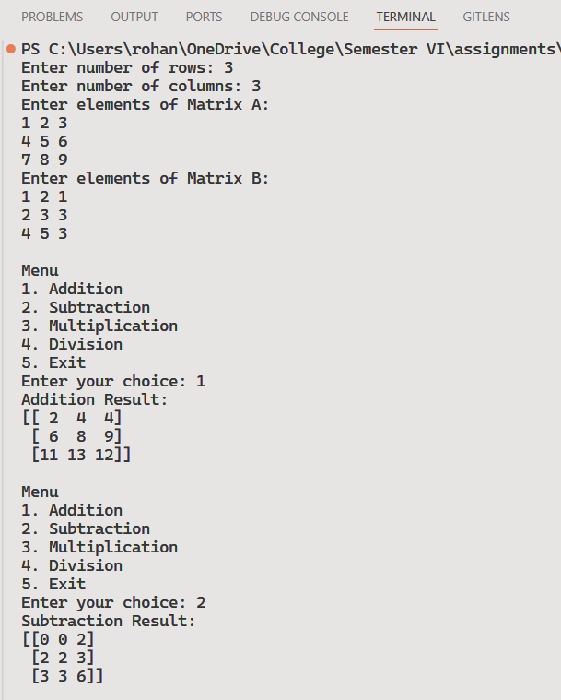 | 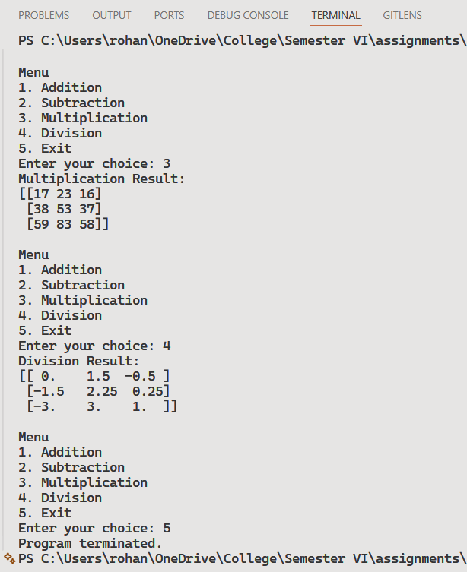

Discussion
- The program can be extended to support matrices of different dimensions where applicable.
- Additional matrix operations such as transpose and determinant can also be added.
Teacher’s signature

