Assignment 16 May 24, 2026

Problem Description
Perform Principal Component Analysis (PCA) on the Iris dataset to reduce its dimensionality. Standardize the features and apply PCA to obtain the first two principal components. Plot the data using these two components and color the points based on species. Interpret how well the principal components separate the different species.
Dataset Link:
https://archive.ics.uci.edu/ml/datasets/iris
Use StandardScaler and PCA(n_components=2) from sklearn and plot using matplotlib.

Solution
Step 1. The program is started.
Step 2. Required libraries such as pandas, matplotlib, StandardScaler, PCA, and Iris dataset modules are imported.
Step 3. The Iris dataset is loaded and stored in variable iris.
Step 4. Feature values of the dataset are extracted and stored in variable X.
Step 5. Target class labels are extracted and stored in variable y.
Step 6. Species names are extracted and stored in variable target_names.
Step 7. An object of StandardScaler is created and stored in variable scaler.
Step 8. The feature values in X are standardized using scaler.fit_transform() and stored in variable X_scaled.
Step 9. An object of PCA is created with n_components = 2.
Step 10. PCA transformation is applied on X_scaled.
Step 11. The transformed principal components are stored in variable principal_components.
Step 12. A DataFrame named pca_df is created using principal_components.
Step 13. Column names PC1 and PC2 are assigned to the DataFrame.
Step 14. Species labels stored in y are added into pca_df.
Step 15. A plotting window is created using matplotlib.
Step 16. A loop is started from species 0 to the total number of species in target_names.
Step 17. Data points corresponding to the current species are selected from pca_df.
Step 18. Scatter plotting is performed using principal components PC1 and PC2.
Step 19. Labels are assigned to the plotted species.
[End of loop defined at Step 16.]
Step 20. The x-axis label is set as Principal Component 1.
Step 21. The y-axis label is set as Principal Component 2.
Step 22. The graph title is displayed.
Step 23. A legend is displayed for species identification.
Step 24. Grid lines are displayed on the graph.
Step 25. The PCA graph is displayed.
Step 26. The program is terminated.

Code
import pandas as pd
import matplotlib.pyplot as plt

from sklearn.datasets import load_iris
from sklearn.preprocessing import StandardScaler
from sklearn.decomposition import PCA

def main():
# Load Iris dataset
iris = load_iris()

X = iris.data
y = iris.target
target_names = iris.target_names

# Standardize features
scaler = StandardScaler()

X_scaled = scaler.fit_transform(X)

# Apply PCA
pca = PCA(n_components=2)

principal_components = pca.fit_transform(X_scaled)

# Create DataFrame
pca_df = pd.DataFrame(
data=principal_components,
columns=["PC1", "PC2"]
)

pca_df["Species"] = y

# Plot PCA result
plt.figure(figsize=(8, 6))

for species in range(len(target_names)):
plt.scatter(
pca_df[pca_df["Species"] == species]["PC1"],
pca_df[pca_df["Species"] == species]["PC2"],
label=target_names[species]
)

# Graph labels
plt.xlabel("Principal Component 1")
plt.ylabel("Principal Component 2")

plt.title("PCA on Iris Dataset")

plt.legend()

plt.grid(True)

plt.show()

if __name__ == "__main__":
main()

Output
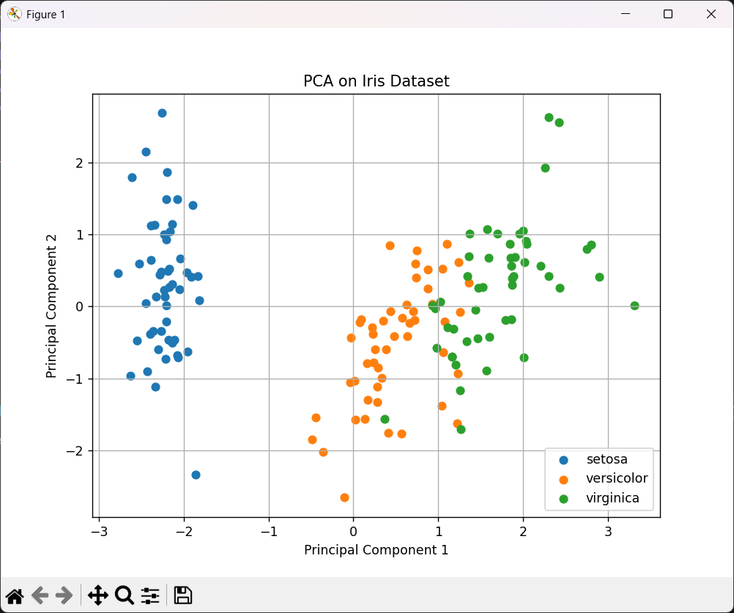

Discussion
- PCA reduces the dimensionality of the Iris dataset from 4 features to 2 principal components while preserving maximum variance.
- The plotted graph helps visualize how well different Iris species are separated using the principal components.
Teacher’s signature

