Assignment 17 May 24, 2026

Problem Description
Draw suitable diagrams to represent both absolute and cumulative frequencies for the following distribution of family size for 100 families.
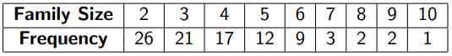
Use plt.bar for absolute frequency and plt.plot(np.cumsum(frequencies)).

Solution
Step 1. The program is started.
Step 2. Required libraries numpy and matplotlib.pyplot are imported.
Step 3. Family size values are stored in list family_size.
Step 4. Corresponding absolute frequencies are stored in list frequencies.
Step 5. Cumulative frequencies are calculated using np.cumsum() and stored in variable cumulative_frequencies.
Step 6. A plotting window for the absolute frequency graph is created.
Step 7. A bar graph is plotted using family_size and frequencies with plt.bar().
Step 8. The x-axis label is set as Family Size.
Step 9. The y-axis label is set as Absolute Frequency.
Step 10. The graph title is displayed.
Step 11. Grid lines are added to the graph.
Step 12. The absolute frequency graph is displayed.
Step 13. A second plotting window for the cumulative frequency graph is created.
Step 14. A line graph is plotted using family_size and cumulative_frequencies with plt.plot().
Step 15. Markers are added on the plotted points.
Step 16. The x-axis label is set as Family Size.
Step 17. The y-axis label is set as Cumulative Frequency.
Step 18. The graph title is displayed.
Step 19. Grid lines are added to the graph.
Step 20. The cumulative frequency graph is displayed.
Step 21. The program is terminated.

Code
import numpy as np
import matplotlib.pyplot as plt

def main():
# Family sizes
family_size = [2, 3, 4, 5, 6, 7, 8, 9, 10]

# Absolute frequencies
frequencies = [26, 21, 17, 12, 9, 3, 2, 2, 1]

# Calculate cumulative frequencies
cumulative_frequencies = np.cumsum(frequencies)

# Plot absolute frequency diagram
plt.figure(figsize=(8, 5))

plt.bar(family_size, frequencies)

plt.xlabel("Family Size")
plt.ylabel("Absolute Frequency")

plt.title("Absolute Frequency Distribution")

plt.grid(True)

plt.show()

# Plot cumulative frequency diagram
plt.figure(figsize=(8, 5))

plt.plot(
family_size,
cumulative_frequencies,
marker="o"
)

plt.xlabel("Family Size")
plt.ylabel("Cumulative Frequency")

plt.title("Cumulative Frequency Distribution")

plt.grid(True)

plt.show()

if __name__ == "__main__":
main()

Output
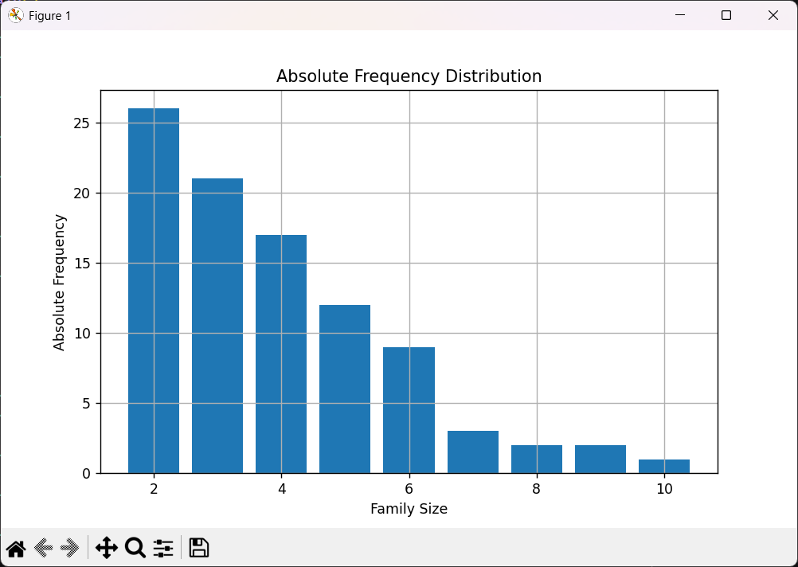
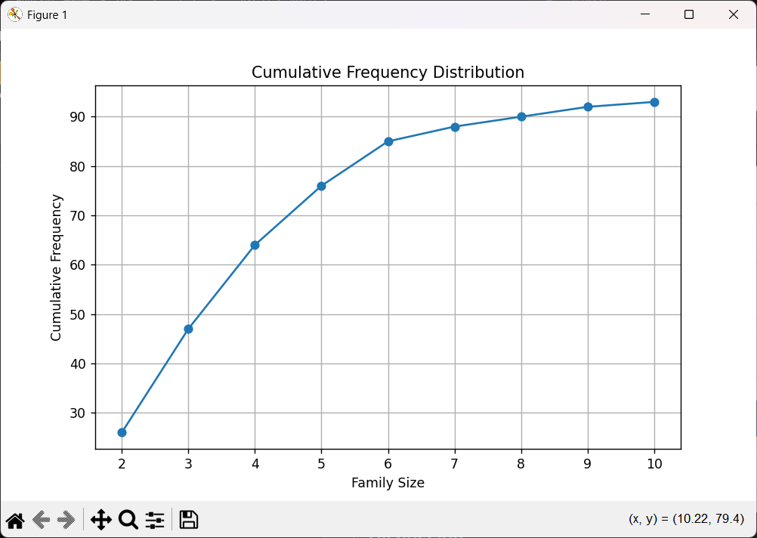

Discussion
- The program can be extended to support matrices of different dimensions where applicable.
- Additional matrix operations such as transpose and determinant can also be added.
Teacher’s signature

