Assignment 18 May 24, 2026

Problem Description
Write a menu driven program that inputs two matrices A and B and perform the following operations: Addition, subtraction, multiplication, division. Hint: Utilize np.add, np.subtract, np.matmul and np.linalg.inv for matrix operations.

Solution
Step 1. The program is started.
Step 2. Required libraries such as pandas, load_iris, skew, and kurtosis are imported.
Step 3. The Iris dataset is loaded and stored in variable iris.
Step 4. A DataFrame named df is created using the feature values of iris.
Step 5. The sepal length column is selected from df and stored in variable sepal_length.
Step 6. Skewness of sepal_length is calculated using skew() and stored in variable skewness.
Step 7. Kurtosis of sepal_length is calculated using kurtosis() and stored in variable kurt.
Step 8. The value of skewness is displayed.
Step 9. The value of kurt is displayed.
Step 10. It is checked whether skewness is greater than 0.
Step 11. If the condition is true, then the distribution is displayed as positively skewed.
[End of condition defined at Step 11.]
Step 12. Otherwise, it is checked whether skewness is less than 0.
Step 13. If the condition is true, then the distribution is displayed as negatively skewed.
[End of condition defined at Step 13.]
Step 14. Otherwise, the distribution is displayed as symmetric.
[End of condition defined at Step 14.]
Step 15. It is checked whether kurt is greater than 0.
Step 16. If the condition is true, then the distribution is displayed as leptokurtic.
[End of condition defined at Step 16.]
Step 17. Otherwise, it is checked whether kurt is less than 0.
Step 18. If the condition is true, then the distribution is displayed as platykurtic.
[End of condition defined at Step 18.]
Step 19. Otherwise, the distribution is displayed as mesokurtic.
[End of condition defined at Step 19.]
Step 20. The program is terminated.

Code
import pandas as pd

from sklearn.datasets import load_iris
from scipy.stats import skew, kurtosis

def main():
# Load Iris dataset
iris = load_iris()

# Create DataFrame
df = pd.DataFrame(
iris.data,
columns=iris.feature_names
)

# Select sepal length
sepal_length = df["sepal length (cm)"]

# Calculate skewness
skewness = skew(sepal_length)

# Calculate kurtosis
kurt = kurtosis(sepal_length)

# Display results
print("Skewness:", skewness)

print("Kurtosis:", kurt)

# Interpretation
if skewness > 0:
print("Distribution is positively skewed.")

elif skewness < 0:
print("Distribution is negatively skewed.")

else:
print("Distribution is symmetric.")

if kurt > 0:
print("Distribution is leptokurtic.")

elif kurt < 0:
print("Distribution is platykurtic.")

else:
print("Distribution is mesokurtic.")

if __name__ == "__main__":
main()

Output
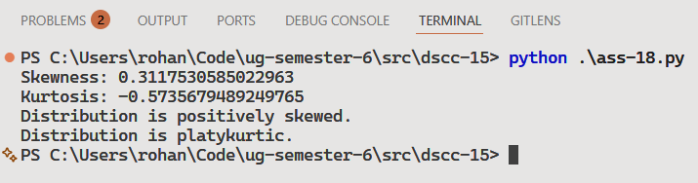

Discussion
- Skewness measures the asymmetry of the sepal length distribution.
- Kurtosis measures the peakedness or flatness of the distribution compared to a normal distribution.
Teacher’s signature

