INFO8240 Assignment 1 Section 2, Team 206

By signing below, I certify that I have fully complied with the INFO8240 Code of Honor.

Student 1: Payal Patel (8733856)
Student 2: Aditya Singh(8758943)
Student 3: Rohan Beldar(8757129)
Student 4: Kesha Pandya(8754967)

Individual VP Lab (20% of A1 mark for each member / presenter)

Complete the table below after each member has completed their VP lab. Fill out the location (e.g., Zoom, MS Teams) and date & time, where the demo was completed. Members must sign their own name.
Team Member  (Presenter) | Location, Demo Date and Time | Certified By  (Another team Member)
- Payal Patel | MS Teams – General->A1  20:45PM 01/10/2021 | Rohan Beldar
- Aditya Singh | MS Teams – General->A1  20:42PM 01/10/2021 | Kesha Pandya
- Rohan Beldar | MS Teams – General->A1  20:49PM 01/10/2021 | Aditya Singh
- Kesha Pandya | MS Teams – General->A1  22:51PM 01/10/2021 | Payal Patel

Team Assignment 1 (80% of A1 mark)

Task 1: Use Case Description with Activity Diagram and SSD
1A. Fully-Developed Use Case Description
Use Case ID | UC01
Use Case Name | Add a new library patron.
Scenario | Create a full-time Employee (e.g. Faculty)
Triggering Event | Enroll for library services.
Brief Description | Primary library services like access to e-resources, issuance and renewal of any book, media collection etc.
Actor(s) | Employee, Supervisor
Related Use Cases | Edit Employee Record
Stakeholders | Employee: to issue book  Librarian: to verify the information  System: to collect patron data for validation and issue the book
Preconditions | Employee must be part of the organization and do the registration to get card number.
Postconditions | Record for an employee has been added and card number is generated.
Flow of Activities | Actor | System
Flow of Activities | 1.Employee visit library desk and create a Personal Identification Number (PIN).  2.The patron select 4-digits PIN.  3. For employees to make any type of request, they must login using their employee card number and PIN.  4.Employee got registered. | 1.1 System will validate patron.  2.1 Once the system identifies that the employee is registered, he/she can access library services.  3.1 The system needs to validate both the login credentials and the PIN before granting access.
Exception Conditions | 2.1 If patron does not exist, then the library staff pauses this use case.

1B. Activity Diagram
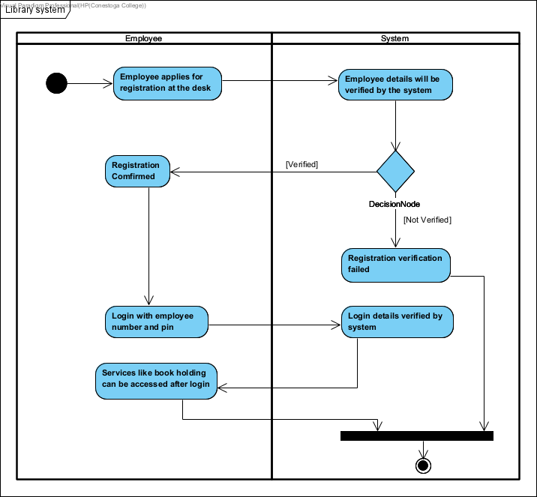

1C. System Sequence Diagram
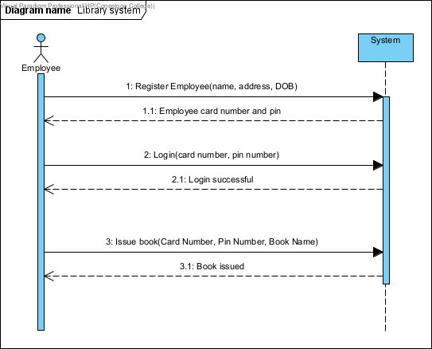

Task 2: Use Case Description with Activity Diagram and SSD
2A. Fully-Developed Use Case Description
USE CASE SELECTION | DESCRIPTION
Use Case Name | Borrow a library item.
Scenario | Borrow a book.
Triggering event | Issue a book for an Employee.
Brief description | Employee picks their desired book and ask the librarian to issue at the library desk. Then the library staff will issue that book after certain step of verification such as ID, patron number.
Actors | Employee, Librarian, System
Related use cases | Return library item
Stakeholders | Employee, System, Librarian
Preconditions | Employee must be within organization and must have their own Employee ID.
Postconditions | Book is issued to the employee if everything is legitimate, otherwise items will be back on the shelves and available for borrowing.
Flow of activities | Actor | System
 | 1.Employee visit library desk and ask the librarian to issue a book.  2. Librarian will use the built-in circulation desk Radio Frequency Identification (RFID) scanner to read the accession numbers of the book that the employee wants to borrow.  3.1 A book will be issued to the employee. | 1.1 . The system matches the card number and PIN of the Employee.  1.2 Once system identifies that the user is full time employee, he/she can borrow a book.  2.1 The system will tell the librarian if the employee surpassed the limit.  3 The system will record the date, patron number and accession number, and the book is issued.
Exception Conditions | If the limit is reached or the employee has credit to clear the book will not be issued and it will be back on shelves.

2B. Activity Diagram
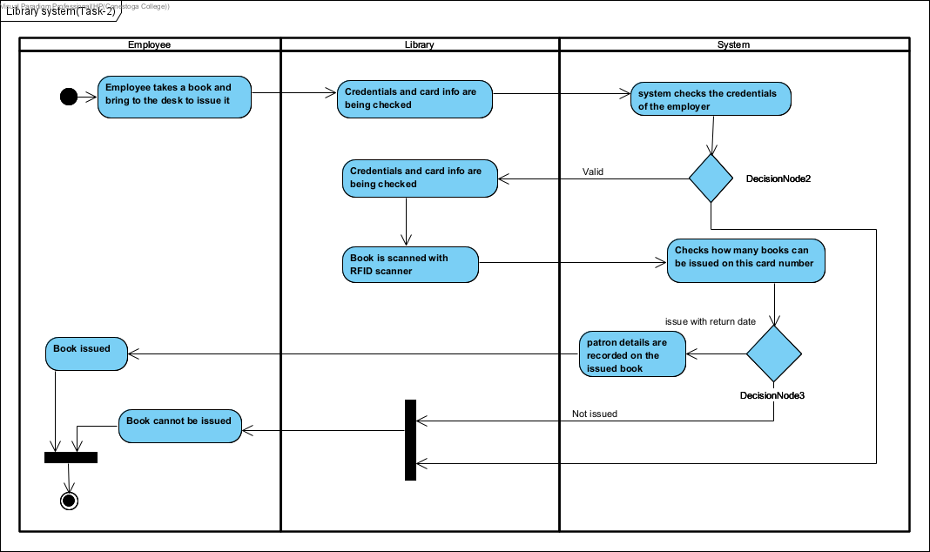

2C. System Sequence Diagram
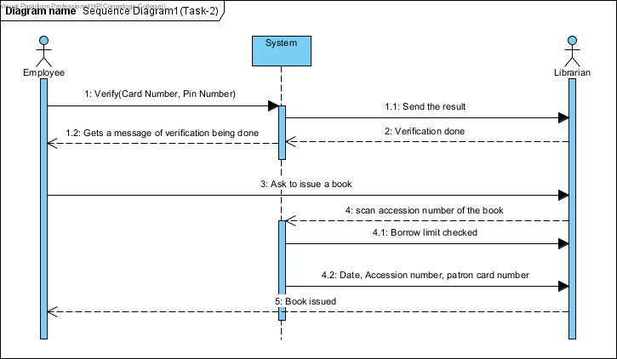

Task 3: CITL Partial Use Case Diagram
