INFO8240 Assignment 2 Section 2, Group 6

By signing below, I certify that I have fully complied with the INFO8240 Code of Honor.

Student 1: Aditya Singh
Student 2: Kesha Pandya
Student 3: Payal Patel
Student 4: Rohan Beldar

Individual VP Lab (20% of A2 mark for each member / presenter)

Complete the table below after each member has completed their VP lab. Fill out the location (e.g., Zoom, MS Teams) and date & time, where the demo was completed. Members must sign their own name.
Team Member  (Presenter) | Location, Demo Date and Time | Certified By  (Another team Member)
- Aditya Singh | Group 6> A2, 10/23/2021, 9:36 PM | Payal Patel
- Payal Patel | Group 6> A2, 10/23/2021, 5:30 PM | Kesha Pandya
- Kesha Pandya | Group 6> A2, 10/24/2021, 3:10 PM | Payal Patel
- Rohan Beldar | Group 6> A2, 10/23/2021, 7:18 PM | Aditya Singh

Team Assignment 2 (80% of A2 mark)

Task 1: CITL Domain Class Diagram

Task 1A: Patron Class Hierarchy
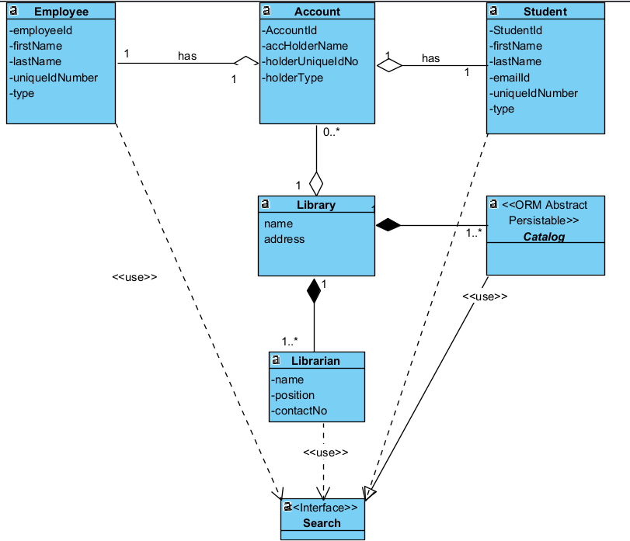

Task 1B: Library Item Class Hierarchy
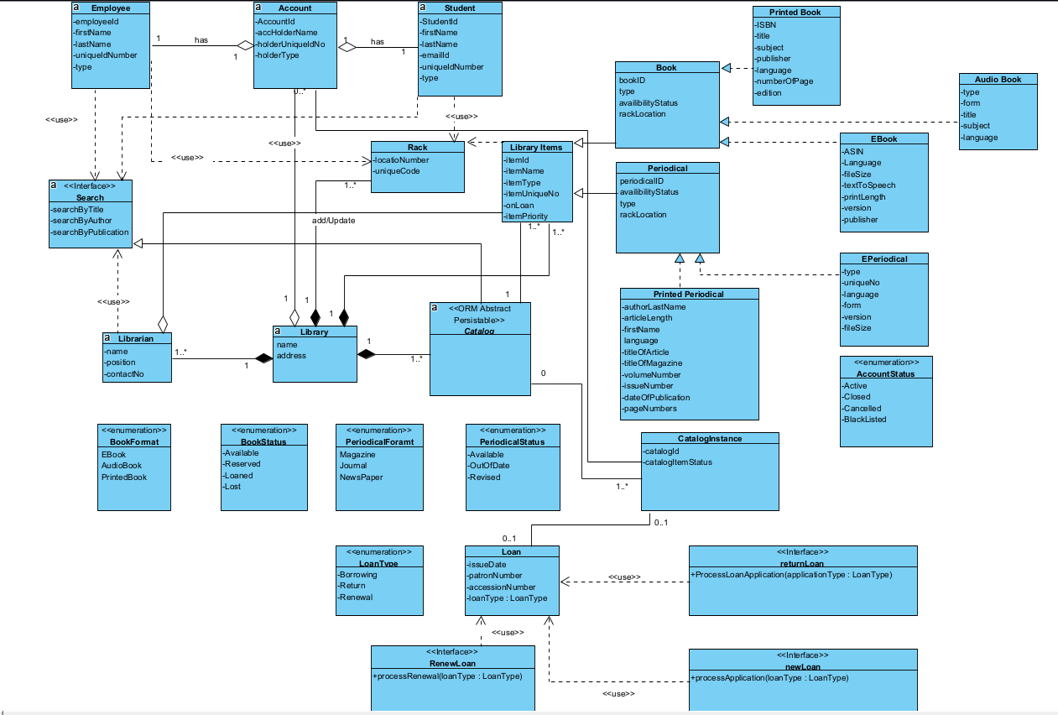

Task 1C: Loan and Catalog Item classes
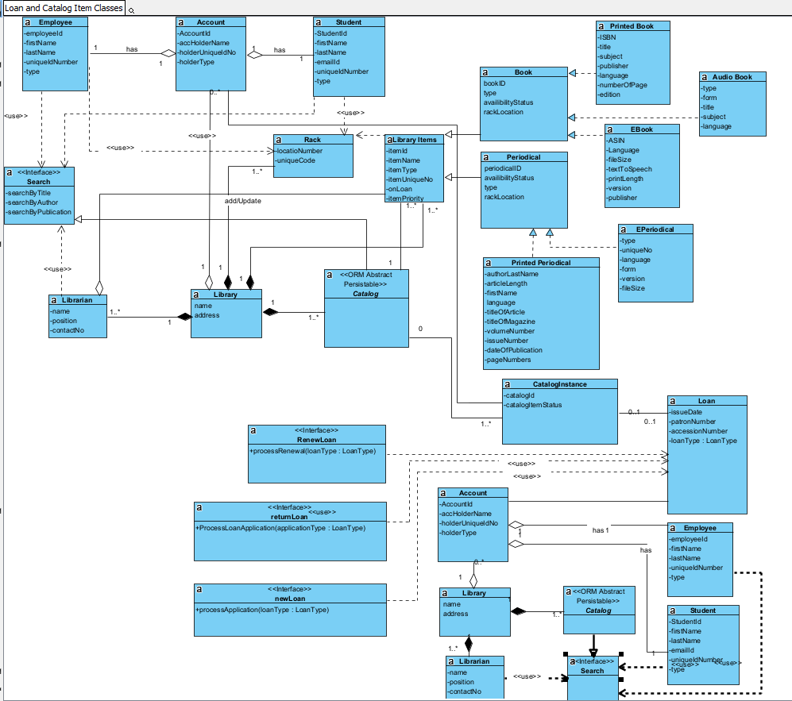
Task 2: CITL Catalog Item Object Life Cycle

Task 2A: CITL Catalog Item State Table

State ID | State Name | Transition Causing Exit
S01 | Visit | Take to library Management
S02 | Search Item | Search for item
S03 | Item Details | Details of item
S04 | Item state | State of item
S05 | Verify identity | Verification of card
S06 | New loan | New registered loan
S07 | Existing loan | Loan is existing
S08 | Loan return | Expire loan date
S09 | Renew loan | Extend loan
 | … | …

Task 2B: CITL Catalog Item State Machine Diagram (SMD)

