INFO8240 Assignment 3 Section 2, Team 04

By signing below, I certify that I have fully complied with the INFO8240 Code of Honor.

Student 1: _____Payal Patel (8733856)______________________
Student 2: _____Aditya Singh(8758943)______________________
Student 3: _____Rohan Beldar(8757129)_________________________
Student 4: _____Kesha Pandya(8754967)_________________________

Individual VP Lab (20% of A3 mark for each member / presenter)

Complete the table below after each member has completed their VP lab. Fill out the location (e.g., Zoom, MS Teams) and date & time, where the demo was completed. Members must sign their own name.
Team Member  (Presenter) | Location, Demo Date and Time | Certified By  (Another team Member)
- Payal Patel | 18-11-2021, 1:00 pm | Aditya Singh
- Rohan Beldar | 18-11-2021, 1:00 pm | Kesha Pandya
- Aditya Singh | 18-11-2021, 1:00 pm | Rohan Beldar
- Kesha PAndya | 18-11-2021, 1:00 pm | Payal Patel

Team Assignment 3 (80% of A3 mark)

Task 1:

Task 1A:
(A)Library Collections Subsystem

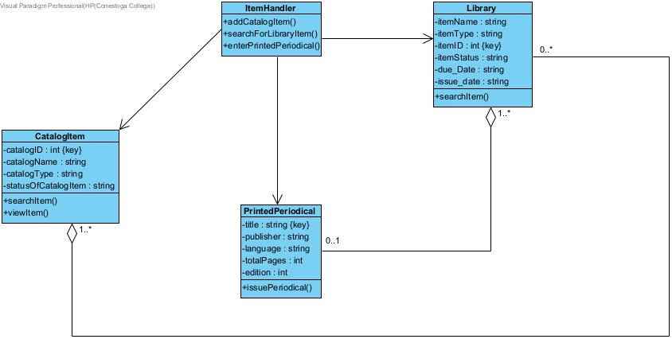

Task 1B:
- Add Catalog Item
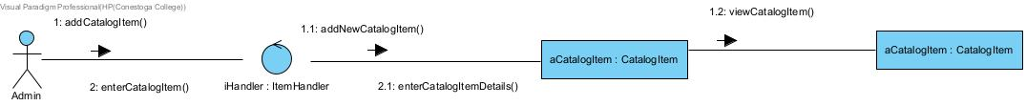

- Search Library Item

- Enter Printed Periodical
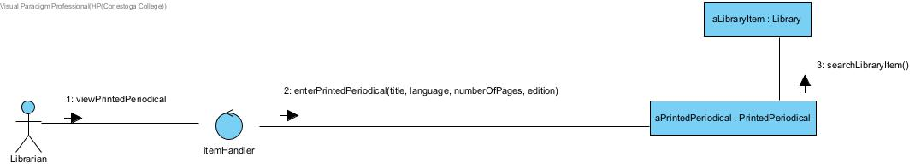

Task 2:

Task 2A:
Patron Account Subsystem Class Diagram
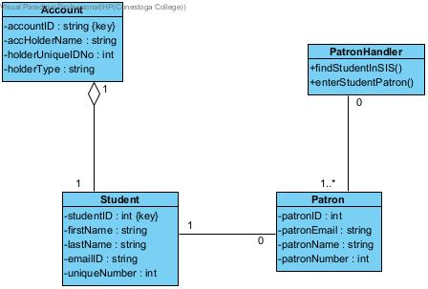

Task 2B:
Add a Library Patron
- StudentInSIS
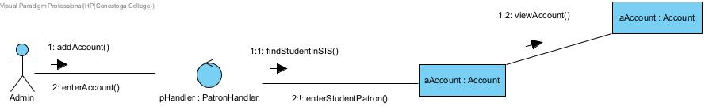

- Enter Student Patron

Task 3:

Task 3A:
Library Borrowing Subsytem
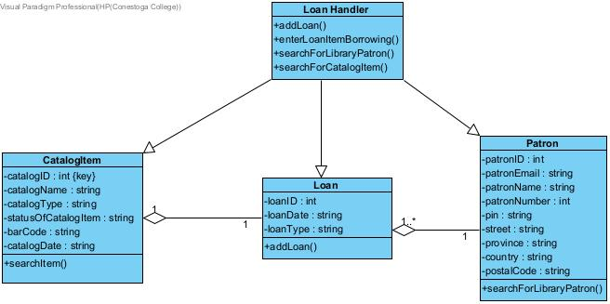

Task 3B:
Add Loan
